**E-Mandi**



A Major Project Report Submitted to

Rajiv Gandhi Proudyogiki Vishwavidyalaya, Bhopal

towards Partial Fulfillment of

the Degree of

**Bachelor of Engineering**

**In**

**Computer Science and Engineering**

**Guided By: Submitted By:**

Mrs. Harshita Mandloi Priyesh Bagrecha

Lecturer Rajkumar Nemani

Computer Science & Engg. Shikhar Agrawal

Tanay Mukherjee

Computer Science and Engineering Department

ChameliDevi School Of Engineering

Indore (M.P.)

2012-2013

**CHAMELIDEVI SCHOOL OF ENGINEERING**

**INDORE**

**PERFORMA FOR SUGGESTION OF MAJOR PROJECT PROPOSAL**

**Enrollment No:**

0832CS091083, 0832CS091089, 0832CS091109, 0832CS091123

**College Name:** Chameli Devi School of Engineering

**Branch:** Computer Science & Engineering **Sem:** VIII

**1.Name of the Students:** Priyesh Bagrecha, Rajkumar Nemani, Shikhar Agrawal, Tanay Mukherjee.

**2.Title of the Project:** E-Mandi

**3.Name of the Guide:** Mrs. Harshita Mandloi

**4.Working/Teaching experience of the Guide:**  years

**5.Software used in the Project:** Eclipse Helios v3.6.0 , DB2 Express-c, Rational Rose, Apache tomcat 6.0**,**  JDK 1.6.21.

**Name and Signature of the Student Name, Designation and**

**Signature of the Guide**

Priyesh Bagrecha Mrs. Harshita Mandloi

Rajkumar Nemani Lecturer

Shikhar Agrawal Computer Science & Engg

Tanay Mukherjee

Date: ...................

**CHAMELI DEVI SCHOOL OF ENGINEERING**

**INDORE**



**CERTIFICATE OF AUTHENTICATED WORK**

This is to certify that the project report entitled **E-Mandi** submitted to **R.G.P.V Bhopal** in partial fulfilment of the requirement for the award of the degree of **Bachelor of Engineering** is an original work carried out by **Priyesh Bagrecha(0832cs091083), Rajkumar Nemani(0832cs091089), Shikhar Agrawal(0832cs091109), Tanay Mukherjee (0832cs091123)** under my guidance. The matter embodied in the project is authenticated and is genuine work done by the students and has not been submitted whether to this University or to any other University/Institute for the fulfilment of the requirement of any course of study.

**Mrs. Harshita Mandloi**  **Mr. Vivek Gupta**

Lecturer Head of Department

Computer Science & Engg Computer Science & Engg

**Dr. C.N.S Murthy**

Dean,

C.D.S.E Indore

**CHAMELIDEVI SCHOOL OF ENGINEERING**

**INDORE**



**RECOMMENDATION**

A major project report entitled **E-Mandi** submitted by **Priyesh Bagrecha, Rajkumar Nemani, Shikhar Agrawal, Tanay Mukherjee**  are recommended and forwarded for partial fulfilment of Degree of **Bachelor of Engineering** in **Computer Science and Engineering** of **Rajiv Gandhi Proudyogiki Vishwavidyalaya, Bhopal,** for academic year of 2012-2013.

**Ms. Priyanka Gupta Mr. Vivek Gupta**

Lecturer Head of Department

Computer Science & Engg Computer Science & Engg

**Dr. C.N.S Murthy**

Dean,

C.D.S.E Indore

**CHAMELIDEVI SCHOOL OF ENGINEERING**

**INDORE**



**CERTIFICATE**

A major project report entitled **E-Mandi** submitted by **Priyesh Bagrecha, Rajkumar Nemani, Shikhar Agrawal, Tanay Mukherjee** towards partial fulfilment of Degree of **Bachelor of Engineering** in **Computer Science and Engineering** of **Rajiv Gandhi Proudyogiki Vishwavidyalaya, Bhopal,** is a satisfactory account of his project work for academic year of 2012-13.

**INTERNAL EXAMINER EXTERNAL EXAMINER**

**CHAMELIDEVI SCHOOL OF ENGINEERING**

**INDORE**

**ROLES AND RESPONSIBILITIES FORM**

|  |  |  |  |
| --- | --- | --- | --- |
| **S.No** | **Enrollment No.** | **Name of the Team Member** | **Tasks and Responsibilities** |
| 1. | 0832CS091083 | Priyesh Bagrecha | Analysis, Designing , Coding and Testing |
| 2. | 0832CS091089 | Rajkumar Nemani | Analysis, Designing , Coding and Testing |
| 3. | 0832CS091109 | Shikhar Agrawal | Analysis, Designing , Coding and Testing |
| 4. | 0832CS091123 | Tanay Mukherjee | Analysis, Designing , Coding and Testing |

Name and Signature of the Project Team Members:

1.Priyesh Bagrecha Signature:

2. Rajkumar Nemani Signature:

3. Shikhar Agrawal Signature:

4. Tanay Mukherjee Signature:

Signature of the Guide: Date:……………

**ABSTRACT**

Till today what we have observed is that the mandi concept has always been complex procedure in India and the market scenario was restricted to people who had their forefathers involved in it. For general civilian it was quite difficult to understand the flow the whole market scenario starting from farmers to whole seller to retailer to general masses.

Farmers are seen to be exploited and they don’t get the actual price for the raw commodity; on the other hand there had been instances where price hike occurs that is mainly due to the storage of the vegetables, cereals and fruits illegally in the godowns for longer period and hence ultimately the general public faces the problem. Finally we came with the solution of automizing the whole concept.

The main aim is to create a portal that can have a proper check on the whole mandi system. The existing pitfalls of price hikes and illegal auditing can be eradicated. To make amendments such that farmers get the right prices for the raw materials and the negotiations happening between the farmers and whole sellers & whole sellers and retailers can be regularly maintained.

The reports will be generated periodically and this will make the state governments to have a proper eye on the whole system and thus the so called mandi-mafias will be under control and any action that is illegal can be known and right actions can be taken.

Looking for an online centralised web-portal where the civilians can know the price of vegetables, cereals and fruits at any time in various mandis of the district and also the comparison between the prices set by governments. It is basically a electronic vegetable market making the vegetable market more convenient for the use of civilian and even to keep the transparency in the whole market system from retailer to the wholesaler.

**ACKNOWLEDGEMENT**

It’s a great pleasure and moment of immense satisfaction for us to express our profound gratitude to our respected supervisor, **Mrs. Harshita Mandloi** whose constant encouragement enabled us to work enthusiastically. Her perpetual motivation, patience and excellent expertise in discussion progress of the project work have benefited us to an extent, which is beyond commendation.

We express gratitude towards **Mr. Vivek Gupta**, Head of Department of Computer Science & Engineering C.D.S.E Indore, for his encouragement and for providing and outstanding academic environment for working in the department. We are thankful to **Dr. C.N.S Murthy,** Dean, Chameli Devi School of Engineering, Indore, for providing the adequate facilities.

We are also thankful to **Dr. S. Rajashekharaiah,** Director, Chameli Devi School of Engineering for his valuable knowledge, guidance and support.

Priyesh Bagrecha

Rajkumar Nemani

Shikhar Agrawal

Tanay Mukherjee

**TABLE OF CONTENTS**

**Table of Contents**

**Chapter No. Title Page No.**

1. Introduction

1.1 Problem Definition 15 1.2 Problem Description 15 1.3 Need of Project 16 1.4 Scope of Project 17 1.5 Report Organization 17

2. Requirement analysis

2.1 Software Engineering Paradigms Applied 19 2.2 Functional Requirements 20 2.3 Non-Functional Requirements 21 2.4 Requirement Specification 21

3. Planning and Designing

3.1 System Architecture 24 3.2 UML Diagrams 25

3.2.1 Use Case Diagram 25 3.2.2 Class Diagram 28 3.2.3 Activity Diagram 29 3.2.4 Sequence Diagram 38

3.3 E-R Diagram 48

4. Implementation

4.1 Technologies Description 50 4.2 Physical Database Design 51

5. Testing

5.1 Coding Details 56 5.2 Testing Strategy 58 5.3 Test Case 60

6. User Manual

6.1 Screen Snapshots 64 6.2 Installation/ Deployment Instructions 125

7. Conclusion

7.1 Conclusion 129

8. Limitations and Future Enhancement

8.1 Limitation of Project 131 8.2 Future Enhancement 132

9. References 134

10. Glossary 136

**List of Figures**

|  |  |  |
| --- | --- | --- |
| **Figure No.** | **Name** | **Page No.** |
| 2.1 | RAD Model Diagram | 19 |
| 3.1 | Architecture diagram | 24 |
| 3.2.1 | Use Case Diagram For End User | 25 |
| 3.2.2 | Use Case Diagram For Admin | 26 |
| 3.2.3 | Use Case Diagram For Farmer /Wholesale/Retailer | 27 |
| 3.3 | Class Diagram | 28 |
| 3.4.1 | Activity diagram for Registration | 29 |
| 3.4.2 | Activity diagram for Login | 30 |
| 3.4.3 | Activity diagram for Search | 31 |
| 3.4.4 | Activity diagram for Admin | 32 |
| 3.4.5 | Activity diagram for Blog | 33 |
| 3.4.6 | Activity diagram for Forum | 34 |
| 3.4.7 | Activity diagram for Feedback | 35 |
| 3.4.8 | Activity diagram for Lodging Complaint | 36 |
| 3.4.9 | Activity diagram for Response to Complaint | 37 |
| 3.5.1 | Sequence Diagram For Admin | 38 |
| 3.5.2 | Sequence Diagram For Farmer Login | 39 |
| 3.5.3 | Sequence Diagram For Wholesaler Login | 40 |
| 3.5.4 | Sequence Diagram For Retailer Login | 41 |
| 3.5.5 | Sequence Diagram For Price Civilian | 42 |
| 3.5.6 | Sequence Diagram For Registration | 43 |
| 3.5.7 | Sequence Diagram For Blog | 44 |
| 3.5.8 | Sequence Diagram For Feedback | 45 |
| 3.5.9 | Sequence Diagram For Complaint | 46 |
| 3.5.10 | Sequence Diagram For Forum | 47 |
| 3.6 | Entity Relationship Diagram | 48 |
| 4.1 | Database Design diagram | 54 |

**List of Tables**

|  |  |  |
| --- | --- | --- |
| **Figure No.** | **Name** | **Page No.** |
| 5.1 | Test case 1 | 60 |
| 5.2 | Test case 2 | 61 |
| 5.3 | Test case 3 | 62 |
| 5.4 | Test case 4 | 63 |

**CHAPTER 1**

**INTRODUCTION**

1.1 Problem Definition 1.2 Problem Description 1.3 Need of Project 1.4 Scope of Project 1.5 Report Organization

**1.1 Problem Definition**

The main aim is to create a portal that can have a proper check on the whole mandi system. The existing pitfalls of price hikes and illegal auditing can be eradicated. To make amendments such that farmers get the right prices for the raw materials and the negotiations happening between the farmers and whole sellers & whole sellers and retailers can be regularly maintained.

The reports will be generated periodically and this will make the state governments to have a proper eye on the whole system and thus the so called mandi-mafias will be under control and any action that is illegal can be known and right actions can be taken.

**1.2 Problem Description**

* **Existing System –**
  + The farmers were exploited in sense that they never got the best price for their vegetables or cereals or fruits.
  + No regular reports were available to state government to analyze what is happening in the market.
  + Easy for the mandi-mafias to hold power in the market by illegally storing items and hence resulting in price hikes and black marketing.
  + Civilians never used to know the difference in price in various mandis and hence were fooled by marketers.
  + The whole sellers and retailers used to gulp maximum portion of profit in the whole chain involved.
  + Farmers used to have limited access of contact details of whole sellers and retailers other than those whom they knew in prior.
* **Drawbacks –** 
  + How much stock of any particular item was not clearly known to government..
  + Production of any particular vegetable or cereal or fruit for a year throughout the nation cannot be calculated.
  + It was difficult to stop those mafias who held power in mandis and used to exploit the poor farmers.
  + Real price of any commodity was hardly known, there was always some case of black marketing or inflation.
  + Wastage of commodity due to poor maintenance in rainy season or theft activities used to happen.

**1.3 Need of Project**

* **Proposed System –**
* Registration for all users whether it be farmers or whole sellers or retailers or civilians.
* Personal details were available to farmers of the whole sellers and retailers and hence he had more options to choose before selling his item.
* Any non-member can visit the portal and know the prices of various commodities.
* Proper maintenance of reports for mandis at regular intervals.
* Price hike, black marketing and inflation could be made under control and illegal transfer of items against governmental policies can be stopped.
* **Our Plan –** 
  + The farmer will get more contacts of whole sellers and thus will have options before selling the final goods making maximum profit.
  + The civilians knows the price and thus cannot be fooled any further by marketers.
  + The profit eaten up by the whole sellers and retailers can be taken under control.
  + The state government will have regular reports mentioning all negotiation details and agreements and thus will help them to control any malicious activity.
  + The price hikes will be under controlled. The earlier situation of raw materials cannot be unnecessarily preserved and make the market price rise.
  + Complete transparency throughout the chain is maintained.

**1.4 Scope of Project**

* Create different user profiles with respective privileges.
* Maintain a centralized database of all users and security to information which can be accessed by admin for any required updations and also maintains the database for all possible mandis in the district.
* All registered users are authenticated to avail this service.
* Regular prices of items can be known through our portal for various items be it vegetables or cereals or fruits.
* Track all the users and their contact details regularly.
* Java client facility for working officers.
* FAQ section will be also there for user benefits in case of any misunderstanding or doubt regarding any details in the portal.
* Conformation link will be sent to all those who are registered in the portal.
* Proper reports are periodically generated and thus help state government to have a look at it and check for any malicious activity.
* Amount of items in stock are known and no wastage of any commodity can happen and thus proper check against any possible price hikes in future is eradicated.

**1.5 Report Organization**

The project report till gives only the introduction to application the description that follows gives you detail of what the system is and how system works.

The most important part to follow in report is how we have realized our project including technologies and tools used requirements analysis, how we planned to meet deadlines, software and hardware requirements both at server and client side, Preliminary product description. Various conception models including Class diagram, sequence diagram, use case diagram, activity diagram, collaboration diagram, ER diagram and others. Then follows System Design that include basic modules, Data design, Procedural design, User interfaces, security issues and test cases design. Finally report consists of implementing and testing details and at last conclusion, future extension and Improvements.

**CHAPTER 2**

**REQUIREMENT ANALYSIS**

2.1 Software Engineering Paradigms Applied

2.2 Functional Requirements

2.3 Non-Functional Requirements

**2.1 Software Engineering Paradigms Applied**

**RAD Model**

RAD model is Rapid Application Development model.It is a type of incremental model In RAD model the components or functions are developed in parallel as if they were mini projects. The developments are time boxed, delivered and then assembled into a working prototype.  This can quickly give the customer something to see and use and to provide feedback regarding the delivery and their requirements.

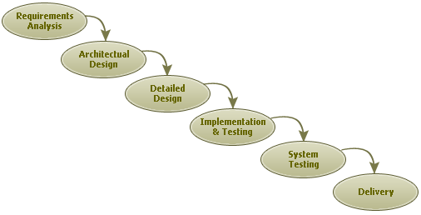

**Figure 2.1:** RAD Model

Rapid Application Development (RAD) is a term originally used to describe a software development process first developed and successfully deployed during the mid-1970s by the New York Telephone Co's Systems Development Center under the direction of Dan Gielan. Following a series of remarkably successful implementations of this process, Gielan lectured extensively in various forums on the methodology, practice, and benefits of this process RAD involves iterative development and the construction of prototypes. In 1990, in his book RAD, Rapid Application Development documented his interpretation of the methodology. More recently, the term and its acronym have come to be used in a broader, general sense that encompasses a variety of methods aimed at speeding application development, such as the use of software frameworks of varied types, such as web application frameworks Rapid application development was a response to processes developed in the 1970s and 1980s, such as the Structured Systems Analysis and Design Method and other Waterfall models One problem with previous methodologies was that applications took so long to build that requirements had changed before the system was complete, resulting in inadequate or even unusable systems..

**Advantages of the RAD model:**

* Reduced development time.
* Increases reusability of components
* Quick initial reviews occur
* Encourages customer feedback
* Integration from very beginning solves a lot of integration issues

**2.2 Functional Requirements**

* People can register to have a complete view of the market including the pricing of vegetables, pricing difference between whole seller and retailer, actual pricing stated by government, best possible retailer in the market for civilian in his area, revenue generated last month and a period of time.
* Non registered can have a overview of these facilities excluding some.
* Feedback or complaint facilities directly connected to government bodies to keep a view .on the market but mentioning the unique id of the complainer .
* Admin should be able to see all record from any users.
* The records shown for selling should be available in a format of Quantity name , Quantity available, price expected.
* The database should be robust enough to handle all the online transactions which will be happening 24 X 7.
* Website will be available in regional languages.
* People will have facility of viewing the price difference between different regions and the inflation rate also.
* Person have facility of booking vegetables for commercial use on a large scale online through bigger marketers.
* Help section for those who are unable to understand the website or any of its part.
* Photo Gallery is present where we want to share the photos of eve’s that are happening around to motivate people for the same.
* Provisions for farmers that had been introduced by government will be made known to them.
* Healthy farming including inorganic techniques and lesser use of fertilizers will be promoted.
* Discussion forums will be created where doubts and other issues can be profoundly discussed.
* Personal details will be secured in every term and contact details will be made known only to required parties.
* Farmers can invite their fellow farmer friends, same for whole sellers, retails and civilians; such functionality will be provided.

**2.3 Non-Functional Requirements**

* Linking this application with social networking websites like facebook, twitter etc. and thus using it as a marketing strategy.
* Developing a system smart enough to send mails as well as messages to every whole seller, whenever a farmer posts on the portal of having stock of some item.
* Minutely managing every transaction and having log of all negotiations and agreements that had happened between any two parties mentioned above.

**2.4 Requirement Specification**

**2.4.1 Software Requirements-**

* To access the Application Online
  + Any web browser
  + Any operating System

* Web Server
  + Necessarily websphere
  + Any operating system
* Database
  + DB2
  + Any operating system

* At Development End
  + Eclipse
  + jdk 1.6
* Database Backup
  + IBM Tivoli storage manager
* Report Creation
  + IBM Rational
  + IBM lotus Software

**2.4.2 HARDWARE REQUIREMENTS**

Minimum Requirements

* *On the Client Side*

|  |  |  |  |  |
| --- | --- | --- | --- | --- |
|  | Processor | RAM | Disc Space | Modem |
| Any Web Browser | P2 or above | 256MB | 1GB | Any |

* + *On the Server Side*

|  |  |  |  |  |
| --- | --- | --- | --- | --- |
|  | Processor | RAM | Disc Space | Modem |
| DB2 | P2 or above | 512MB | 10GB | Any |
| WebSphere | P2 or above | 2GsB | 4GB | Any |

**CHAPTER 3**

**PLANNING AND DESIGNING**

3.1 System Architecture 3.2 UML Diagrams

3.2.1 Use Case Diagram

3.2.2 Class Diagram

3.2.3 Activity Diagram

3.2.4 Sequence Diagram

3.3 E-R Diagram

**3.1 System Architecture:**

**3-Tier Client/Server Architecture**

3-Tier client-server architectures have 3 essential components:

1. A Client PC
2. An Application Server
3. A Database Server

3-Tier Architecture Considerations:

1. Client program contains presentation logic only
2. Less resources needed for client workstation
3. No client modification if database location changes
4. Less code to distribute to client workstations

2. One server handles many client requests

1. More resources available for server program.
2. Reduces data traffic on the network.



**Figure 3.1:** Architecture Diagram

**3.2 UML Diagrams:**

The unified modeling language is a language for specification, constructing, visualizing and documenting the software and its components. The UML is a graphical language with set of rules and syntaxes. The goal of UML is to keep the modeling simple.

The Unified Modeling Language (UML) is a diagramming language or notation to specify, visualize and document models of Object Oriented software systems. UML is not a development method that means it does not tell you what to do first and what to do next or how to design your system, but it helps you to visualize your design and communicate with others. UML is controlled by the Object Management Group (OMG) and is the industry standard for graphically describing software.

UML is composed of many model elements that represent the different parts of a software system. The UML elements are used to create diagrams, which represent a certain part, or a point of view of the system.

**3.2.1 Use Case Diagram:**

**3.2.1.1 Use-case diagram for Civilian and End User:**

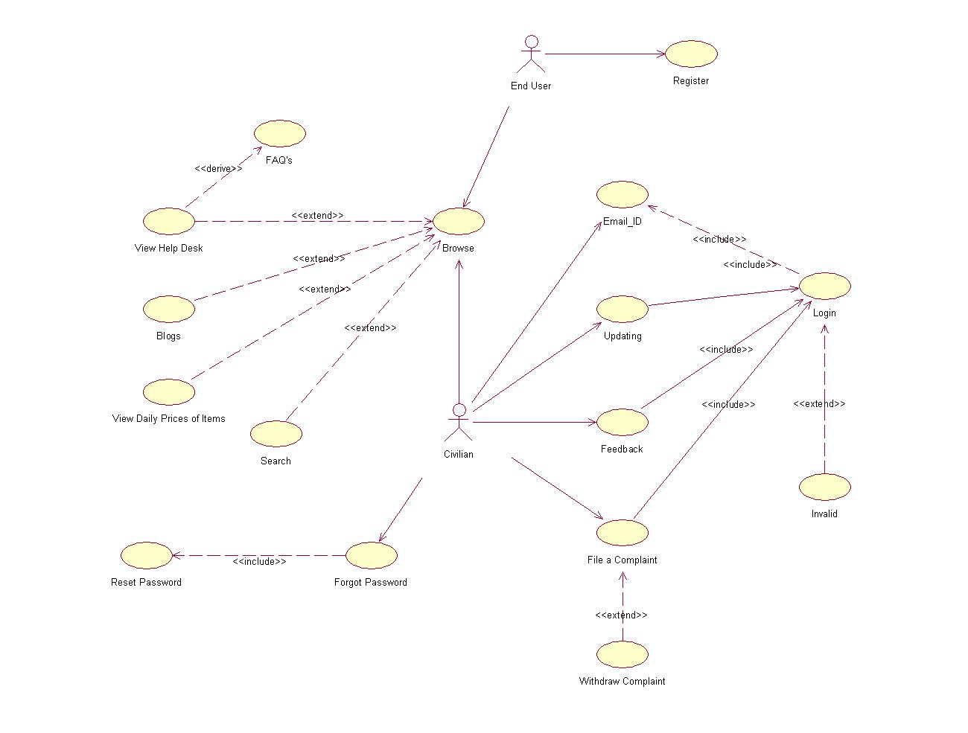

**Figure 3.2.1:** Use Case Diagram for Civilian and End User

**3.2.1.2 Use-case diagram for Admin:**

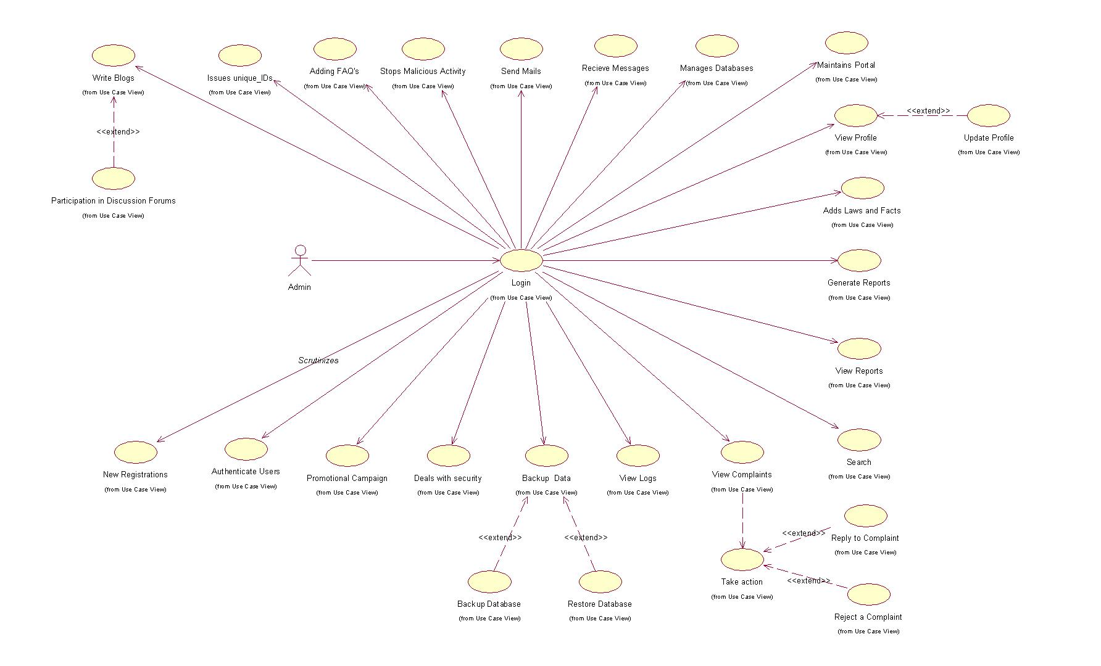

**Figure 3.2.2:** Use Case Diagram for Admin

**3.2.1.3 Use-case diagram for Admin:**

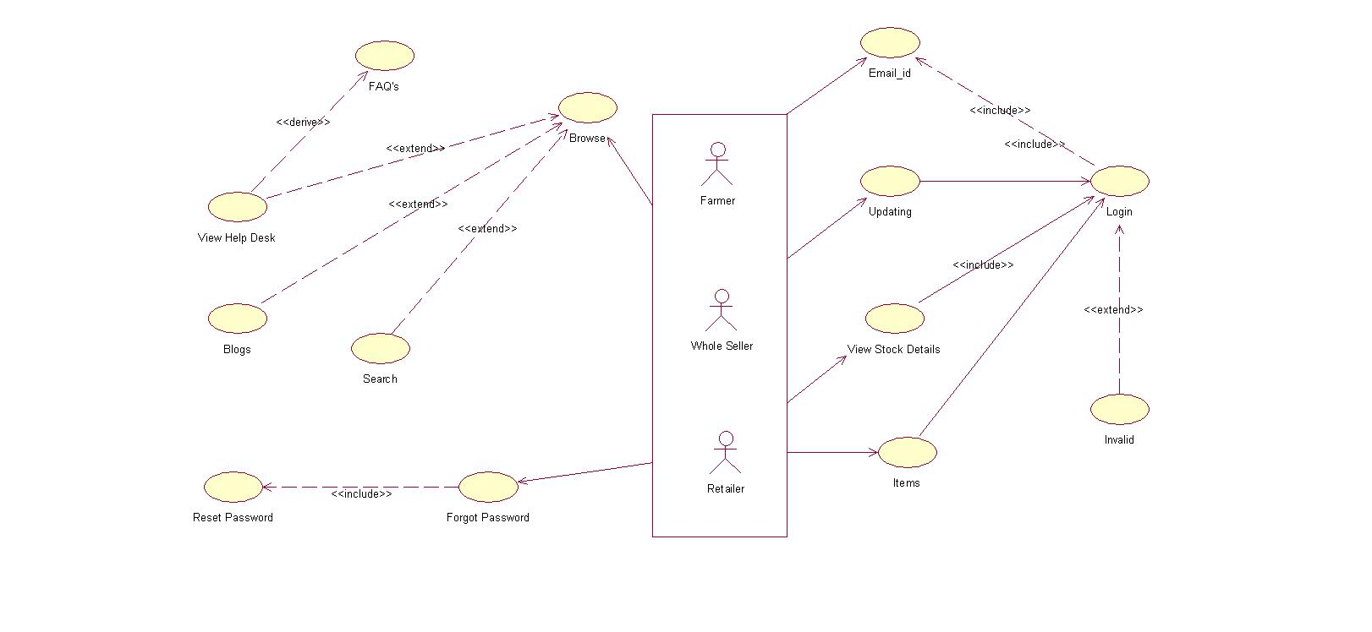

**Figure 3.2.3:** Use Case Diagram for Farmer/Wholesaler/Retailer

**3.2.2 Class Diagram:**

Class Diagrams show the different classes that make up a system and how they relate to each other. Class Diagrams are said to be ‘static’ diagrams because they show the classes, along with their methods and attributes as well as the static relationships between them: which classes ‘know’ about which classes or which classes ‘are part’ of another class, but do not show the method calls between them.

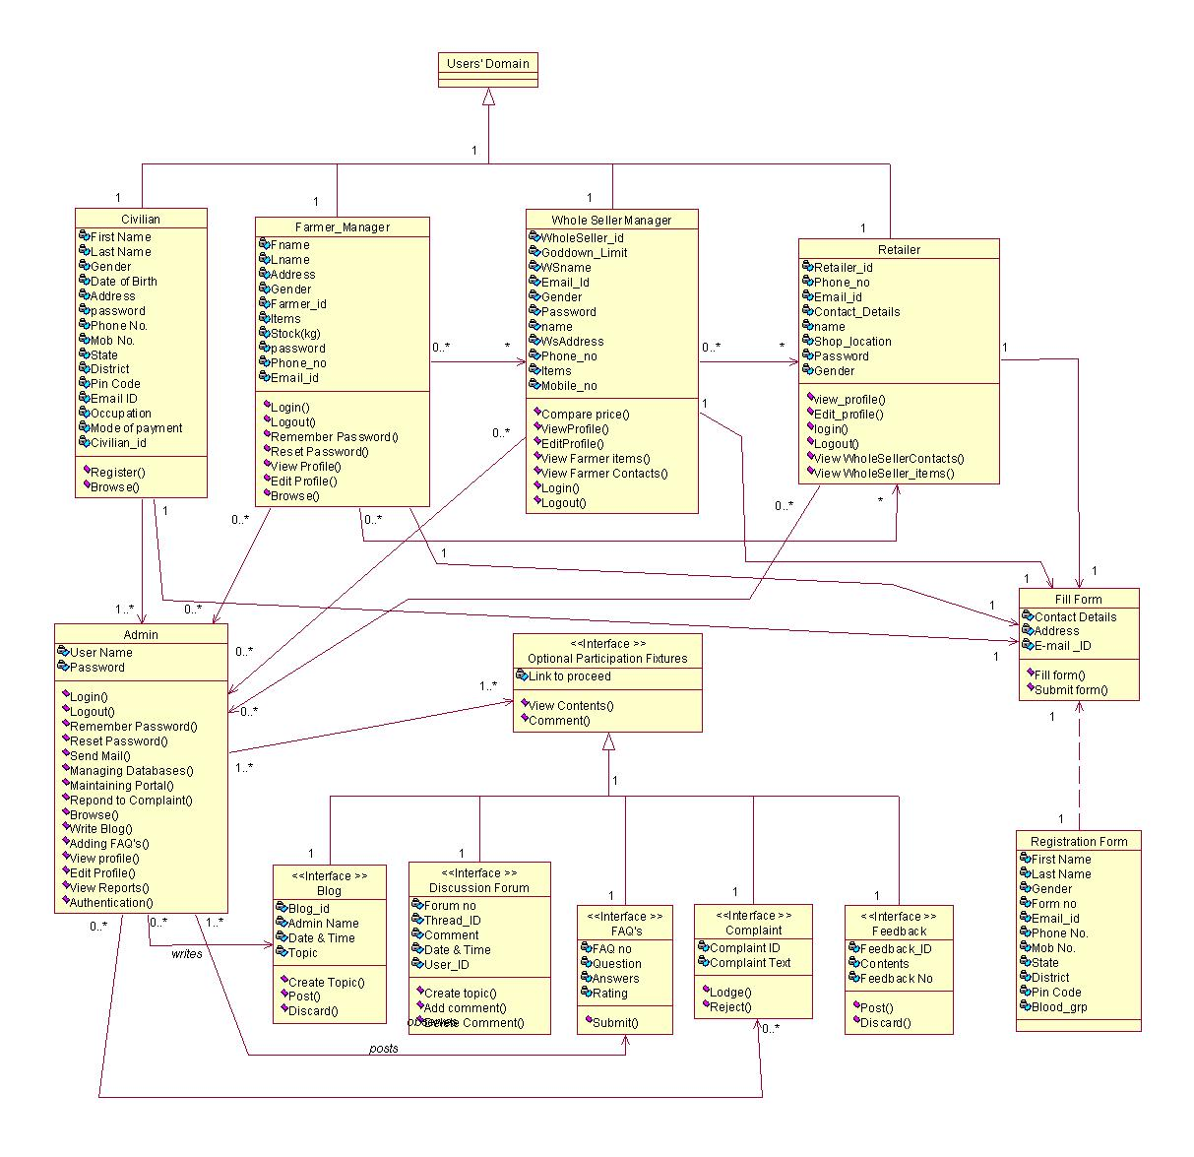

**Figure 3.3:** Class Diagram

**3.2.3 Activity Diagram:**

An activity diagram illustrates the dynamic nature of a system by modeling the flow of control from activity to activity. An activity represents an operation on some class in the system that results in a change in the state of the system. Typically, activity diagrams are used to model workflow or business processes and internal operation. Because an activity diagram is a special kind of state chart diagram, it uses some of the same modelling conventions.

**3.2.3.1 Activity diagram for user registration:**

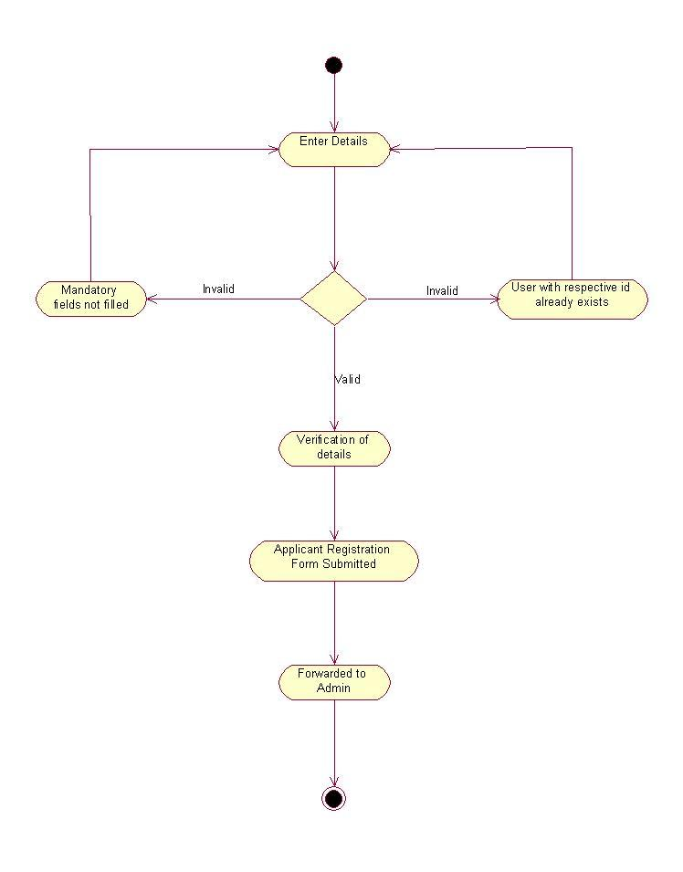

**Figure 3.4.1:** Activity diagram for user registration

**3.2.3.2 Activity diagram for login privileges:**

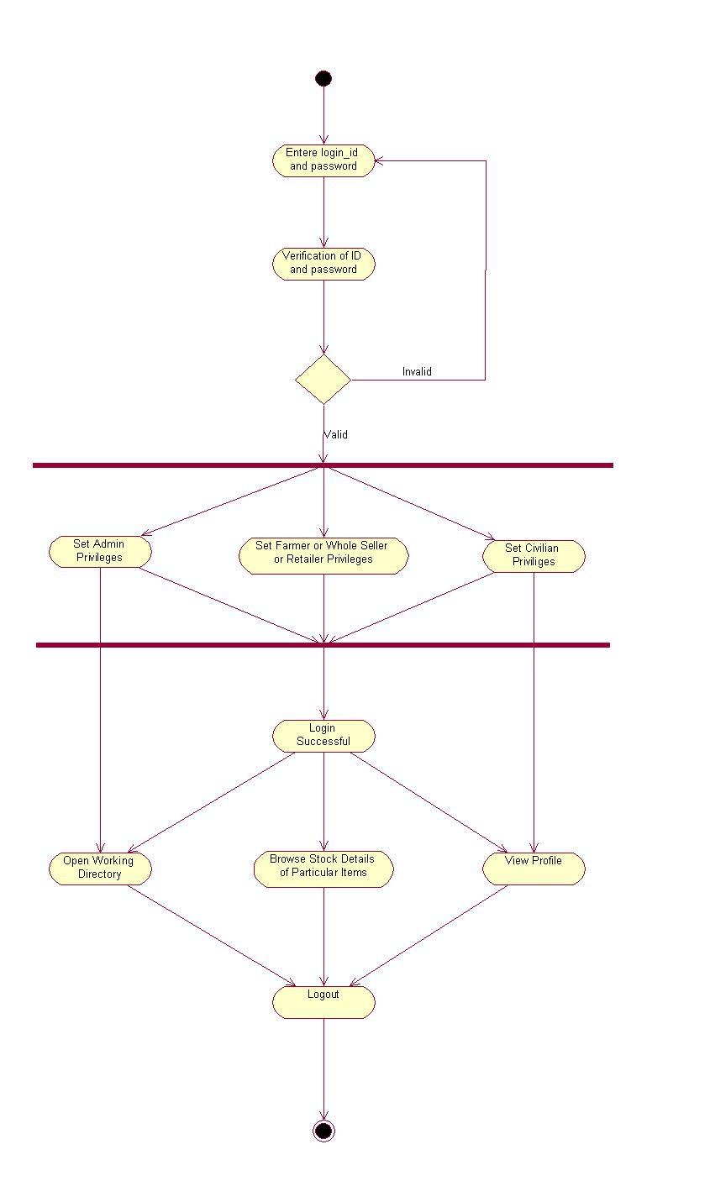

**Figure 3.4.2:** Activity diagram for login privileges

**3.2.3.3 Activity diagram for search:**

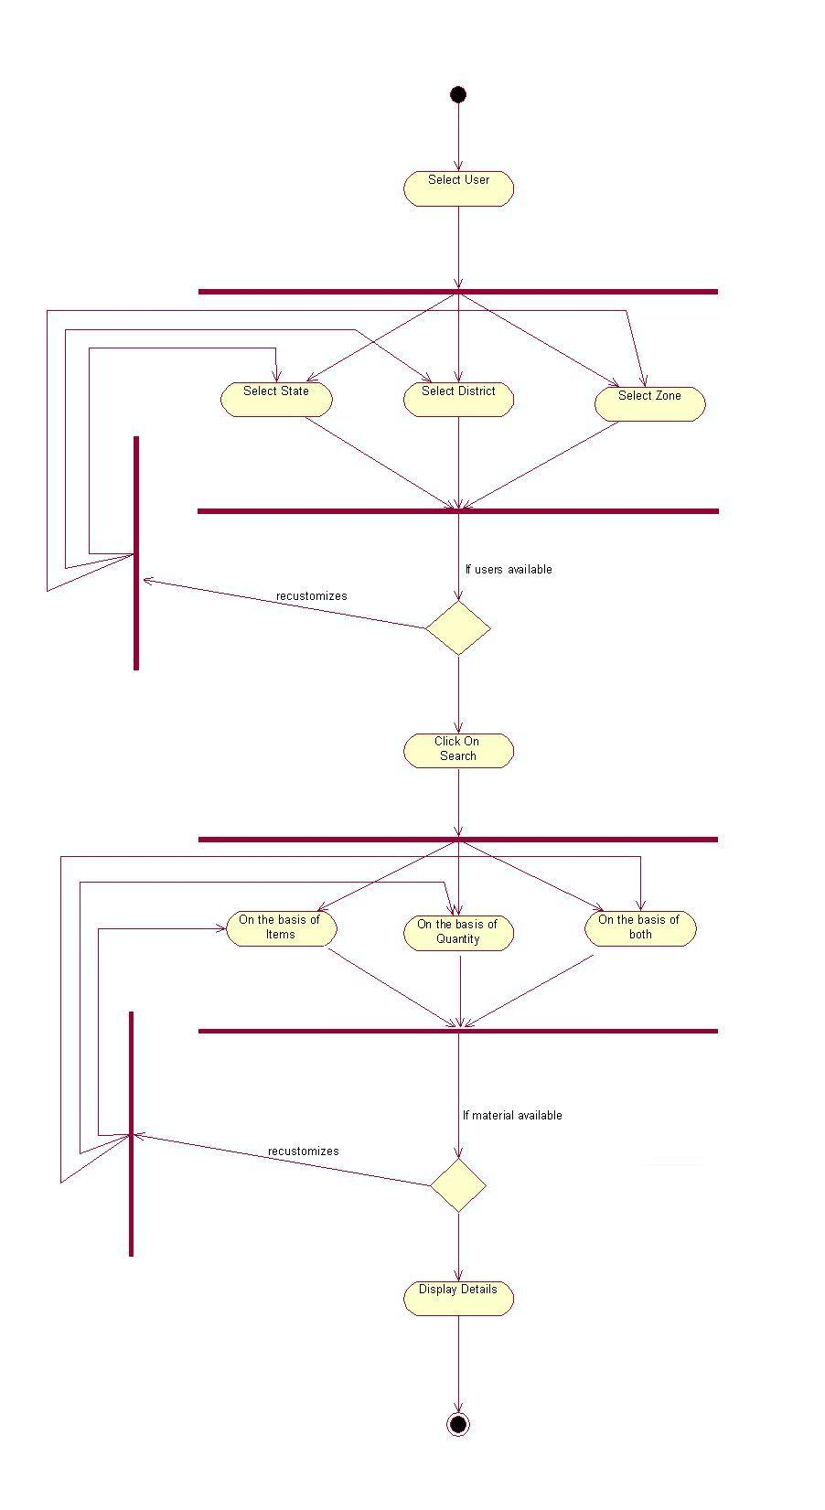

**Figure 3.4.3:** Activity diagram for search

**3.2.3.4 Activity diagram for admin:**

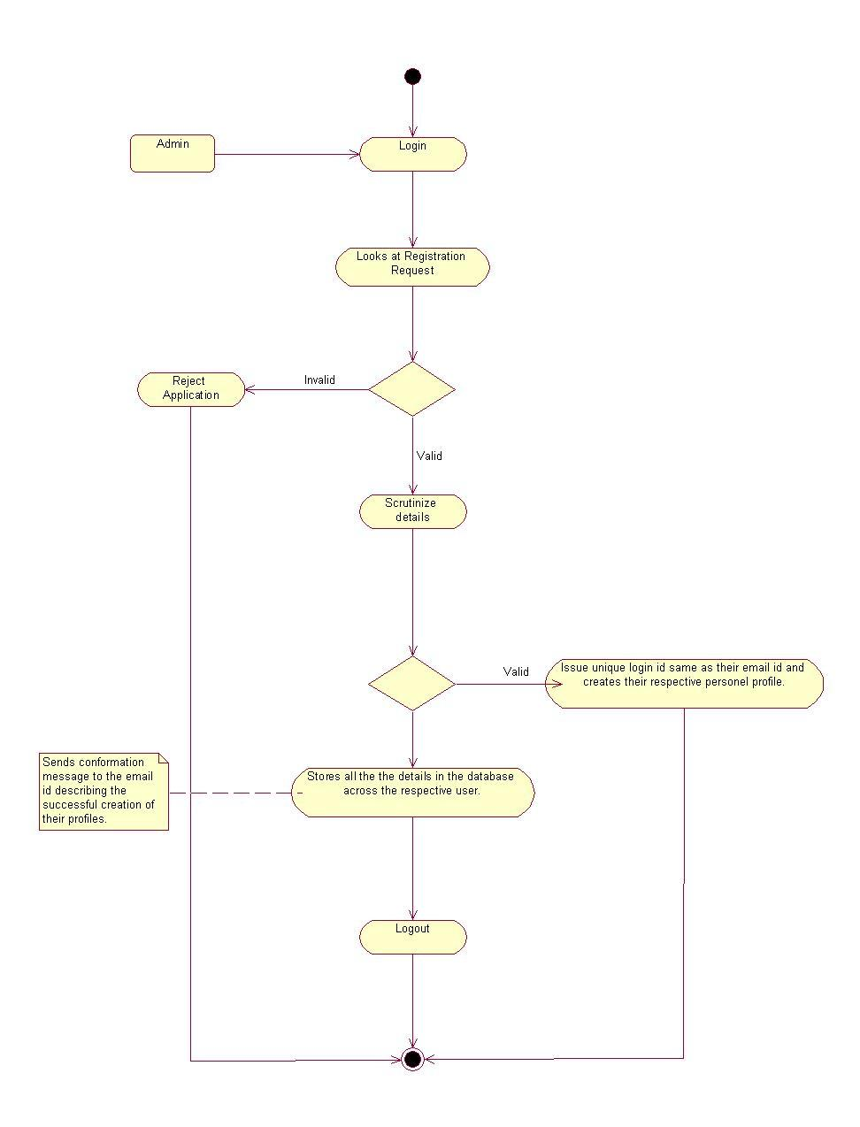

**Figure 3.4.4:** Activity diagram for admin

**3.2.3.5 Activity diagram for blog:**

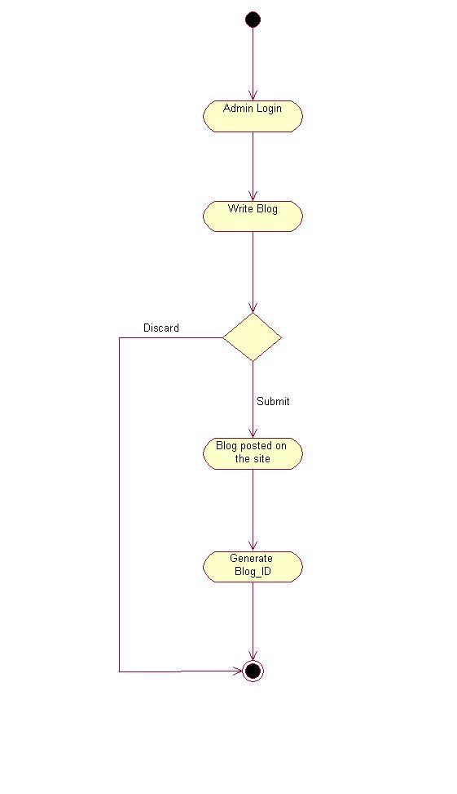

**Figure 3.4.5:** Activity diagram for blog

**3.2.3.6 Activity diagram for discussion forum:**

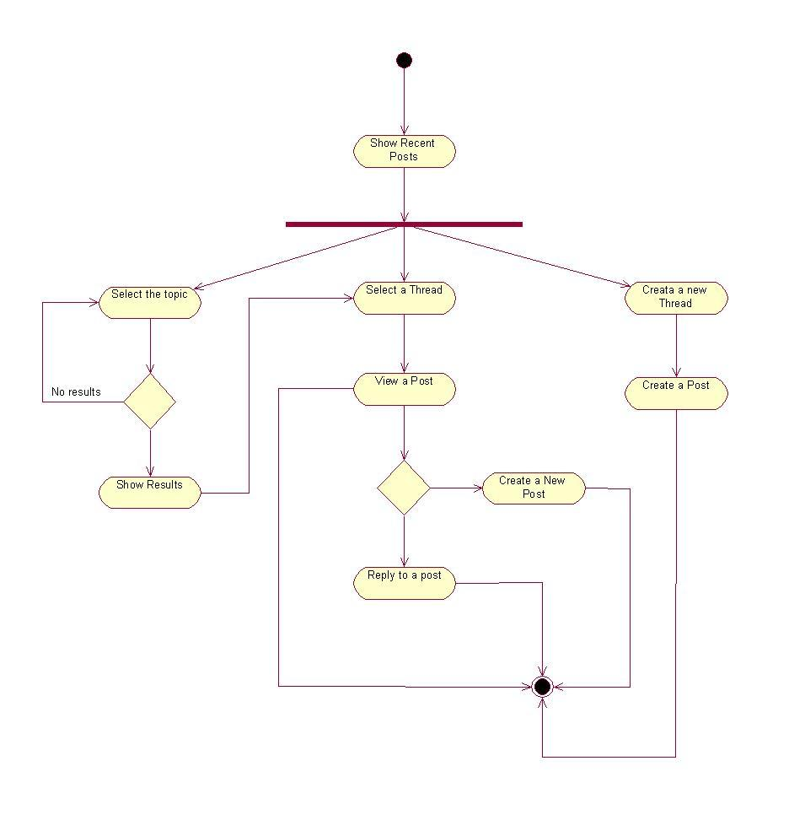

**Figure 3.4.6:** Activity diagram for discussion forum

**3.2.3.7 Activity diagram for feedback:**

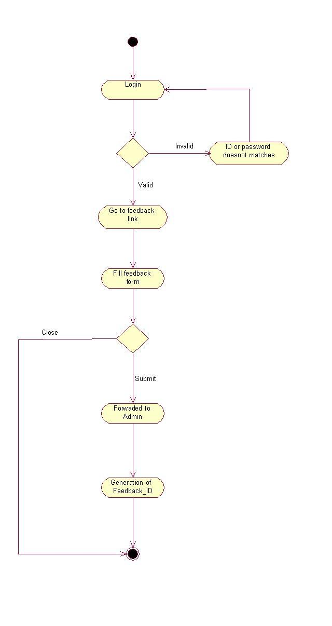

**Figure 3.4.7:** Activity diagram for feedback

**3.2.3.8 Activity diagram for lodging complaint:**

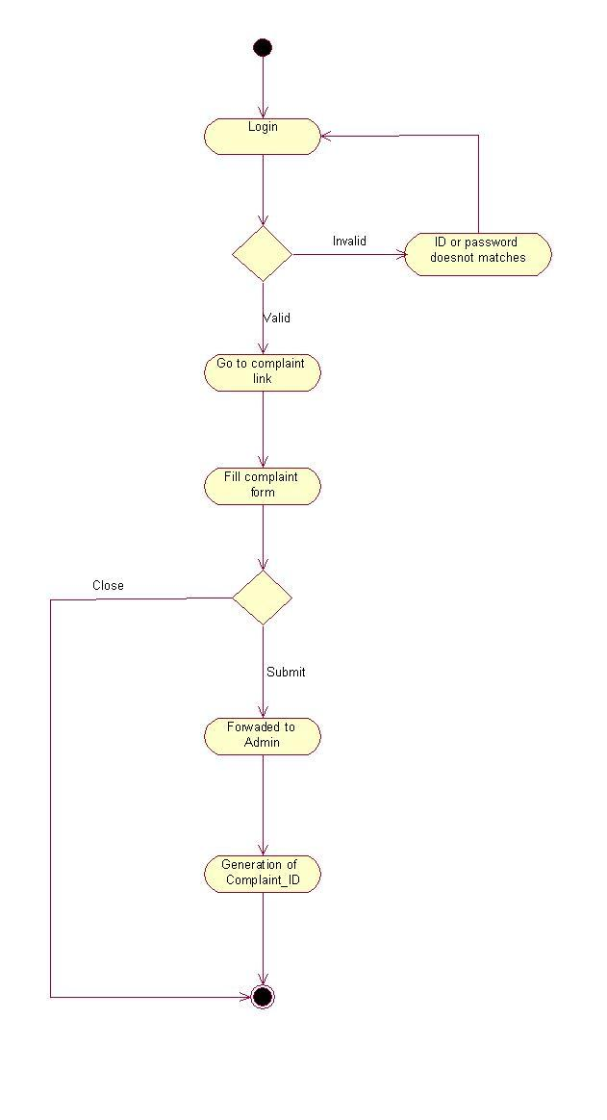

**Figure 3.4.8:** Activity diagram for lodging complaint

**3.2.3.9 Activity diagram for response to complaint**

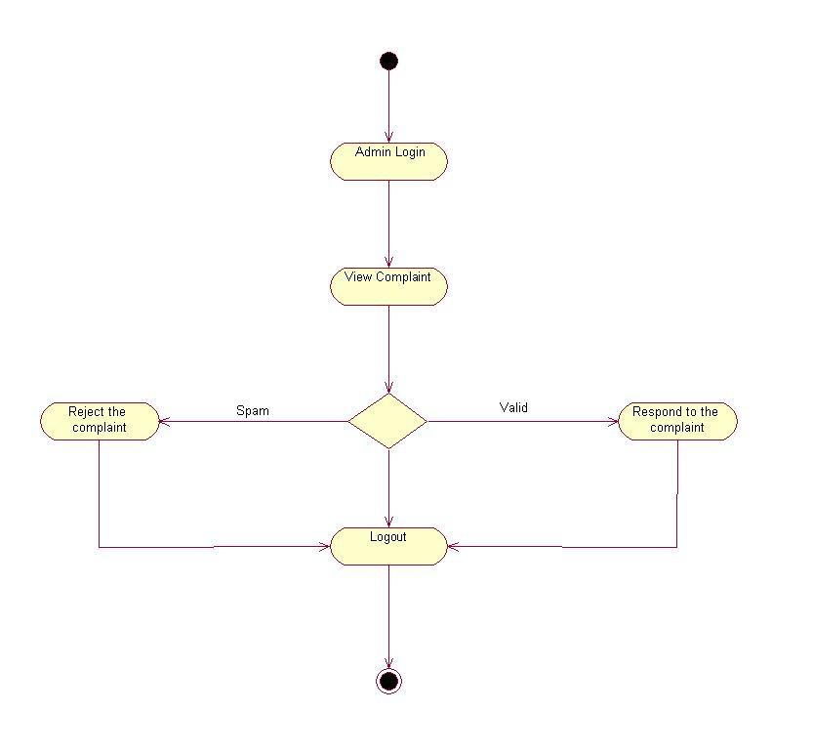

**Figure 3.4.9:** Activity diagram for response to complaint

**3.2.4 Sequence Diagram:**

Sequence Diagrams show the message exchange (i.e. method call) between several Objects in a specific time-delimited situation. Objects are instances of classes. Sequence Diagrams put special emphasis in the order and the times in which the messages to the objects are sent. In Sequence Diagrams objects are represented through vertical dashed lines, with the name of the Object on the top. The time axis is also vertical, increasing downwards, so that messages are sent from one Object to another in the form of arrows with the operation and parameters name.

Messages can be either synchronous, the normal type of message call where control is passed to the called object until that method has finished running, or asynchronous where control is passed back directly to the calling object. Synchronous messages have a vertical box on the side of the called object to show the flow of program control.

**3.2.4.1 Sequence Diagram for admin:**

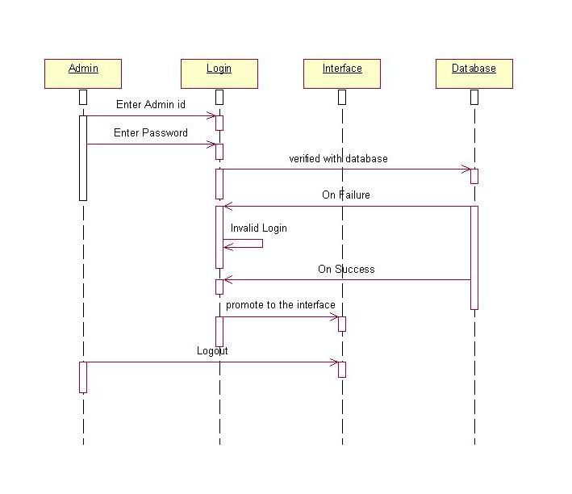

**Figure 3.5.1**: Sequence Diagram for admin

**3.2.4.2 Sequence Diagram for farmer login:**

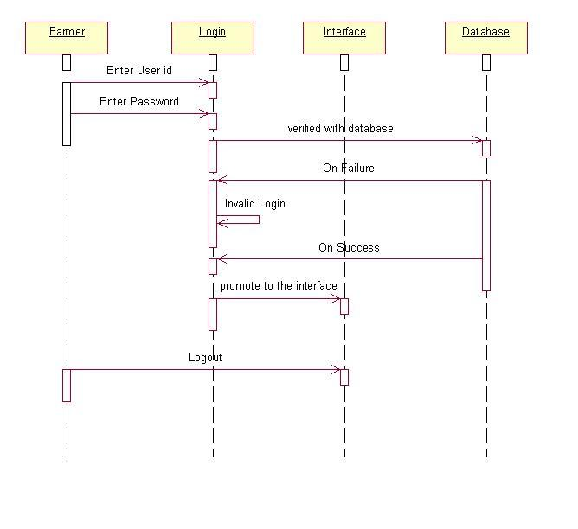

**Figure 3.5.2**: Sequence Diagram for farmer login

**3.2.4.3 Sequence Diagram for wholesaler login:**

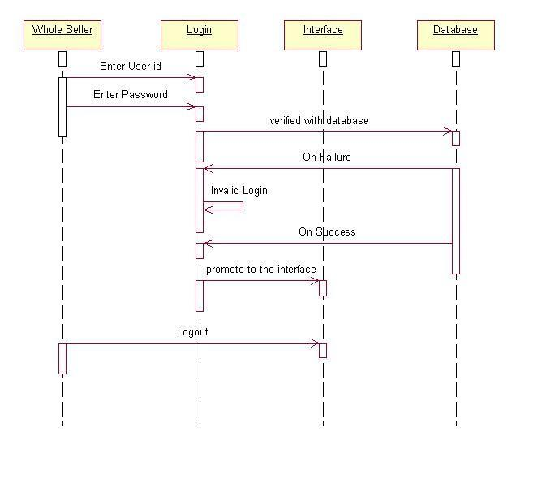

**Figure 3.5.3**: Sequence Diagram for wholesaler login

**3.2.4.4 Sequence Diagram for retailer login:**

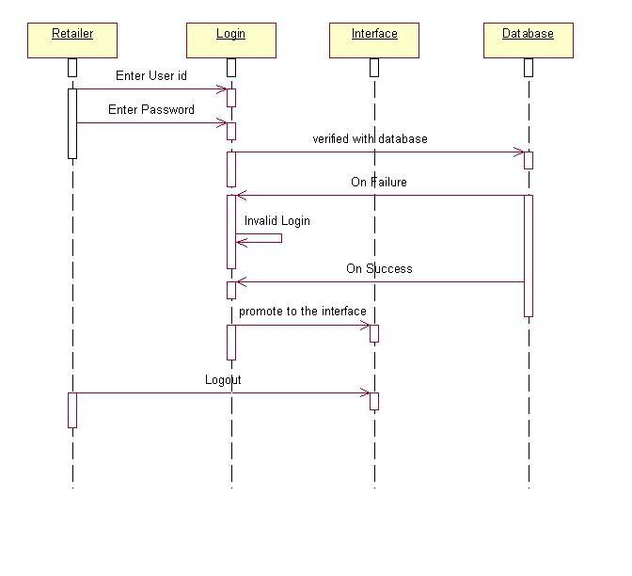

**Figure 3.5.4**: Sequence Diagram for retailer login

**3.2.4.5 Sequence Diagram for civilian:**

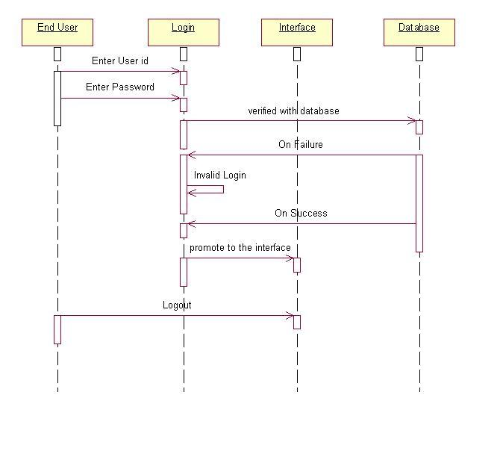

**Figure 3.5.5**: Sequence Diagram for civilian

**3.2.4.6 Sequence Diagram for registration:**

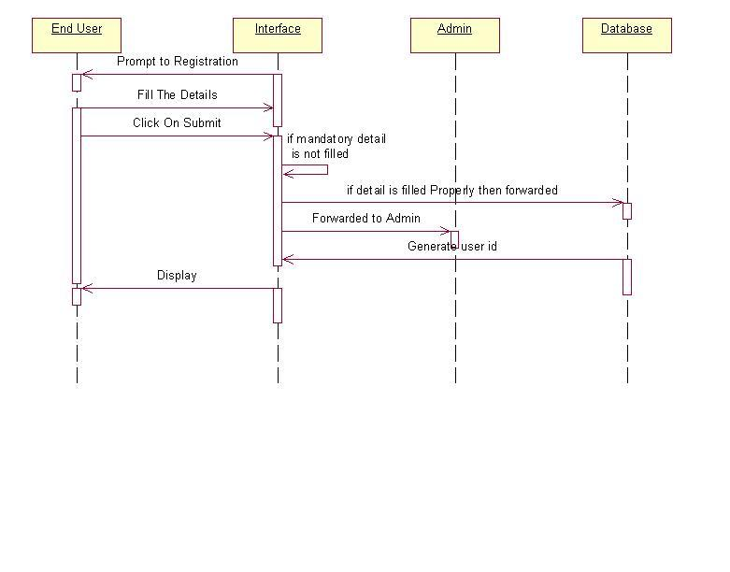

**Figure 3.5.6**: Sequence Diagram for registration

**3.2.4.7 Sequence Diagram for blog:**

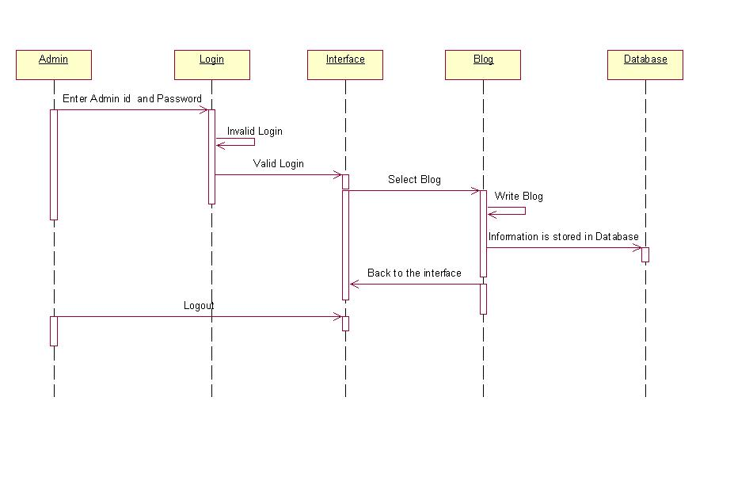

**Figure 3.5.7**: Sequence Diagram for blog

**3.2.4.8 Sequence Diagram for feedback:**

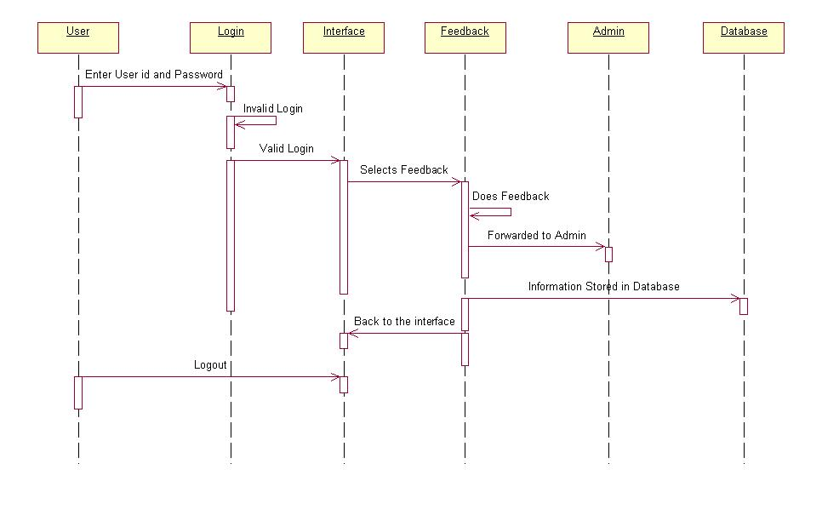

**Figure 3.5.8**: Sequence Diagram for feedback

**3.2.4.9 Sequence Diagram for complaint:**

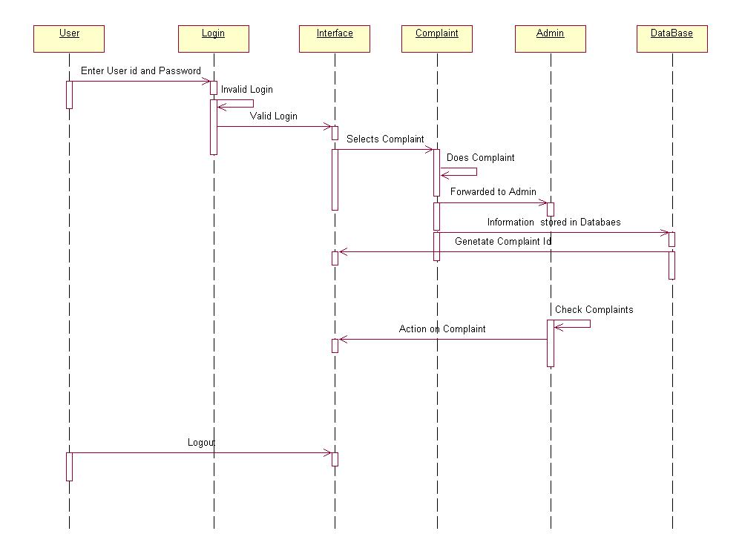

**Figure 3.5.9**: Sequence Diagram for complaint

**3.2.4.10 Sequence Diagram for discussion forum:**

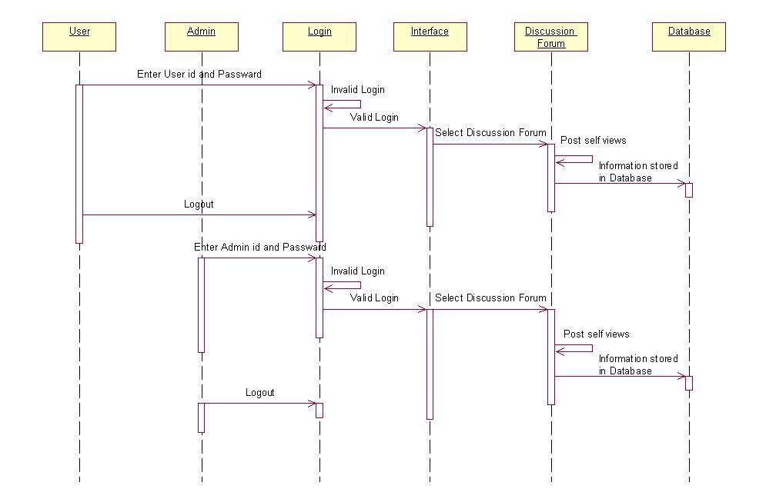

**Figure 3.5.10**: Sequence Diagram for discussion forum

**3.3 E-R Diagram:**

Entity Relationship Diagrams (ER Diagrams) show the conceptual design of database applications. They depict the various entities (concepts) in the information system and the existing relationships and constraints between them. An extension of Entity Relationship Diagrams named ’Extended Entity Relationship Diagrams’ or ’Enhanced Entity Relationship Diagrams’ (EER), are used to incorporate Object Oriented design techniques in ER Diagrams.

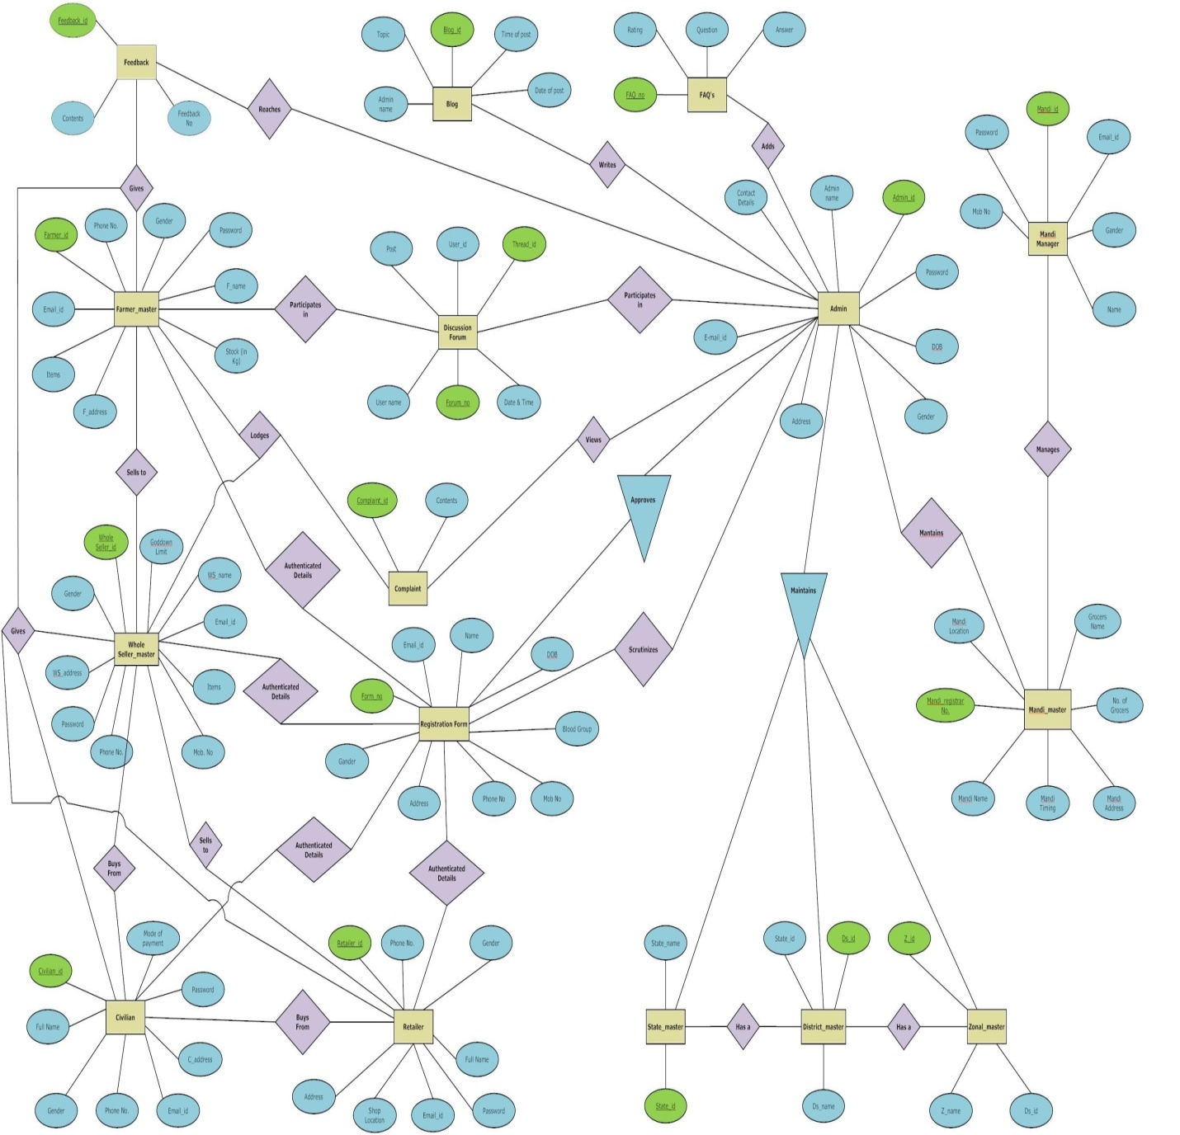

**Figure 3.6:** ER Diagram

**CHAPTER 4**

**IMPLEMENTATION**

4.1 Technologies Description

4.2 Physical Database Design

**4.1 Technologies Description:**

* **Windows XP**

Current version -- 5.1 (Build 2600: Service Pack 3) (April 21, 2008; 4 years ago)

Source model -- Closed source, Shared source

License -- Proprietary commercial software

Kernel -- type Hybrid

Update method -- Windows Update Windows Server Update Services (WSUS) System Center Configuration Manager (SCCM)

Platform support -- IA-32, x86-64 and Itanium

Preceded by -- Windows Me and Windows 2000

Succeeded by -- Windows Vista

**Windows XP** is an operating system produced by Microsoft for use on personal computers, including home and business desktops, laptops and media centers. First released to computer manufacturers on August 24, 2001, it is the second most popular version of Windows, based on installed user base. The name "XP" is short for "eXPerience. Windows XP, the successor to Windows 2000 and Windows Me, was the first consumer-oriented operating system produced by Microsoft to be built on the Windows NT kernel.

* **Java Programming Language**

Java is a programming language originally developed by James Gosling at Sun Microsystems (which has since merged into Oracle Corporation) and released in 1995 as a core component of Sun Microsystems' Java platform. The language derives much of its syntax from C and C++ but has a simpler object model and fewer low-level facilities. Java applications are typically compiled to byte code (class file) that can run on any Java Virtual Machine (JVM) regardless of computer architecture. Java is a general-purpose, concurrent, class-based, object-oriented language that is specifically designed to have as few implementation dependencies as possible. It is intended to let application developers "write once, run anywhere" (WORA), meaning that code that runs on one platform does not need to be recompiled to run on another. Java is currently one of the most popular programming languages in use, particularly for client-server web applications, with a reported 10 million users.

* **Eclipse**

Eclipse is a Multi-language software development environment comprising an integrated development environment (IDE) and an extensible plug-in system. It is written mostly in Java. It can be used to develop applications in Java and by means of various plug-ins, other programming languages including C, C++ etc.

Written in -- Java

Operating System -- Linux, Mac, Windows, Open Solaris (Cross-platform)

Available in -- Multilingual

Development status -- Active

Type -- Software development

License -- Eclipse Public License

Website -- http://www.eclipse.org/

* **DB2**

Developer(s) -- IBM

Initial release -- 1983

Development status -- Active

Written in -- C, C++

Operating system -- Cross-platform

Available in -- English

Type -- RDBMS

License -- Proprietary EULA

Website -- DB2 homepage at ibm.com

**IBM DB2** is a relational model database server developed by IBM. There are three DB2 products that are very similar, but not identical: DB2 for LUW (Linux, Unix, and Windows), DB2 for z/OS (mainframe), and DB2 for iSeries (formerly OS/400).

* **Apache Tomcat 6.0**

Apache Tomcat is a servlet container developed by the Apache Software Foundation (ASF). Tomcat implements the Java Servlet and the Java Server Pages (JSP) specifications from Sun Microsystems, and provides a "pure Java" HTTP web server environment for Java code to run.

Tomcat should not be confused with the Apache web server, which is a C implementation of an HTTP web server; these two web servers are not bundled together. Apache Tomcat includes tools for configuration and management, but can also be configured by editing XML configuration files.

**Development status**

Members of the ASF and independent volunteers develop and maintain Tomcat. Users have free access to the source code and to the binary form of Tomcat under the Apache License. The initial Tomcat release appeared with versions 3.0.x (previous releases were Sun internal releases, and were not publicly released). Tomcat 7.0 is the latest production quality release.

**Components**

Tomcat version 4.x was released with Jasper (a redesigned JSP Server), Catalina (a redesigned servlet container) and Coyote (an HTTP connector).

**Catalina**

Catalina is Tomcat's Servlet container. Catalina implements Sun Microsystem specifications for servlet and Java Server Pages (JSP). The architect for Catalina was Craig McClanahan.

* **HTML:**

Hypertext markup language has been used as a markup language to create static web pages on the desired web pages.

* **JAVASCRIPT:**

Java Script is an object-oriented scripting language used to enable programmatic access to objects within both the client application and other applications. It is primarily used in the form of client, implemented as an integrated component of the web browser, allowing the development of enhanced user interfaces and dynamic websites.

* **AJAX:**

Asynchronous java script and XHTML is a group of interrelated web development techniques used on the client-side to create interactive web applications or applications.

**4.2 Physical Database Design:**

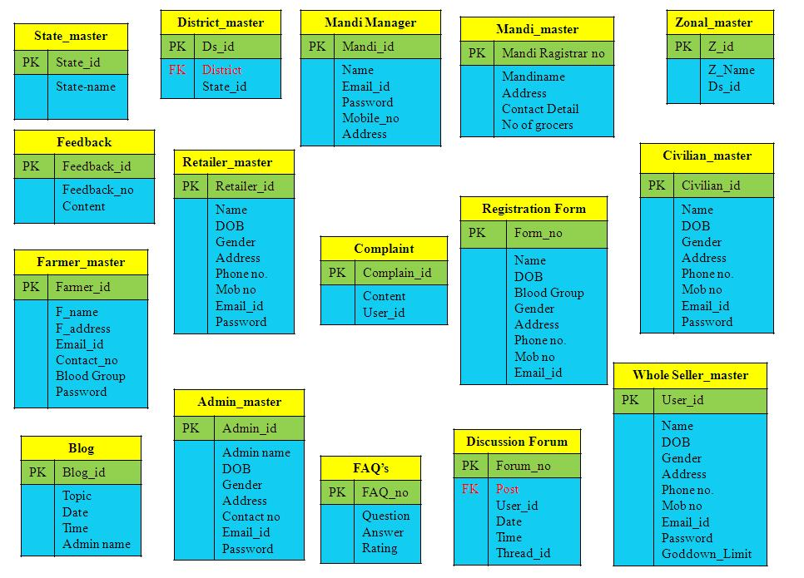

**Figure 4.1:** Database Diagram

**CHAPTER 5**

**CODING & TESTING**

5.1 Coding Details

5.2 Testing Strategy 5.3 Test Case

**5.1 Coding Details:**

## 5.1.1 Language Used Characteristics:

The main features of Java which makes it such a widely used language across the globe are described as follows:

**Java Is Small and Simple:**

However, Java has been described as "C++ minus" because of elements of C++ that were omitted. The most complex parts of C++ were excluded from Java, such as pointers and memory management. These elements are complicated to use, and are thus easy to use incorrectly. Finding a pointer error in a large program is an experience not unlike searching for the one-armed man who framed you for murder. Memory management occurs automatically in Java--programmers do not have to write their own garbage- collection routines to free up memory.

Another design decision to make Java simpler is its elementary data types and objects. The language enforces very strict rules regarding variables--in almost all cases, you have to use variables as the data type they were declared to be, or use explicit casts to manipulate them. This arrangement permits mistakes in variable use to be caught when the program is compiled, rather than letting them creep into a running program where they're harder to find. As a result, programs behave in a more predictable manner.

**Java Is Object Oriented:**

Object-oriented programming (OOP) is a powerful way of organizing and developing software. The short-form description of OOP is that it organizes a program as a set of components called objects. These objects exist independently of each other, and they have rules for communicating with other objects and for telling those objects to do things. Think back to how Star7 devices were developed as a group of independent devices with methods for communicating with each other. Object-oriented programming is highly compatible with what the Green project was created to do and, by extension, for Java as well.

**Java Is Safe:**

Java provides security on several different levels. First, the language was designed to make it extremely difficult to execute damaging code. The elimination of pointers is a big step in this regard. Pointers are a powerful feature, as the programmers of C-like languages can attest, but pointers can be used to forge access to parts of a program where access is not allowed, and to access areas in memory that are supposed to be unalterable. By eliminating all pointers except for a limited form of references to objects, Java is a much more secure language.

Another level of security is the byte code verifier. Before a Java program is run, a verifier checks each byte code to make sure that nothing suspicious is going on.

**Java Is Platform Independent:**

Platform independence is another way of saying that Java is architecture neutral. If both terms leave you saying "huh?" they basically mean that Java programs don't care what system they're running on. Most computer software is developed for a specific operating system. Platform independence is the capability of the same program to work on different operating systems; Java is completely platform independent. A Java .class file of byte code instructions can execute on any platform without alteration.

**Java is distributed:**

Java is designed for the distributed environment of the Internet, because it handles TCP/IP protocols. The feature of inter-address-space messaging is done with the help of the package Remote Method Invocation”. This feature brings an unparalleled level of abstraction to the client/server programming.

## 5.1.2 Coding

Coding is done by using Java JDK 1.6.

## 5.1.3 Code Efficiency

Since the Coding is done by using java hence it is already efficient.

## 5.1.4 Validation Check

Validation check is done by using JavaScript.

**5.2 Testing Strategy:**

The purpose of the Project test strategy is to document the scope and methods that will be used to plan, execute and manage the testing performed within the task Manager project. The purpose of the testing will be to ensure that, based on the solution designed, the system operates successfully.

The following types of tests are performed on the task manager application:

**5.2.1 White Box Testing:**

It focuses on the program control structure. Here all statements in the program have been executed at least once during testing and all logical conditions have been exercised.

**5.2.2 Unit Testing:**

This testing focuses verification effort on the smallest unit of design module. Using procedural design description as a guide, important control paths are tested to uncover errors within the boundaries of module. The relative complexity of tests and uncovered errors is limited by the constraints scope established for using testing. The unit testing can be conducted in parallel for several modules. It is white box oriented.

**5.2.3 Integrated Testing:**

When the separate modules are put together and work in integrated manner, this testing is performed. This testing is a systematic technique. This testing is performed to check that data should not be lost across an interface.

**5.2.4 System Testing:**

System testing is done when the entire system has been fully integrated. The purpose of the system testing is to test how the different modules interact with each other and whether the system provides the functionality that was expected. It consists of following steps:

* Program Testing
* System Testing
* System Documentation
* User Acceptance Testing

**5.2.5 Black Box Testing:**

This is designed to uncover the errors in functional requirements without regard to the internal workings of a program. This testing focuses on the information domain of software, deriving test case by partitioning the input and output domain of programming- a manner that provides thorough test coverage.

**5.2.6 Equivalence Partitioning:**

In equivalence partitioning method we check output on different input.

In task manager we check it by entering different inputs to the system, by this we check whether it is working for all inputs or not.

**5.2.7 Boundary Value Analysis:**

In Boundary Value Analysis we check the values at the boundary. Like at first row or at the end of the rows. Because sometimes we use the array from position 1 but it actually takes the value from the 0th position. So because of this system fails at boundary values. In task manager we tested the application for all boundary values to check whether it is working fine or not.

**5.3 Test Case:**

|  |  |  |  |  |
| --- | --- | --- | --- | --- |
| Test case : **Login and Registration** | | | | |
| Description: The test case simulates one of the actions that user has to perform. the user can go to the login or register button given at the top of the main page. | | | | |
| Step number | Step description | Excepted result | Actual outcome | Inference |
| 01 | Click on the login button given then if already u are registered | A window will come and u can fill your details | U get successfully registered. | Login process working properly |
| 02 | After giving your login details in the fields given. | While providing there is a validation process and it will check your provided details whether it is correct or no. | If the user has not provided the correct ones he/she can’t access the features provided | Login process working properly |
| 03 | If the user has forgotten his/her password while filling the details. | Then a window is provided he can enter his email-id in the field given. | The further process of forgot password will be done. | Login process working properly |
| 04 | If the user is visiting for the first time. Then he can click on Login link and then Join us link provided there | Then a page is redirected to it he can fill his personal details and click on the submit button. | The details of the user get stored in the database. | Registration process working properly |
| 05 | If the user while filling the registration form is providing invalid details | Then messages will come as validation comes into account.  There. | The have to fill valid details only then it will be submitted further. | Registration process working properly |
| 06 | It the user has by mistaken written the wrong details he/she can give reset the values. | The fields will again get blank and he can fill the details again as a fresh attempt. | The fields will again get blank and he can fill the details again as a fresh attempt and again submit the details. | Registration  process working properly |

**Table 5.1:** Test case 1

|  |  |  |  |  |
| --- | --- | --- | --- | --- |
| Test case : **Static and Dynamic pages** | | | | |
| Description: This test case will move around the static and dynamic pages provided. | | | | |
| Step number | Step description | Excepted result | Actual outcome | Inference |
| 01 | The home page will be opened whenever u open the website | The home page will be displayed | The home page will be displayed | Linking of page is working properly |
| 02 | Whenever the user want to know about us he can click on the about us link provided | The about us page will be displayed giving the details | The about us page will be displayed | Linking of page is working properly |
| 03 | Whenever the user want to view image gallery he can click on the gallery link provided | The gallery page will be displayed giving the images | The gallery page will be displayed giving the images | Linking of page is working properly |
| 04 | If the user wants to see the blog he can click the blog link provided. | The blog page will be displayed giving the details | The blog page will be displayed giving the details | Linking of page is working properly |
| 05 | If the user have doubt about the concept or anything he can view FAQ’S page | The FAQ page will be displayed giving the details | The FAQ page will be displayed giving the details | Linking of page is working properly |
| 06 | If the user wants to give the feedback anytime | The home is provided and after the details he can click on submit button provided | The further process of feedback will be done and it will be stored in the database. | Linking of page is working properly |
| 07 | If the user wants to contact to us he can go for the contact form | After filling the form he can submit the details and it will be send further | The details will be stored in the database. | Linking of page is working properly |

**Table 5.2:** Test case 2

|  |  |  |  |  |
| --- | --- | --- | --- | --- |
| Test case : **Post Availability** | | | | |
| Description: The test case simulates one of the actions that user has to perform. the user can go to the Feature Link given at the top of the profile page. | | | | |
| Step number | Step description | Excepted result | Actual outcome | Inference |
| 01 | Click on the feature link given then click on the post availability. | A post availability page will come and u can fill your details | Your availability is posted successfully | Post availability process working properly |
| 02 | After giving your post availability details in the fields given. | While providing there is a validation process and it will check your provided details whether it is correct or no. | If the user has not provided the correct ones he/she can’t access the features provided | Post availability process working properly |

**Table 5.3:** Test case 3

|  |  |  |  |  |
| --- | --- | --- | --- | --- |
| Test case : **Search Farmer, Wholesaler and Retailer** | | | | |
| Description: The test case simulates one of the actions that user has to perform. the user can go to the Feature Link given at the top of the profile page. | | | | |
| Step number | Step description | Excepted result | Actual outcome | Inference |
| 01 | Click on the Home link given. | A Home page will come and u can fill your(Search) details and click on the Search Button. | Search result is shown on the next page. | Search process working properly |
| 02 | After giving your search details in the fields given. | While providing there is a validation process and it will check your provided details whether it is correct or no. | If the user has not provided the correct ones he/she can’t access the features provided | Search process working properly |

**Table 5.4:** Test case 4

**CHAPTER 6**

**USER MANUAL**

6.1 Screen Snapshots

6.2 Installation/ Deployment Instructions

**6.1 Screen Snapshots:**

**HOME PAGE:**

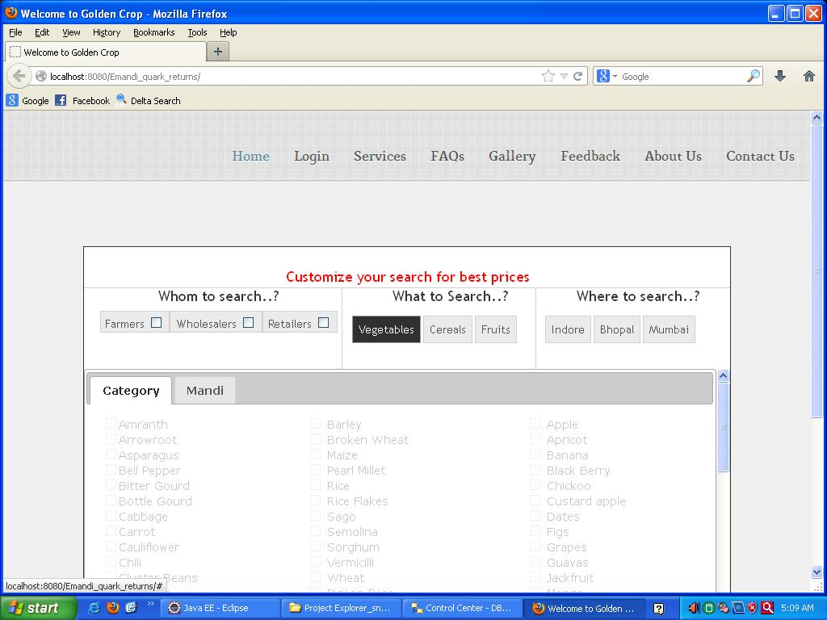

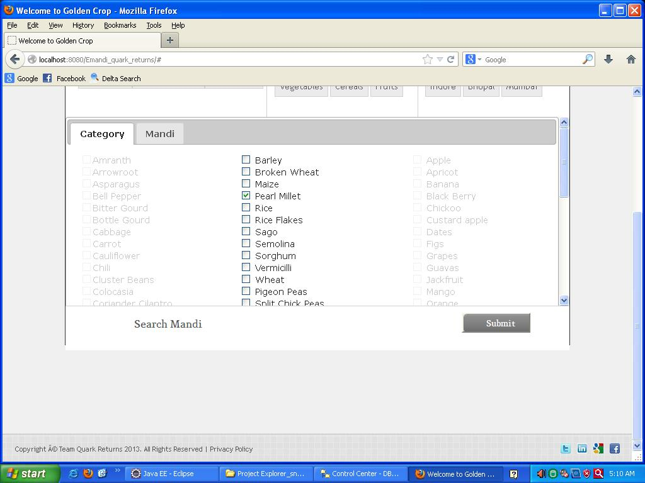

**LOGIN:**

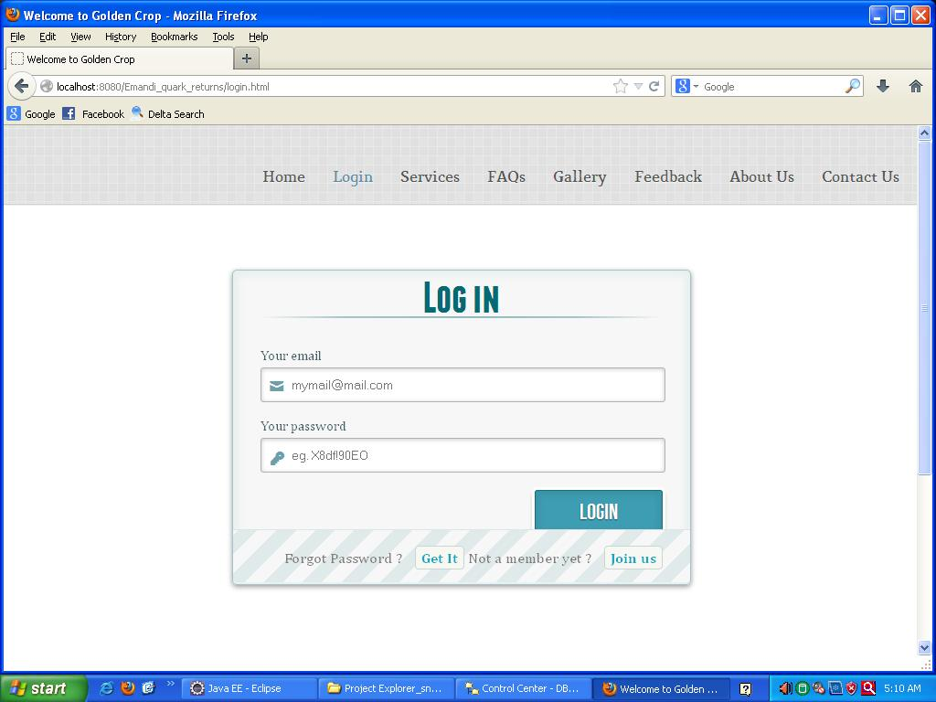

**SIGN UP:**

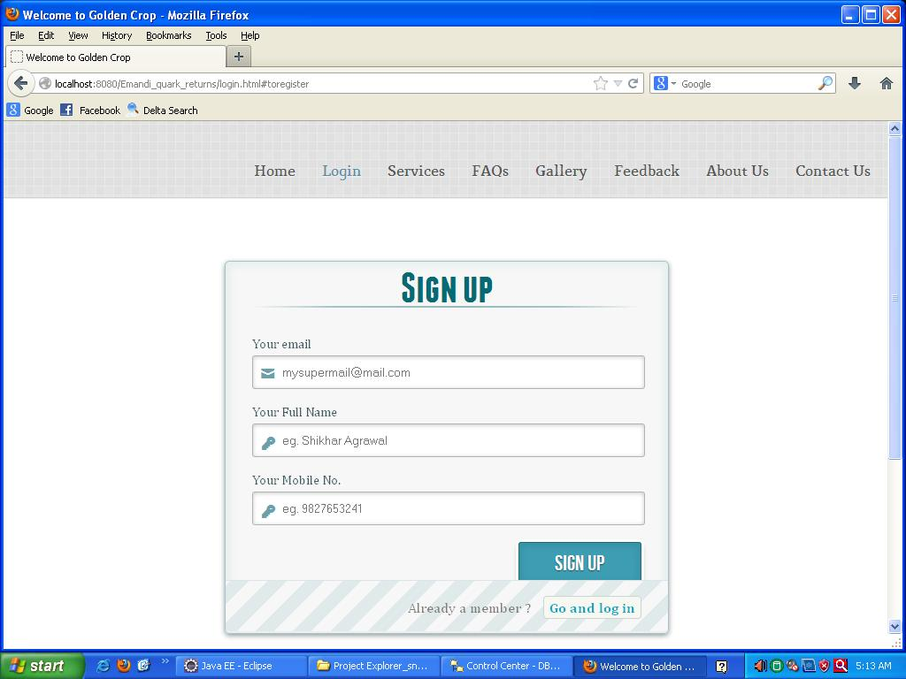

**FORGOT PASSWORD:**

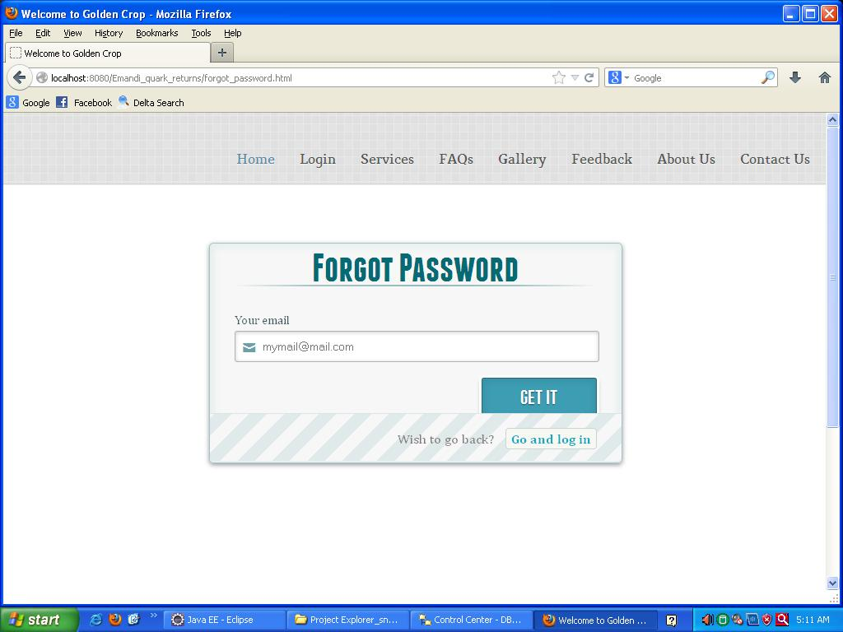

**REGISTRATION:**

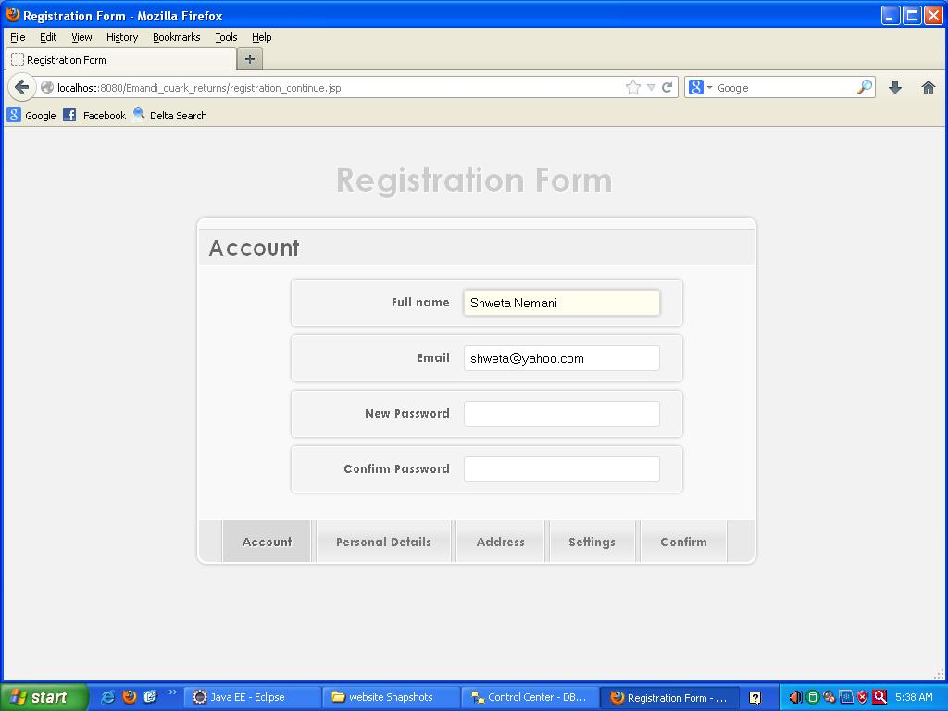

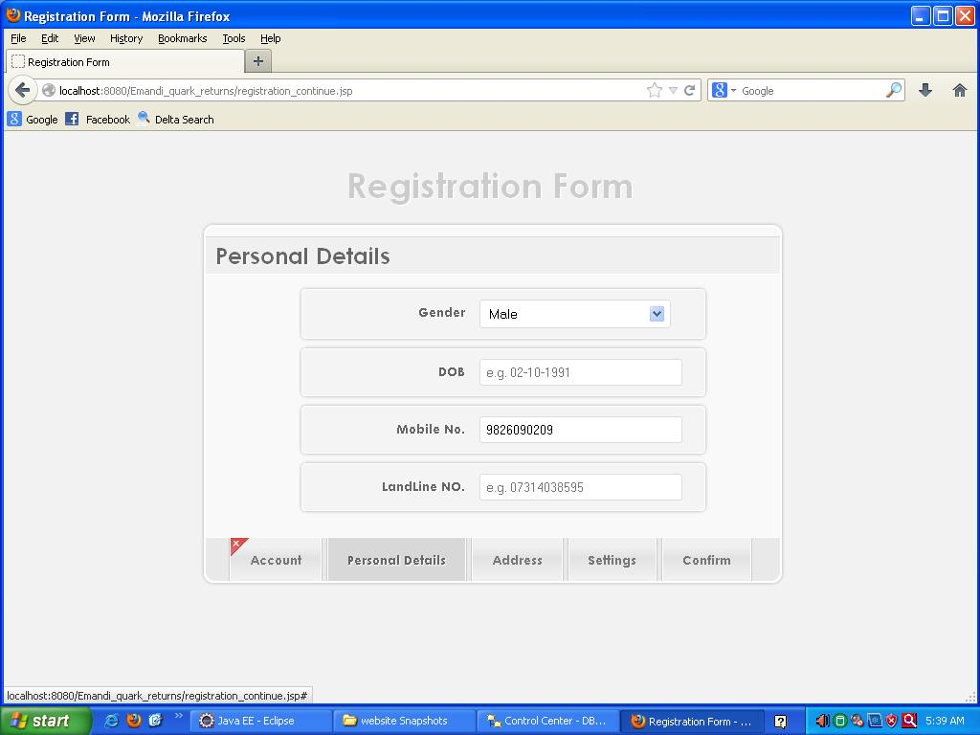

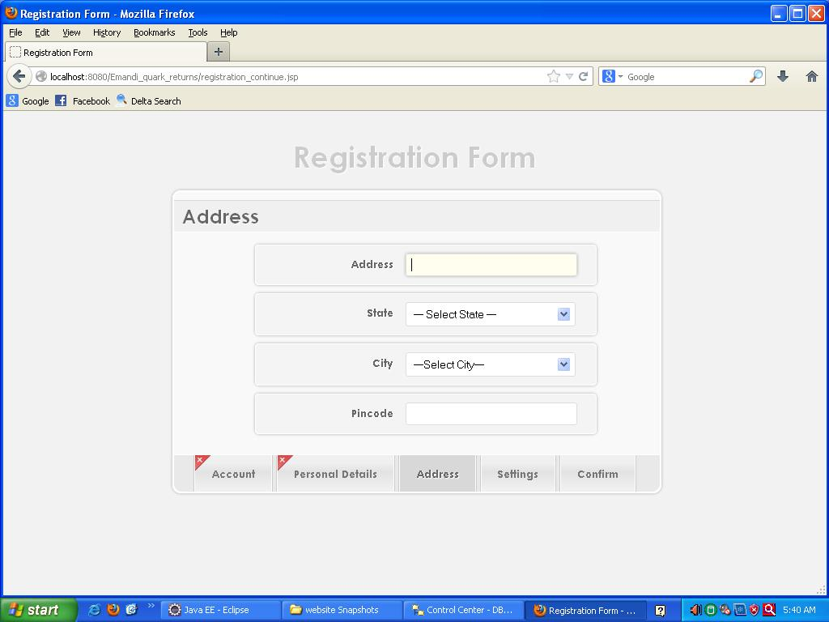

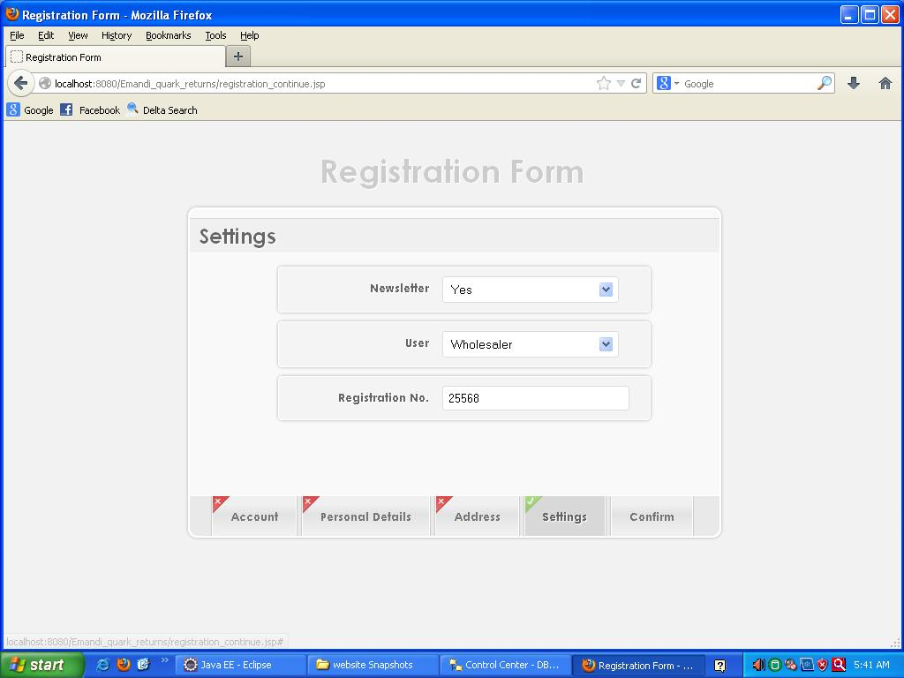

**PHOTO GALLERY:**

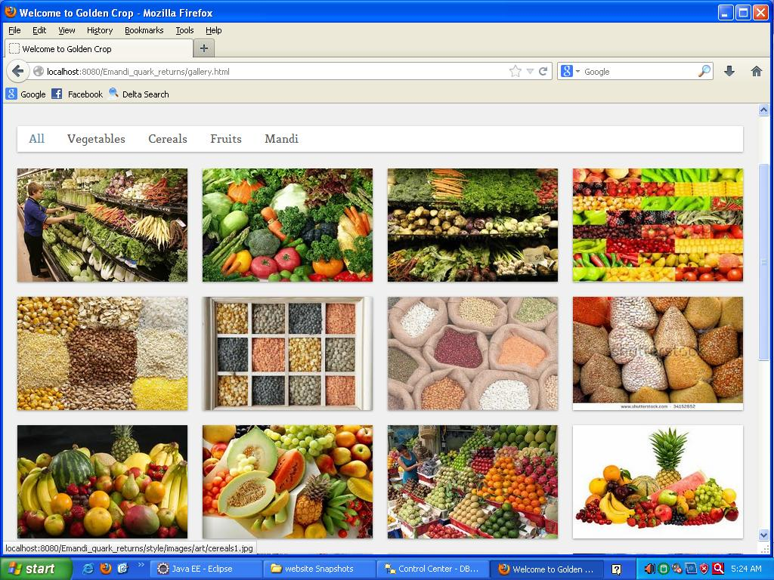

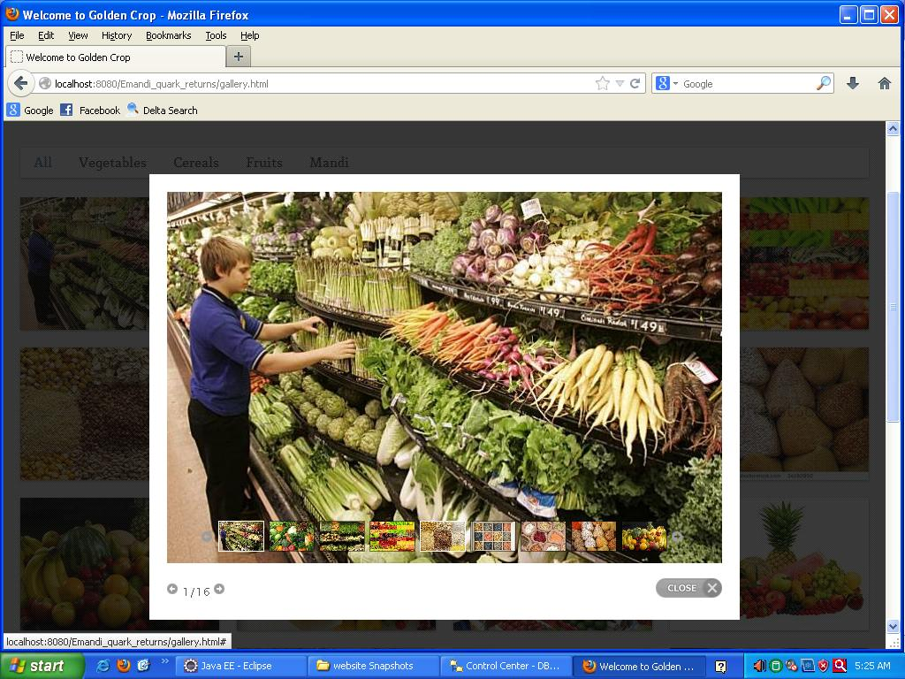

**ABOUT US:**

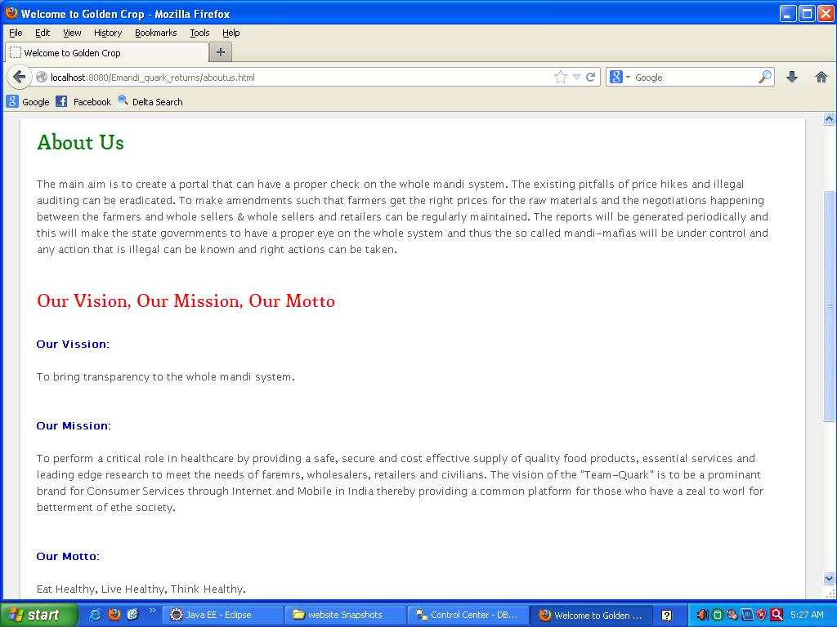

**FAQS:**

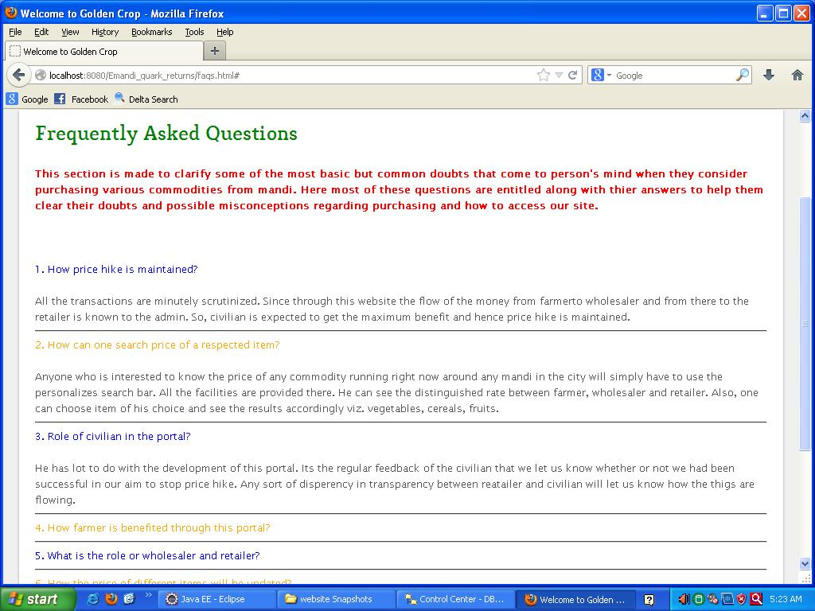

**OTHER USEFUL SITES:**

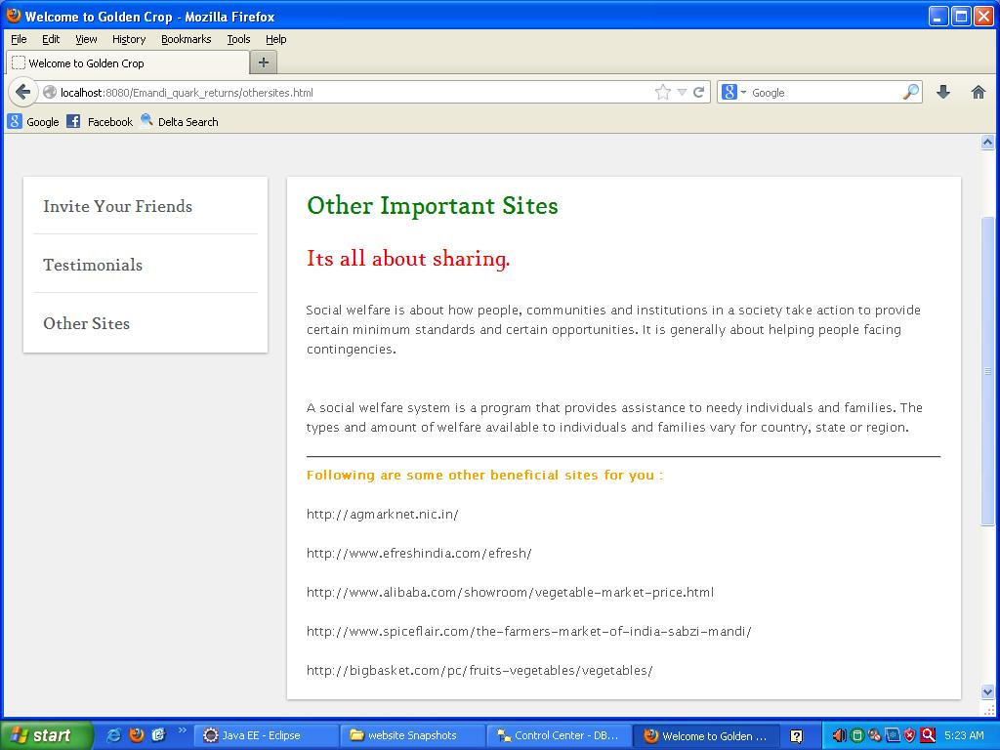

**PRIVACY POLICY:**

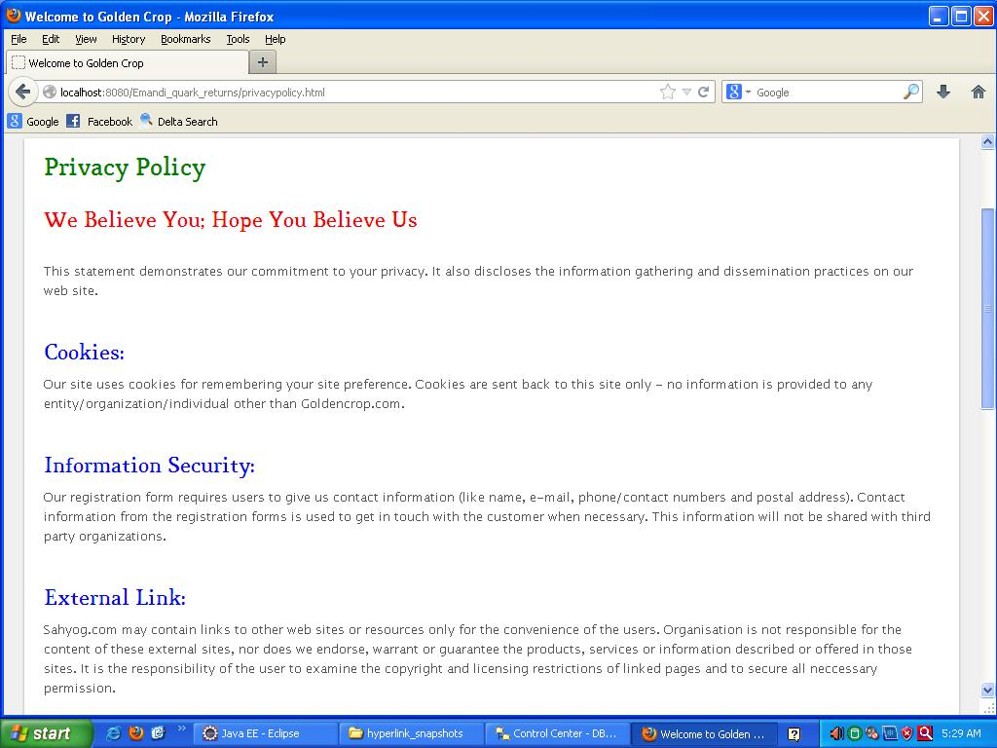

**CONTACT US:**

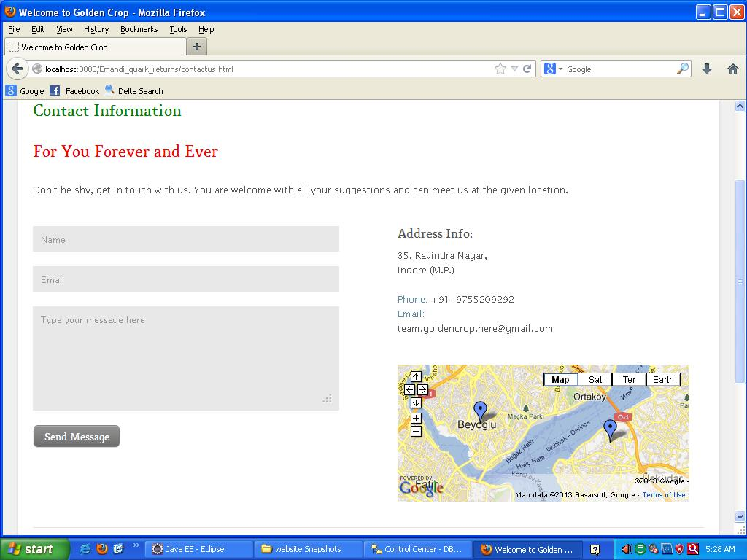

**INVITE YOUR FRIEND:**

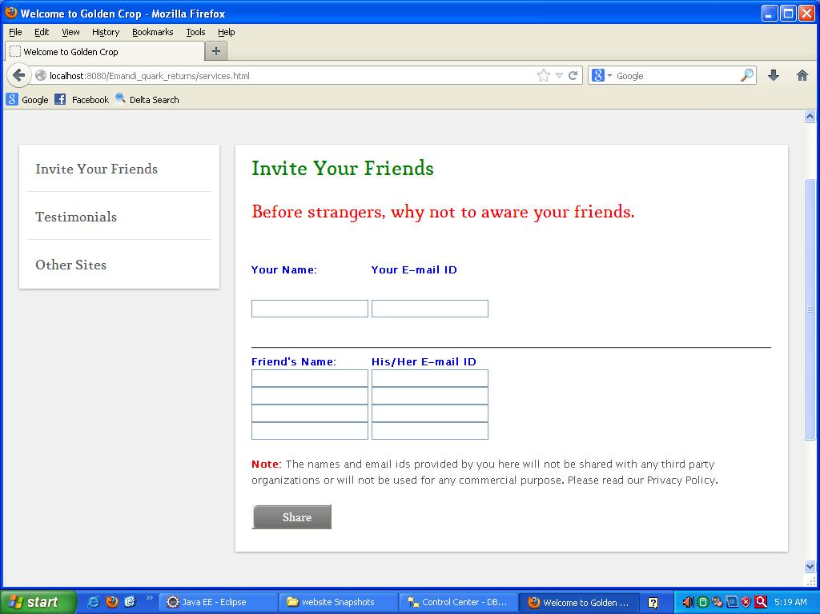

**FEEDBACK FORM:**

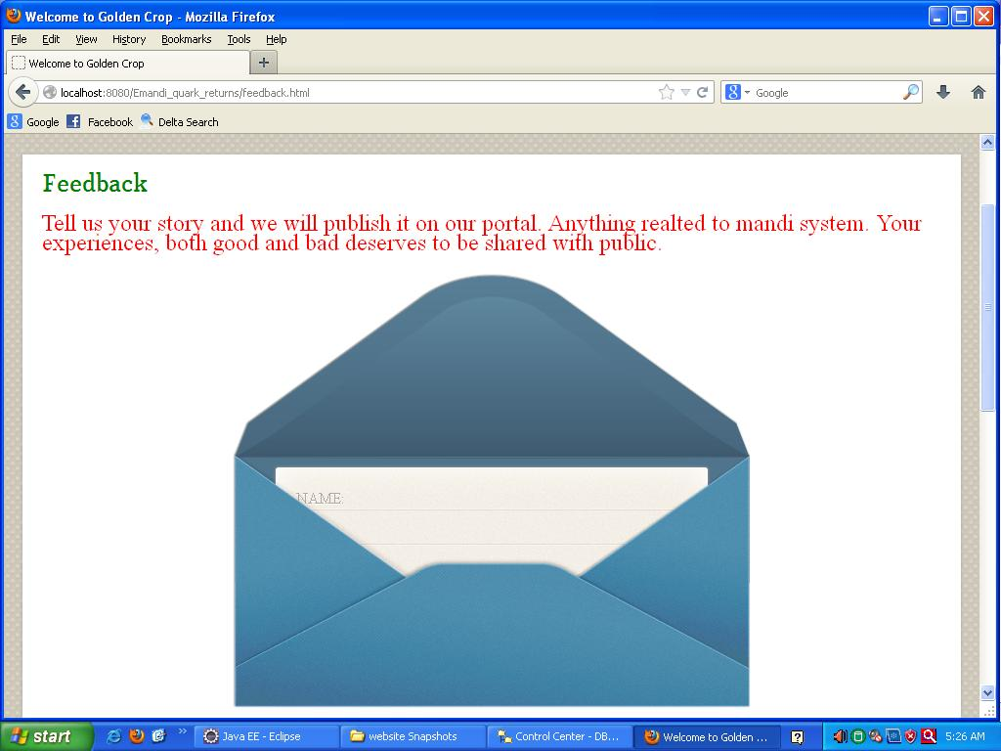

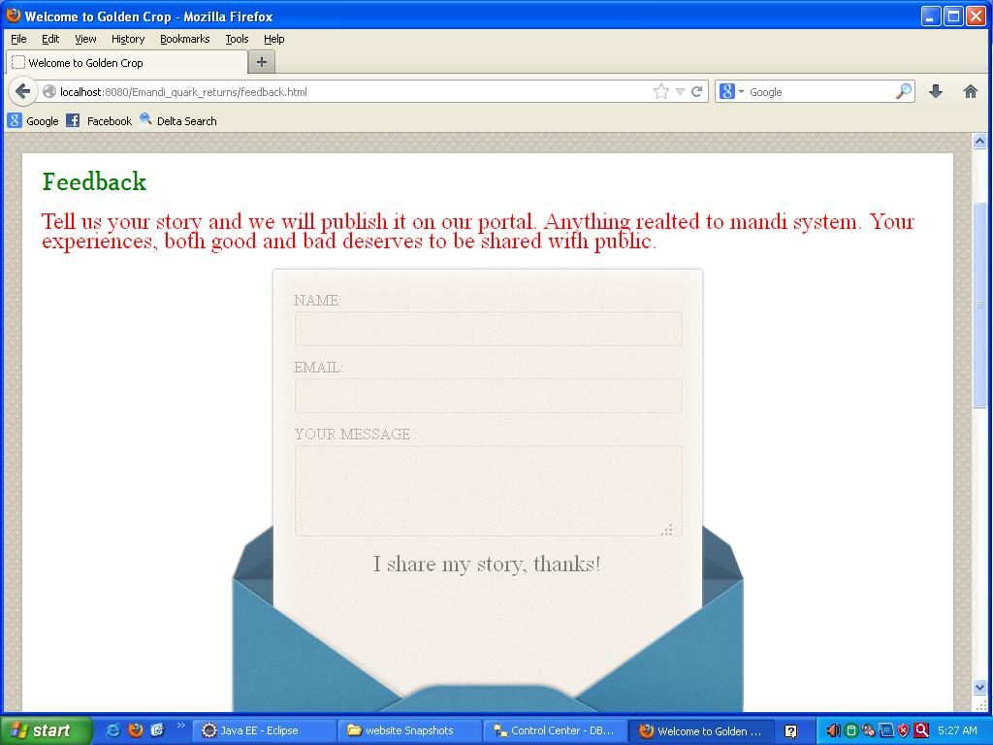

**TESTIMONIAL:**

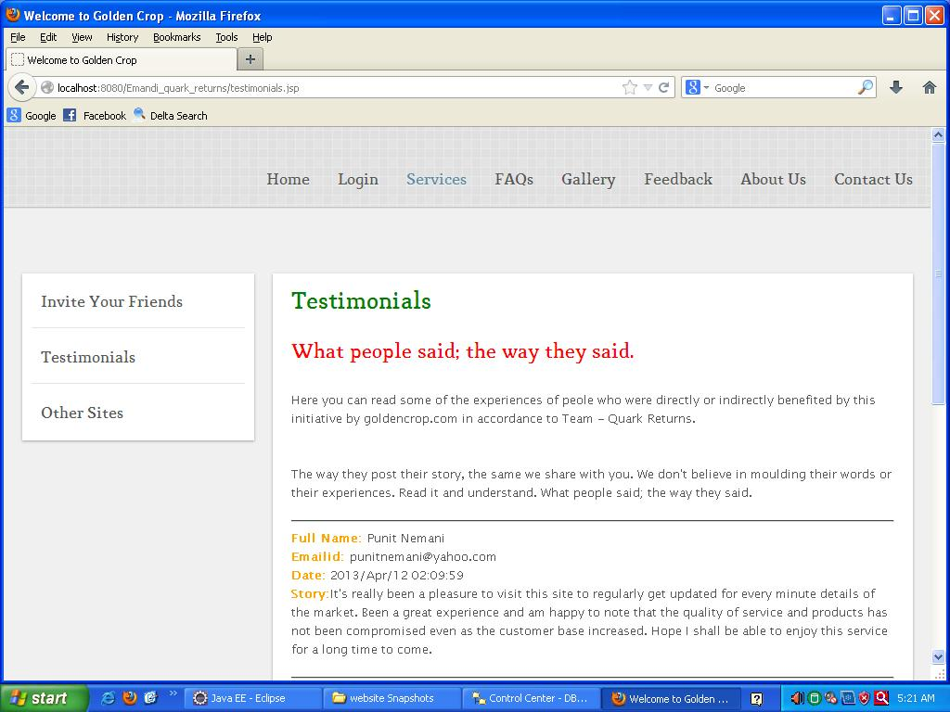

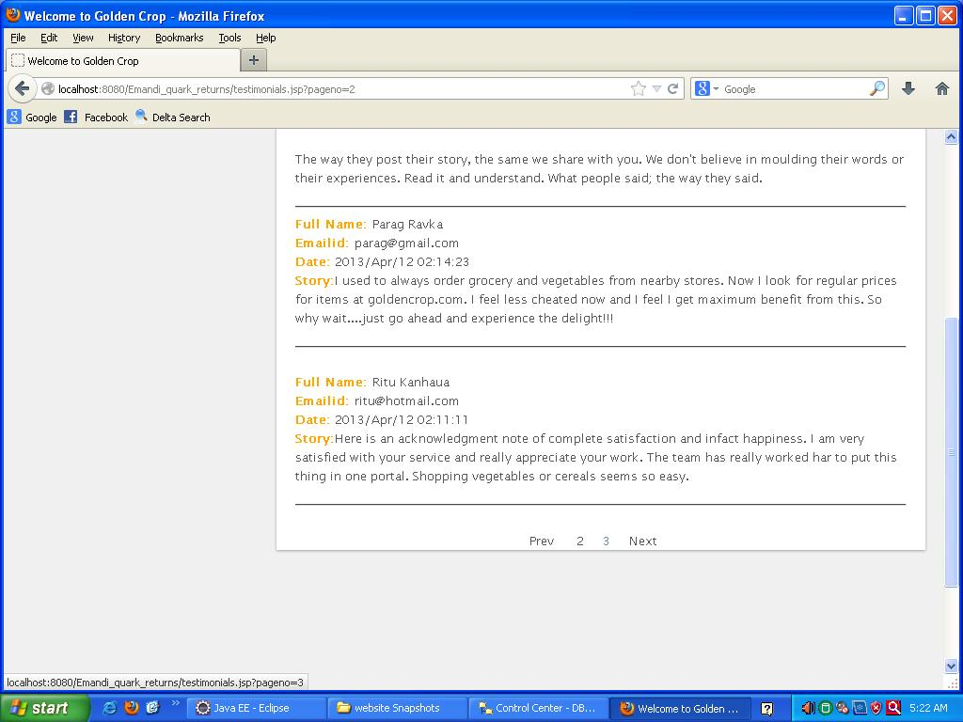

**SEARCH ENGINE:**

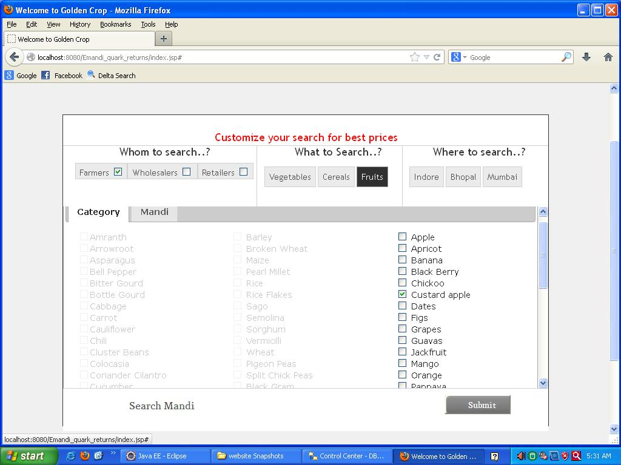

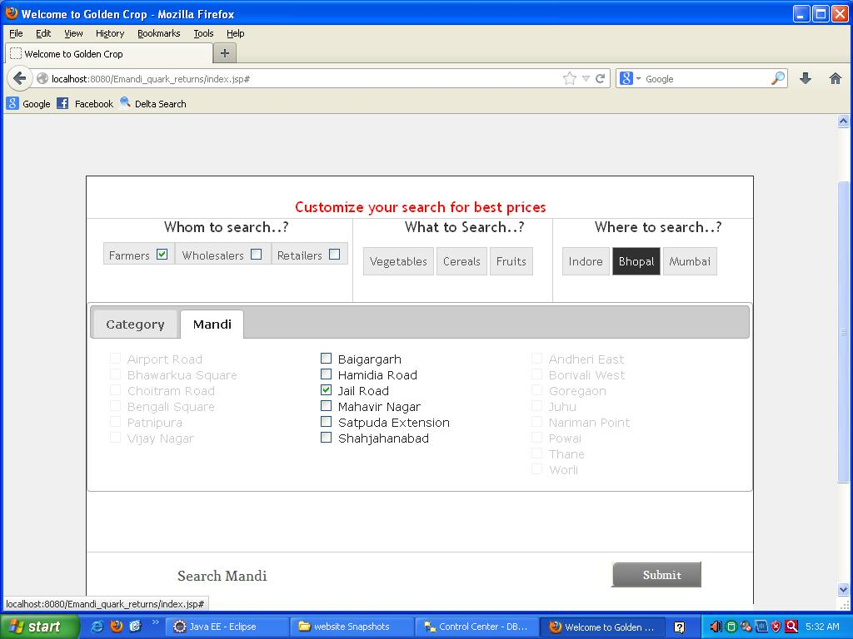

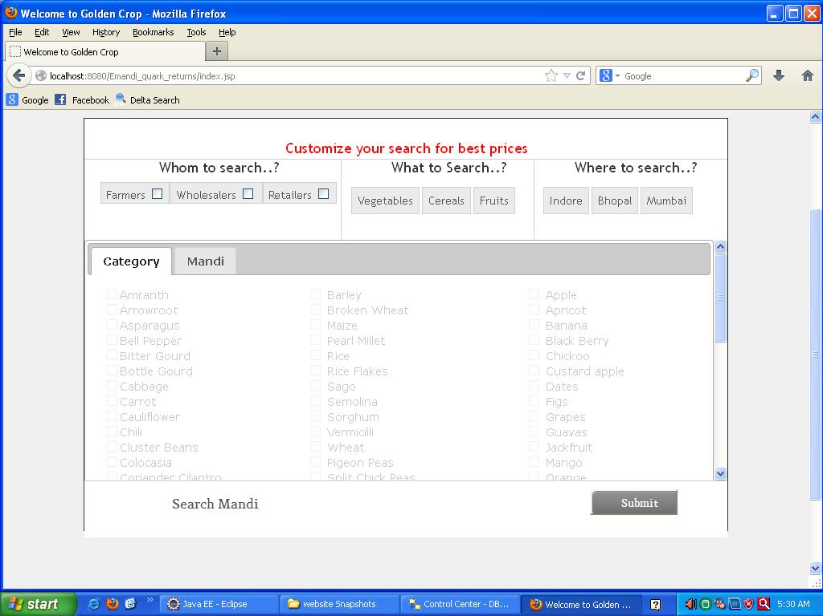

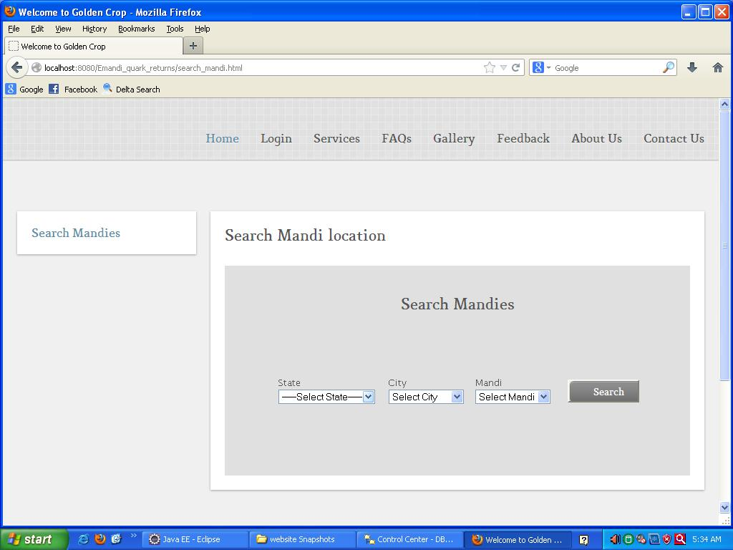

**SOCIAL NETWORK PLUGINS:**

**FACEBOOK PAGE:**

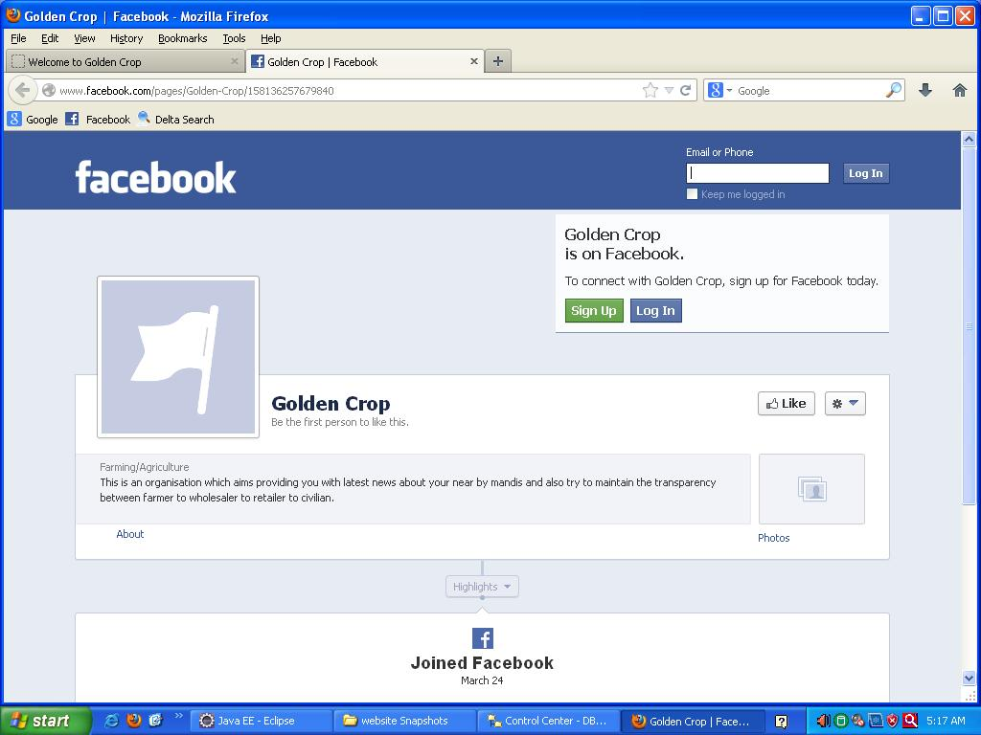

**LINKEDIN PAGE:**

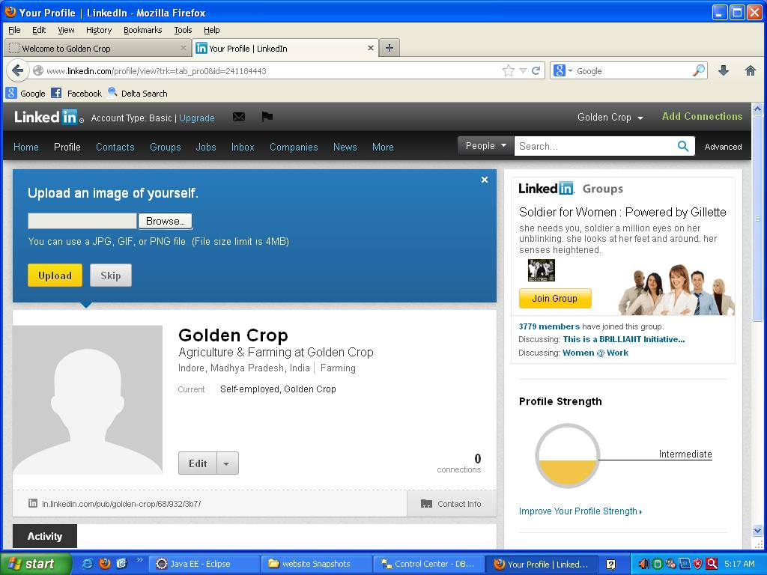

**TWITTER PAGE:**

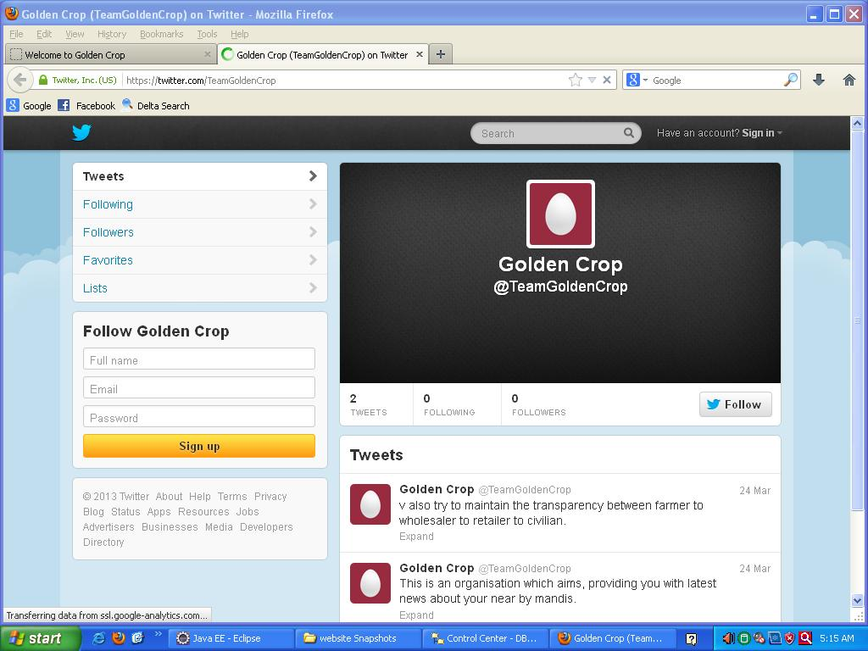

**FARMER PROFILE:**

**Farmer Home Page:**

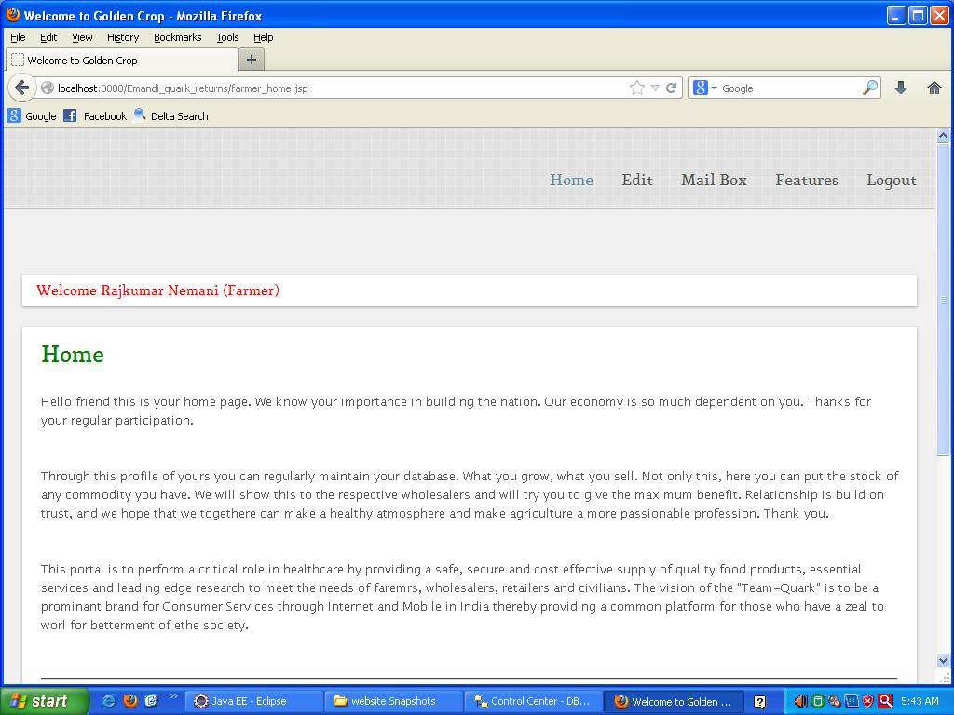

**Farmer Change Password:**

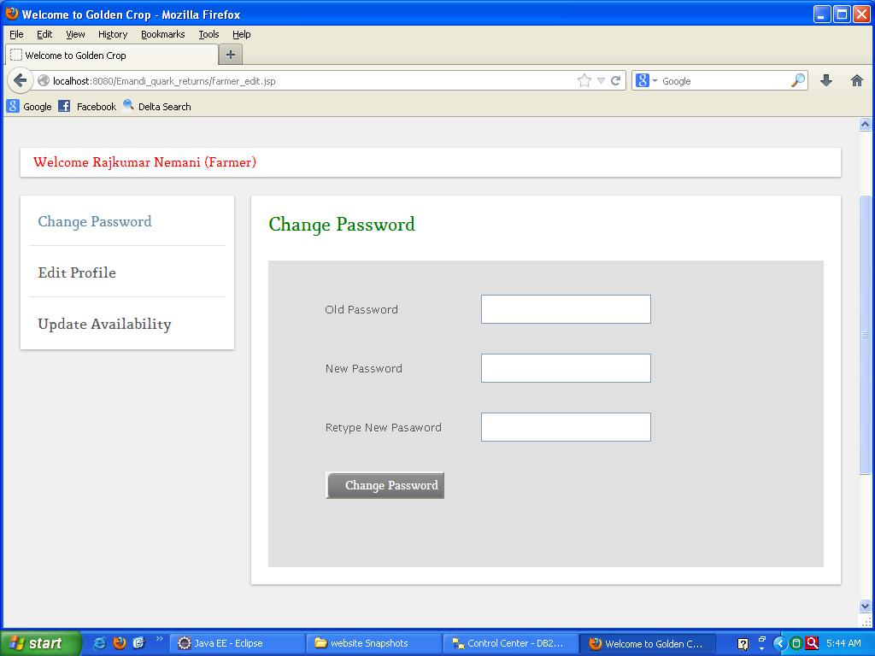

**Farmer Edit Profile:**

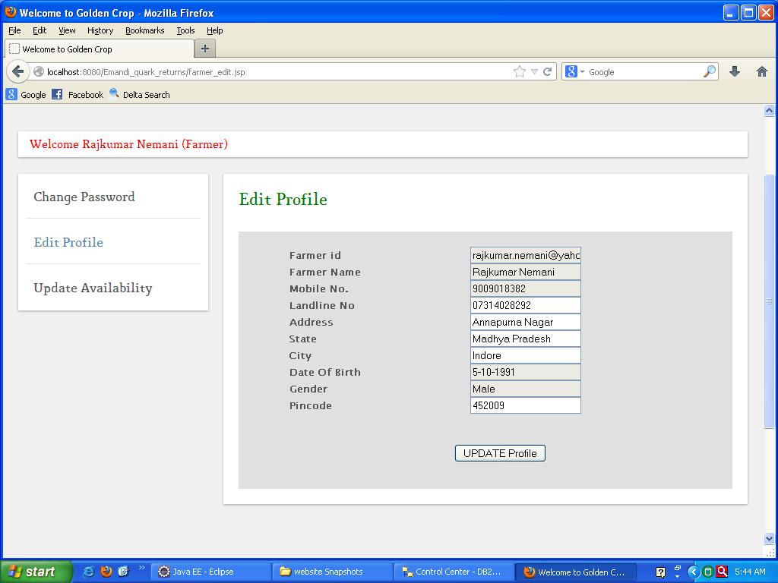

**Farmer Complaint-Suggestion From:**

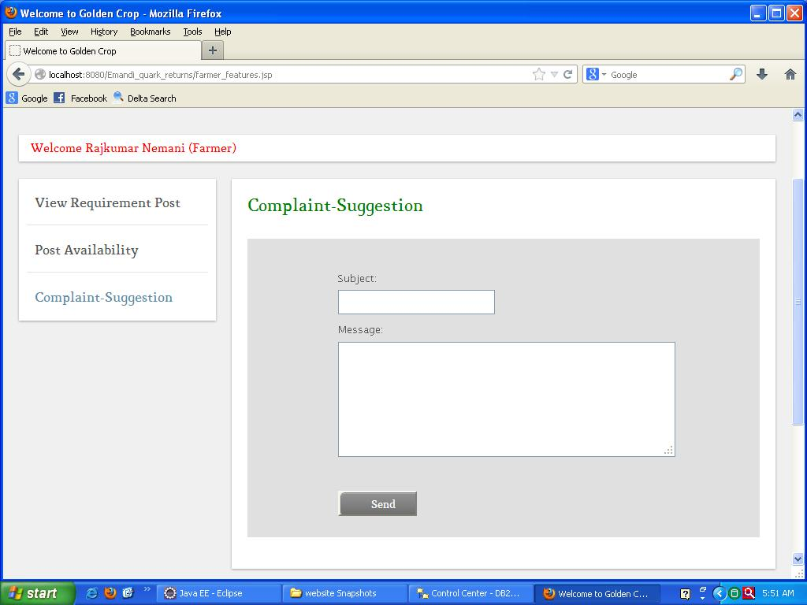

**Farmer Mailbox (Compose Meassage):**

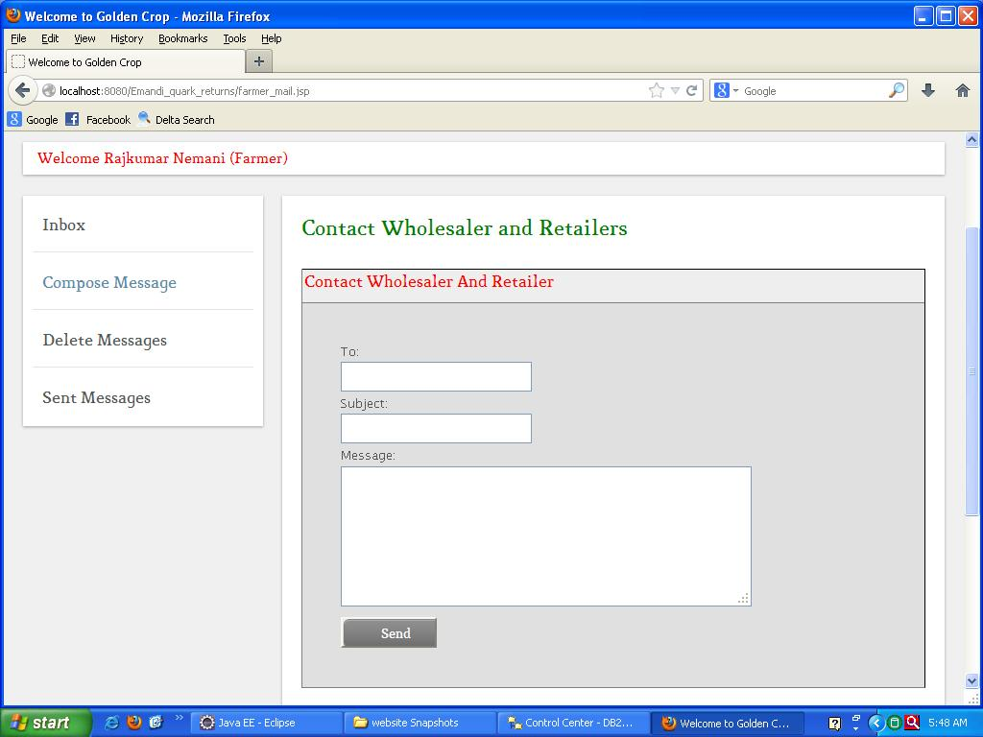

**Farmer Mailbox (Inbox):**

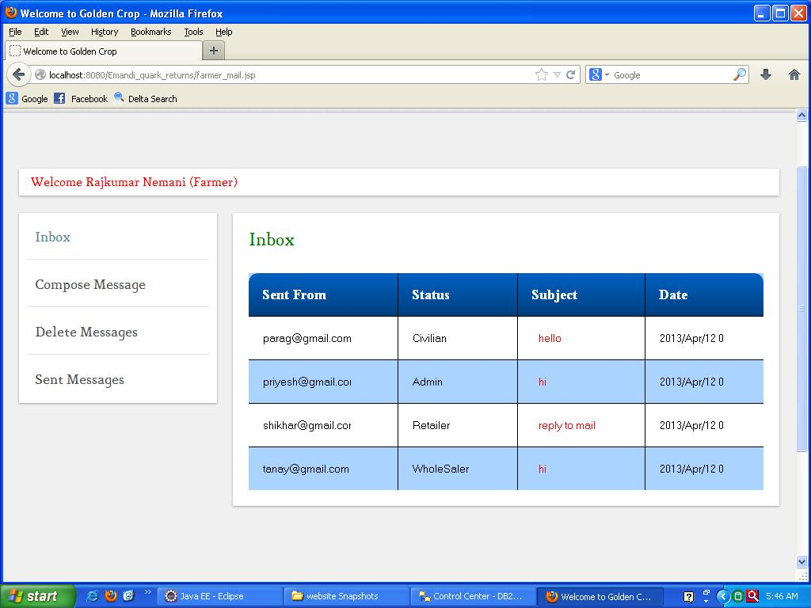

**Farmer Mailbox (Delete Messages):**

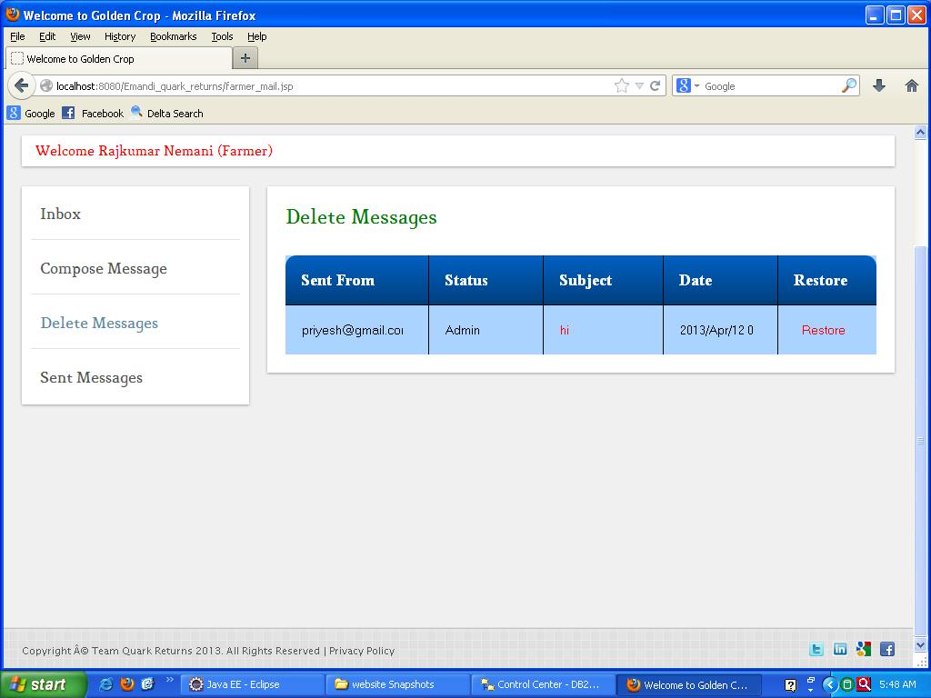

**Farmer Mailbox (Read Message):**

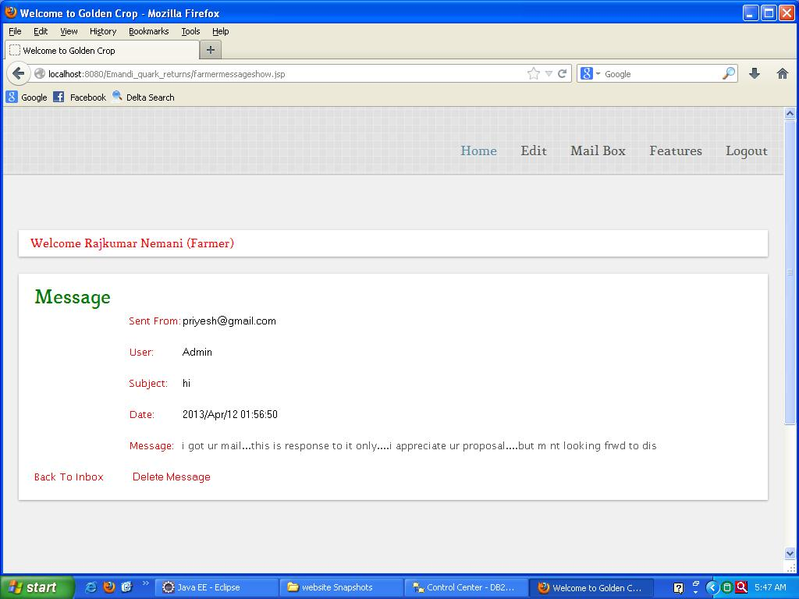

**Farmer Mailbox (Sent Messages):**

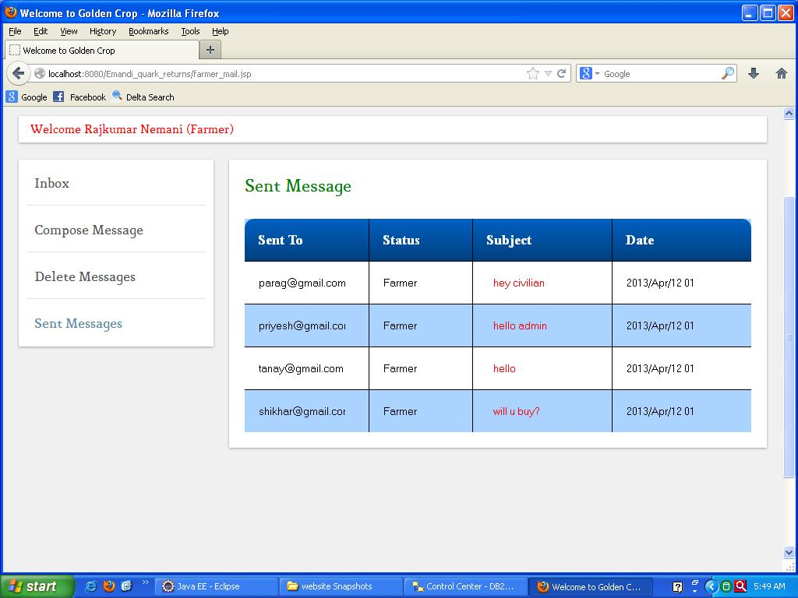

**Farmer Post Availibility:**

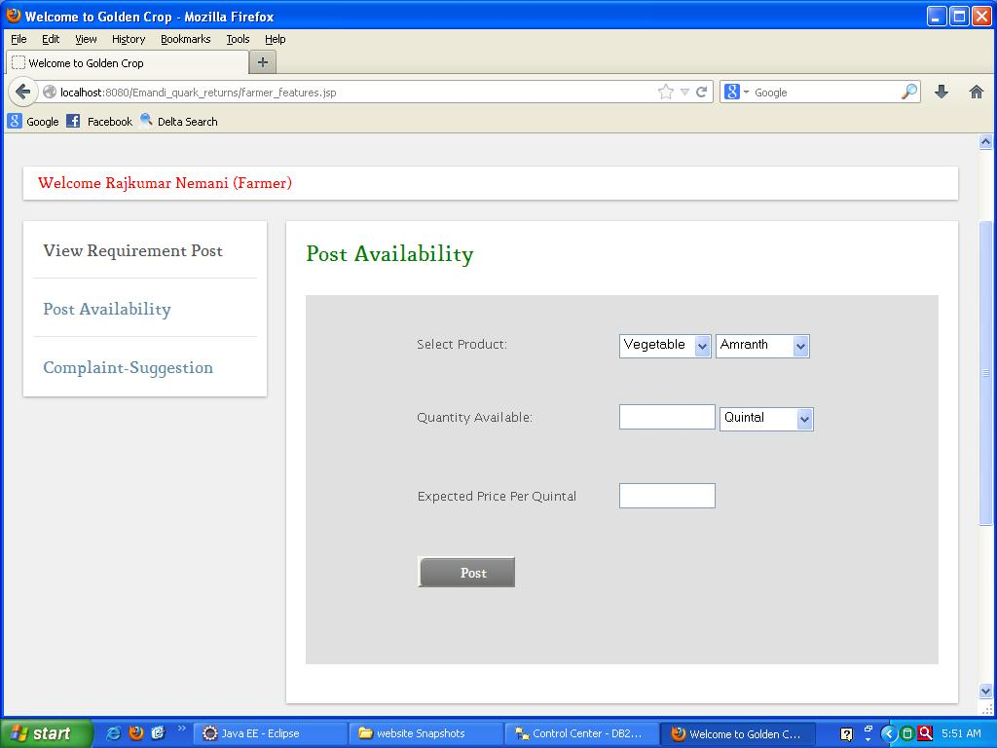

**Farmer Requirement Post:**

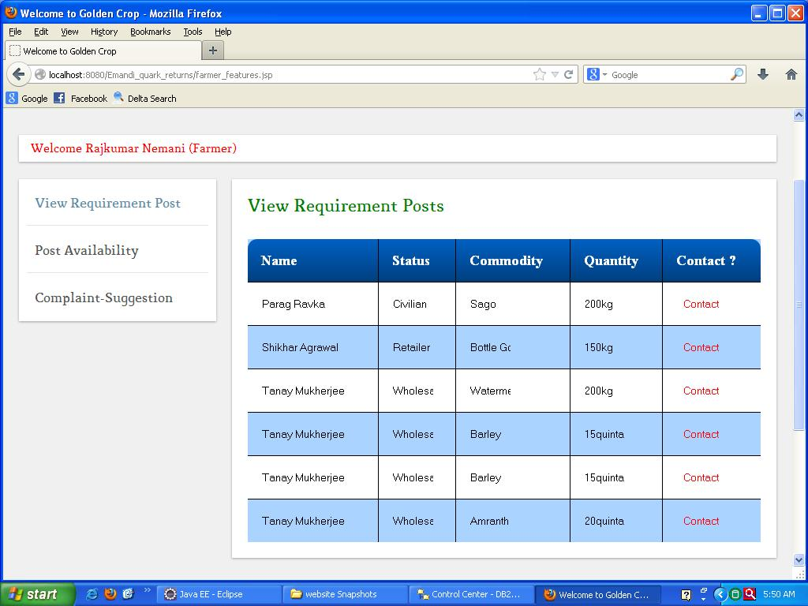

**Farmer Update Availability:**

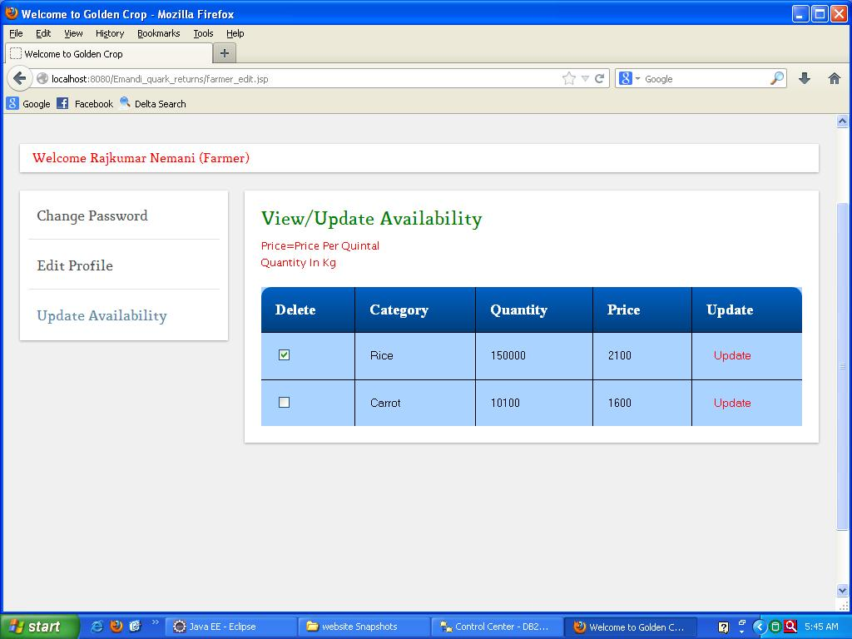

**Farmer View Contact:**

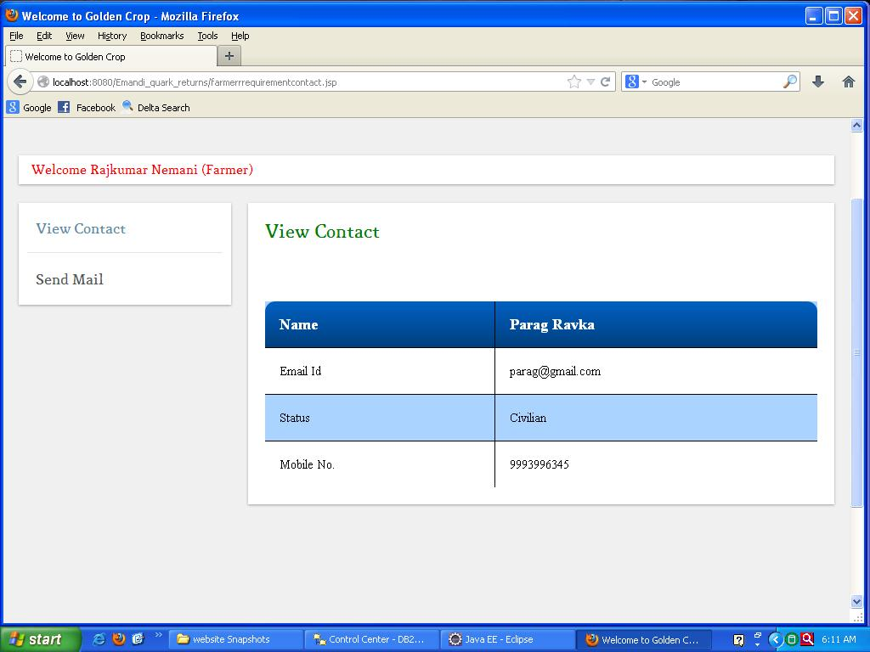

**WHOLESALER PROFILE:**

**Wholesaler Home Page:**

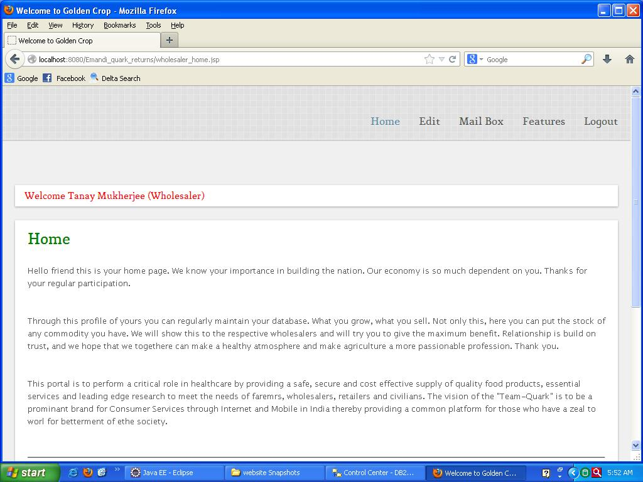

**Wholesaler Edit Profile:**

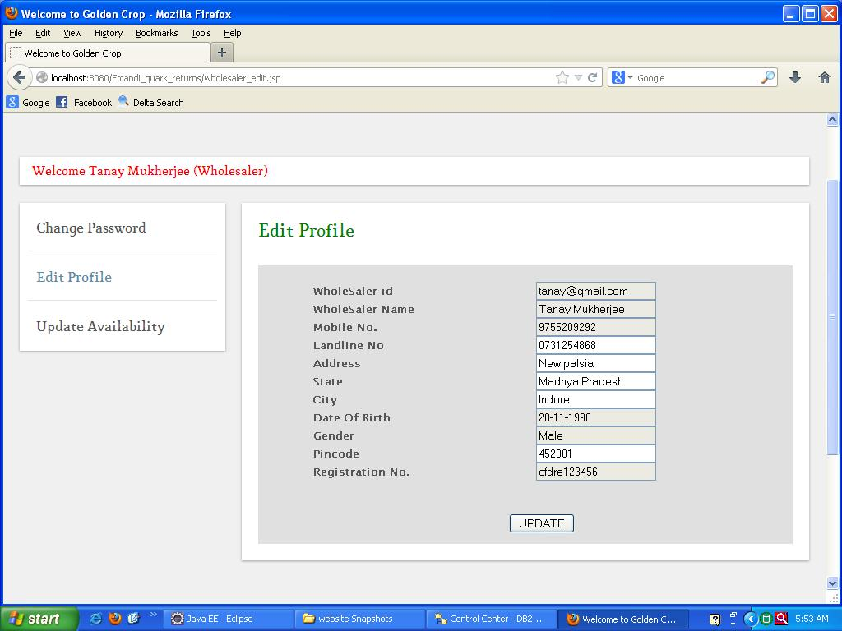

**Wholesaler Change Password:**

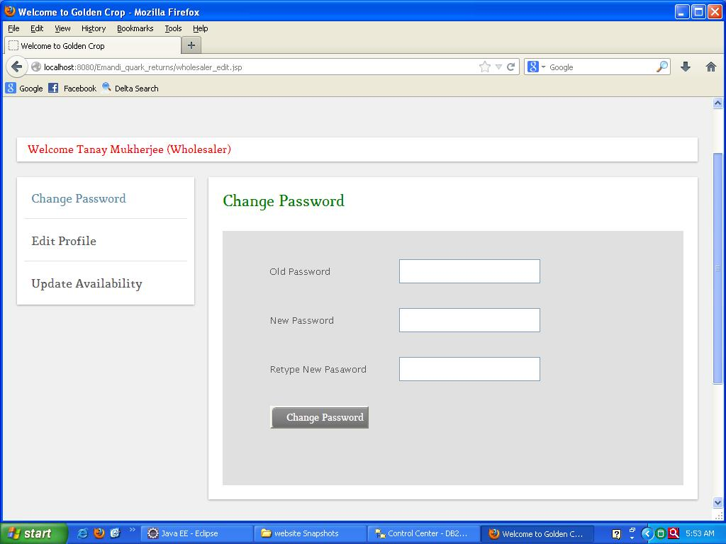

**Wholesaler Complaint-Suggestion Form:**

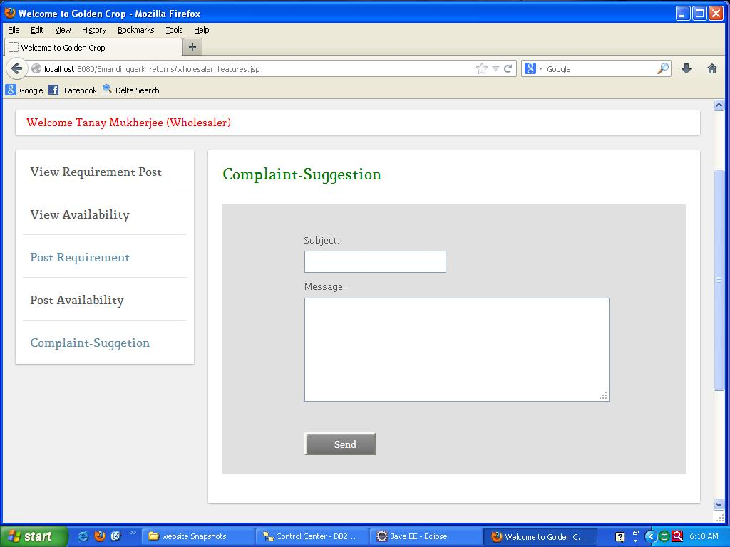

**Wholesaler Mailbox (Compose Message):**

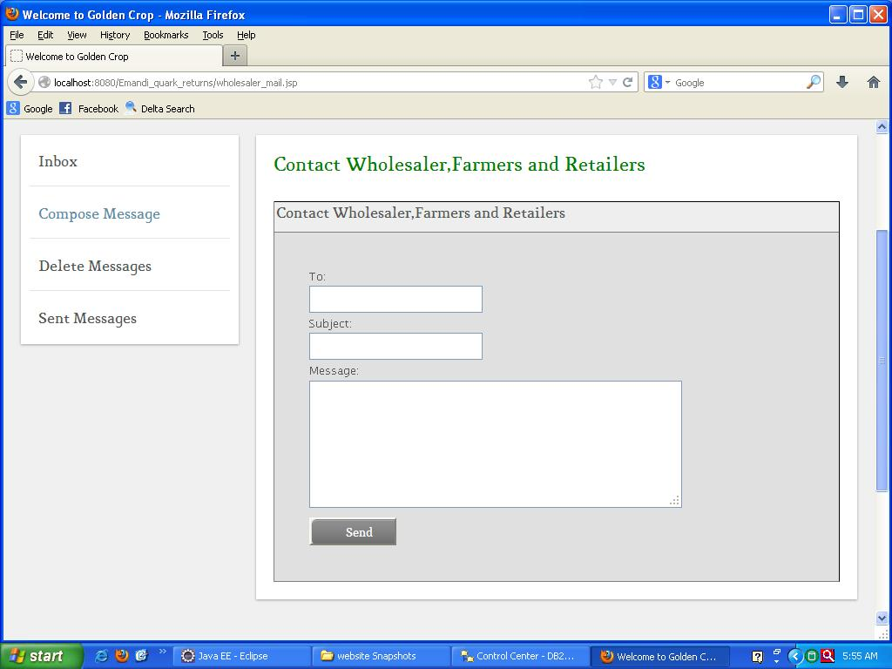

**Wholesaler Mailbox (Inbox):**

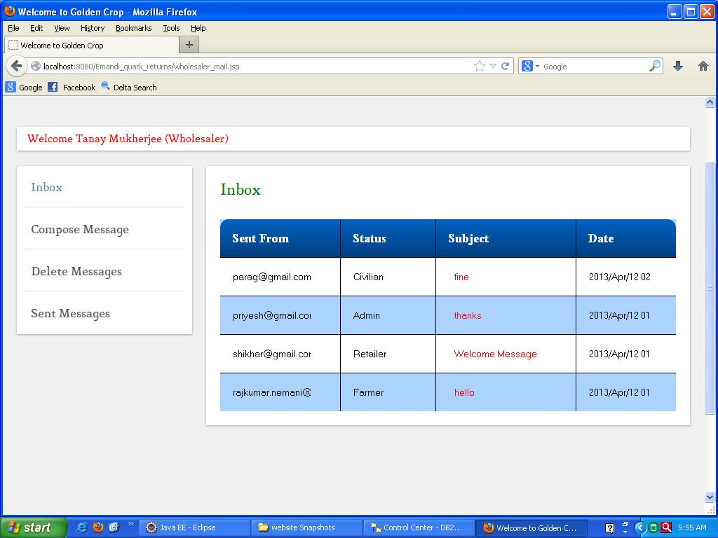

**Wholesaler Mailbox (Read Messages):**

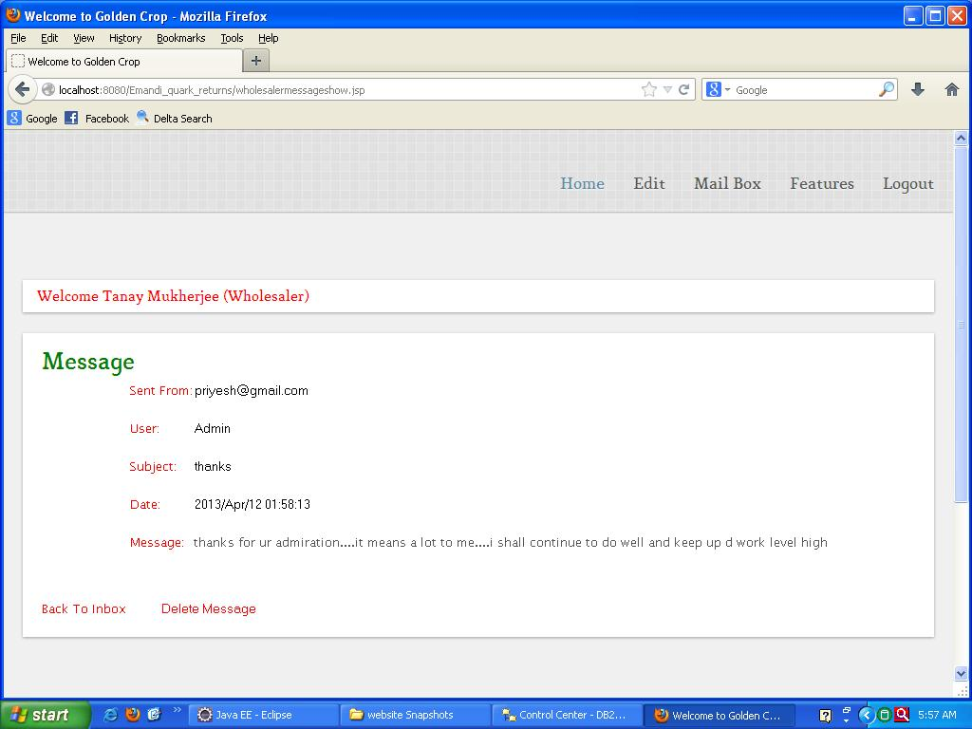

**Wholesaler Mailbox (Delete Mailbox):**

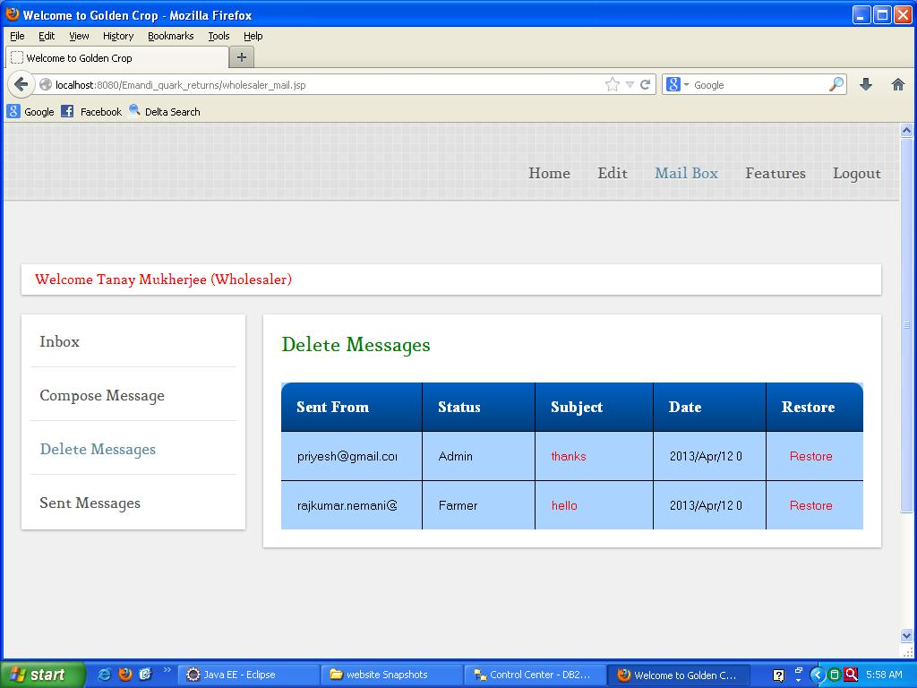

**Wholesaler Mailbox (Sent Messages):**

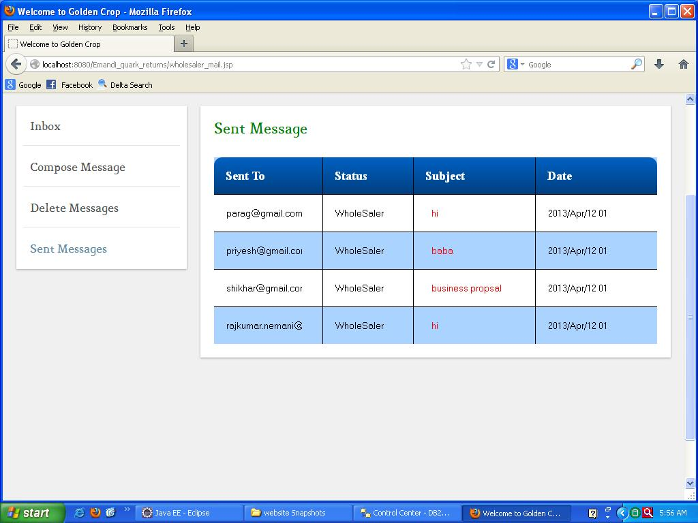

**Wholesaler Post Availibility:**

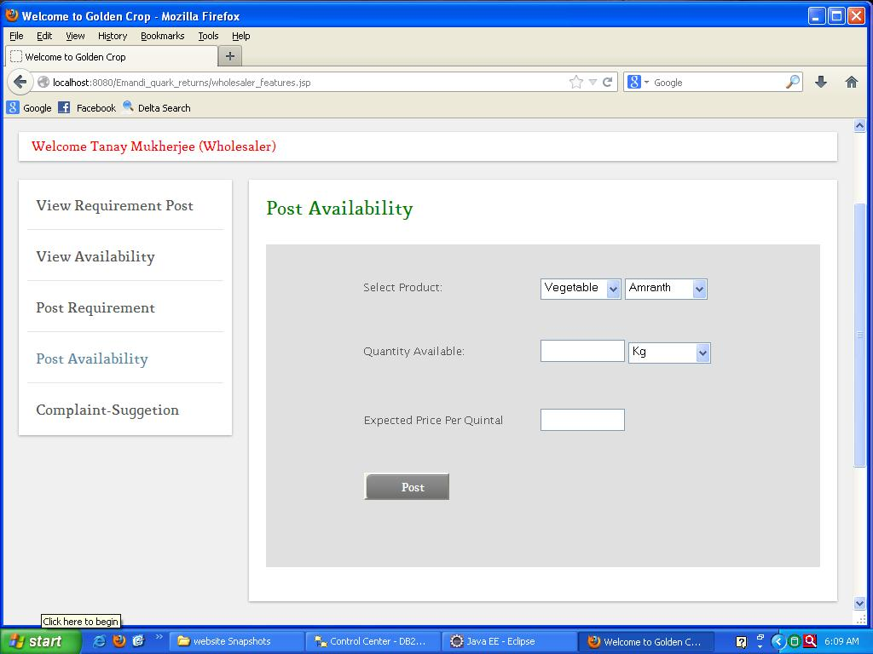

**Wholesaler Requirement Post:**

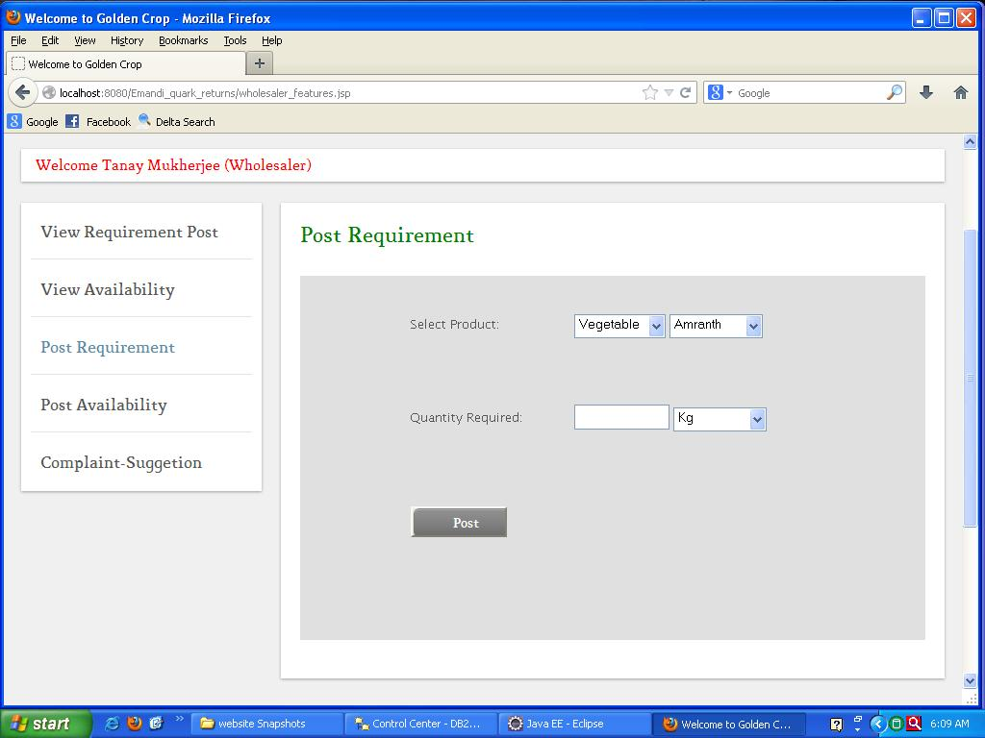

**Wholesaler Update Availability:**

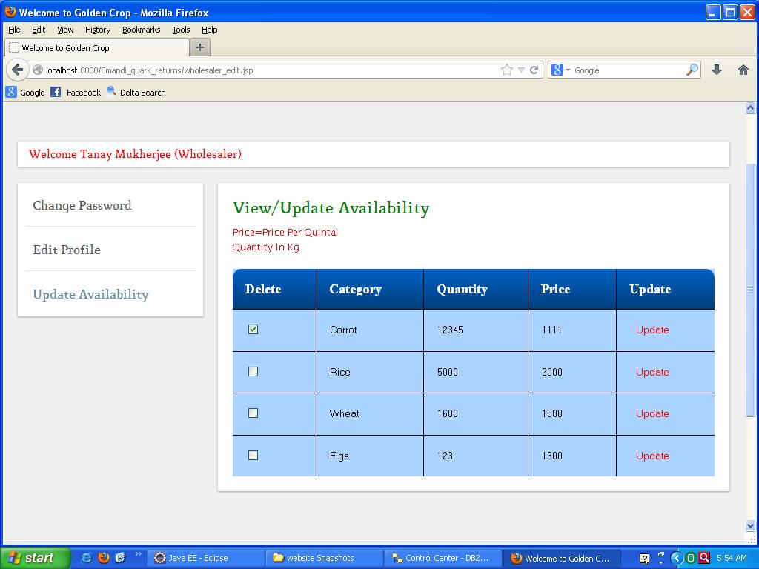

**Wholesaler View Availability:**

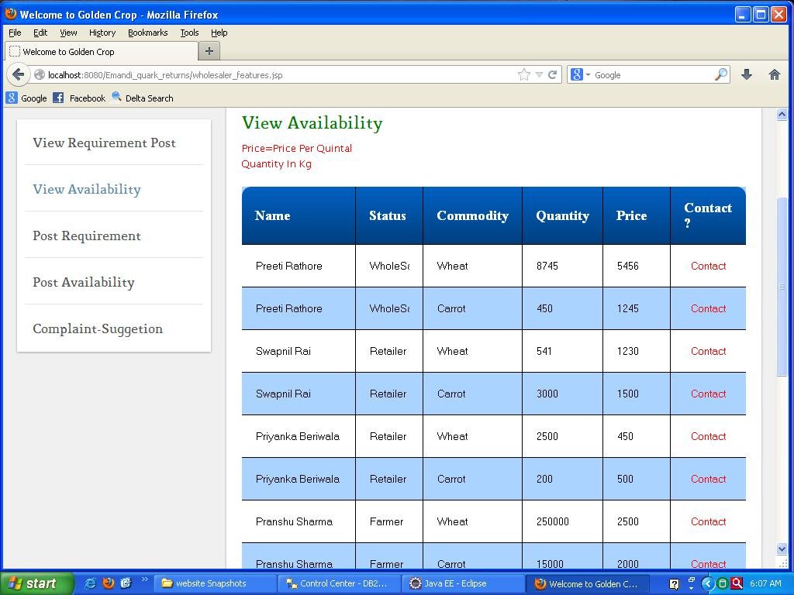

**Wholesaler View Requirement Post:**

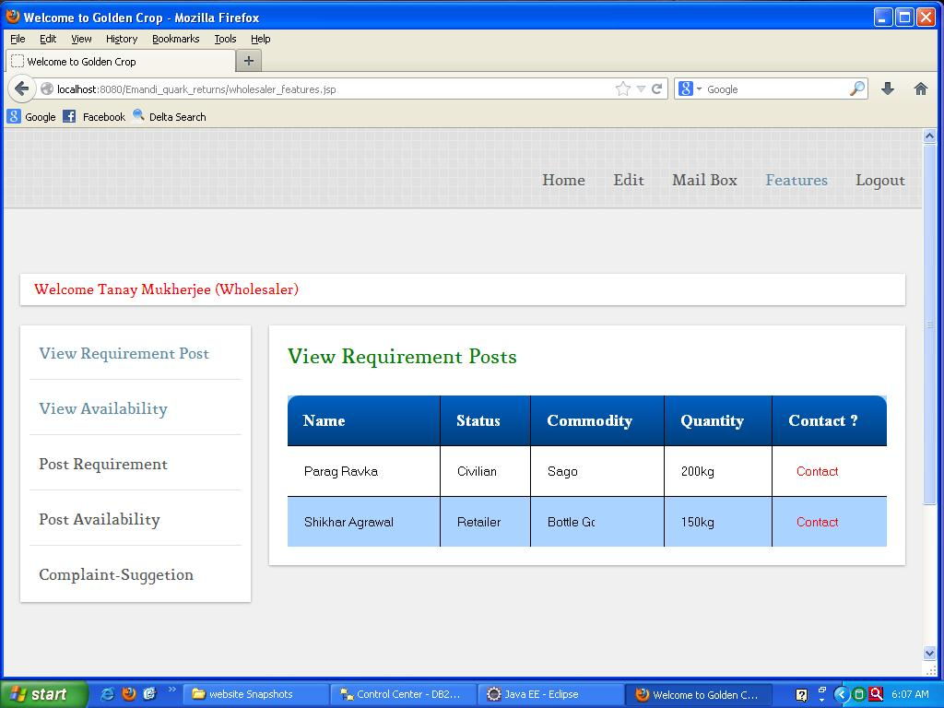

**Wholesaler View Contact:**

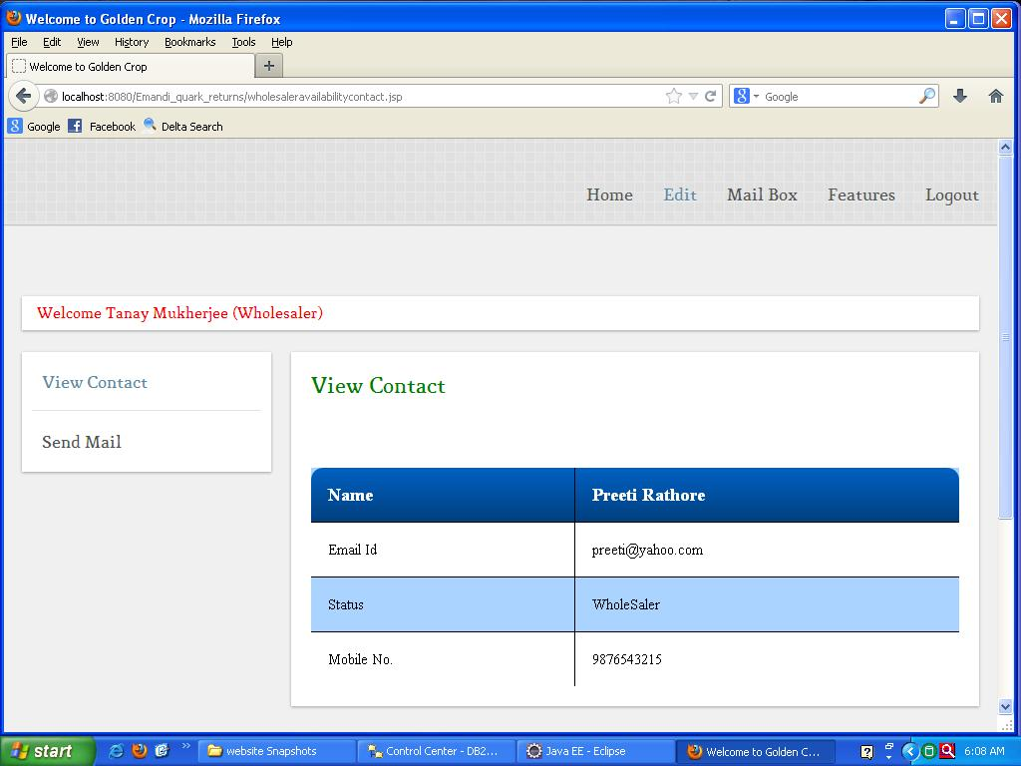

**RETAILER PROFILE:**

**Retailer Home Page:**

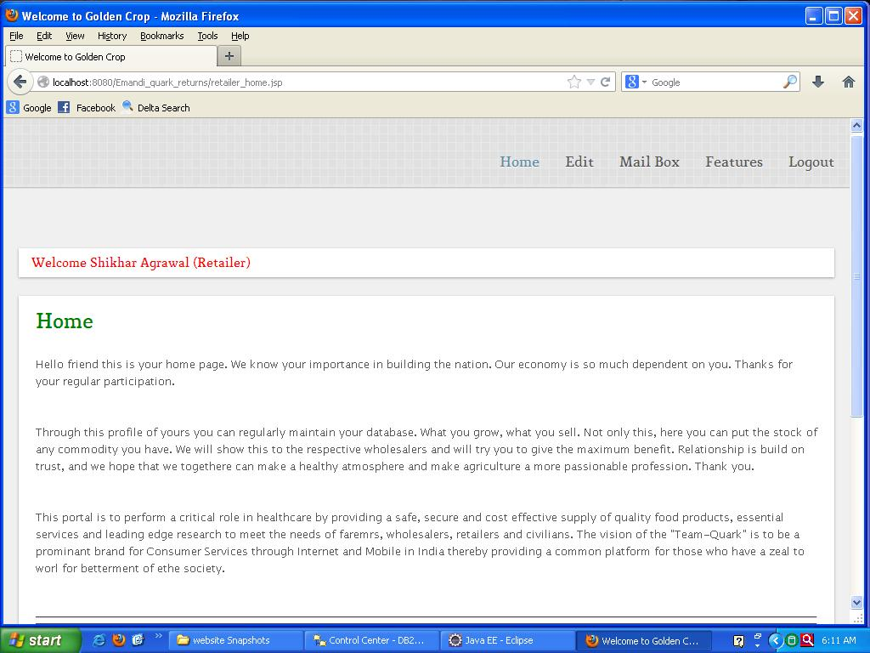

**Retailer Edit Profile:**

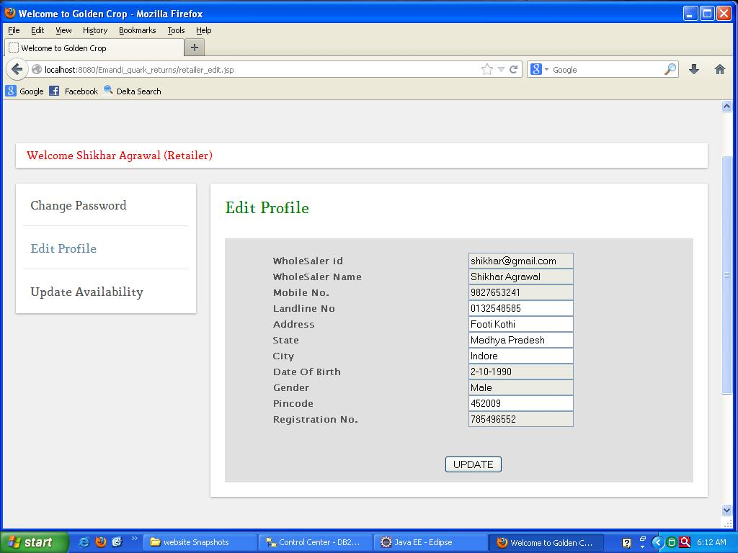

**Retailer Change Password:**

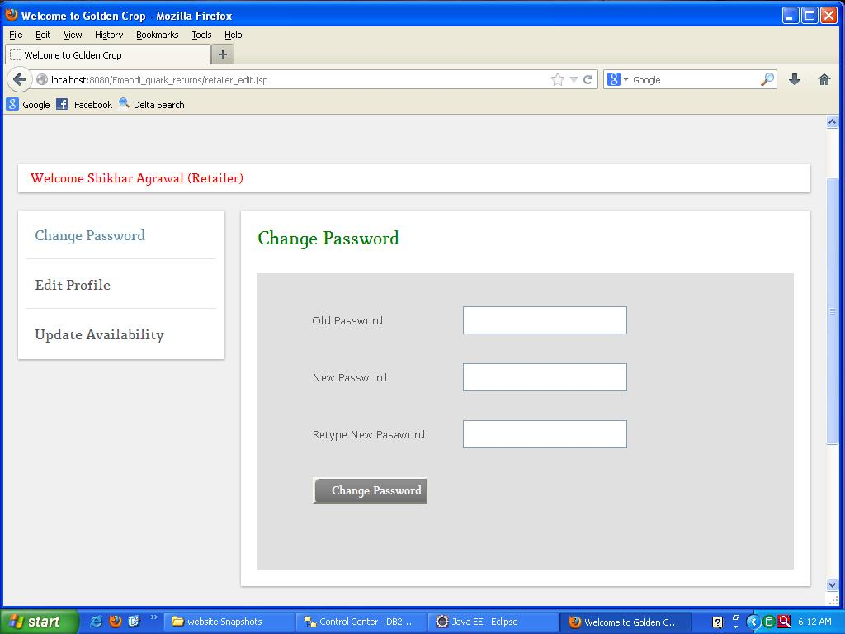

**Retailer Complaint-Suggestion Form:**

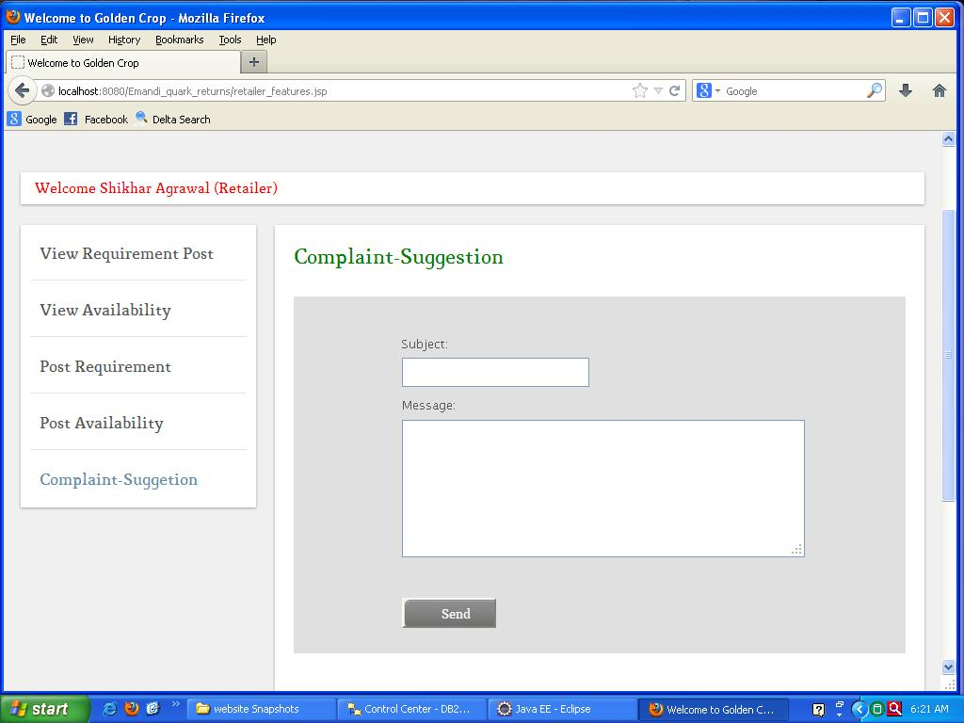

**Retailer Mailbox:**

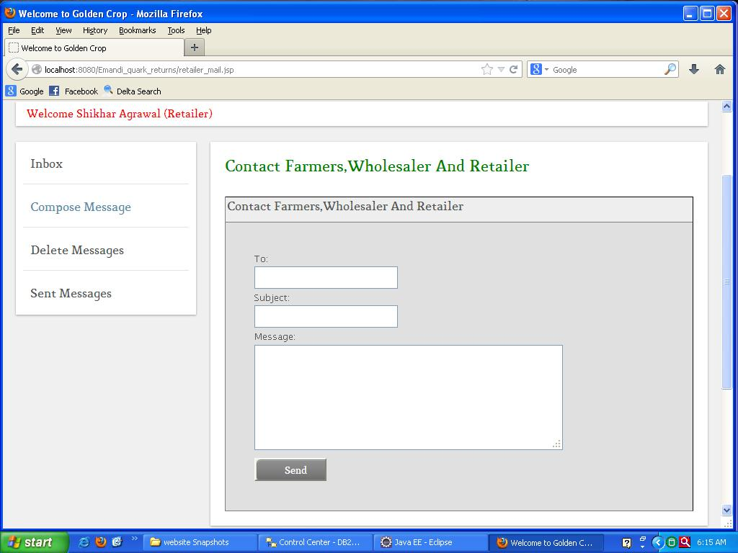

**Retailer Mailbox (Inbox):**

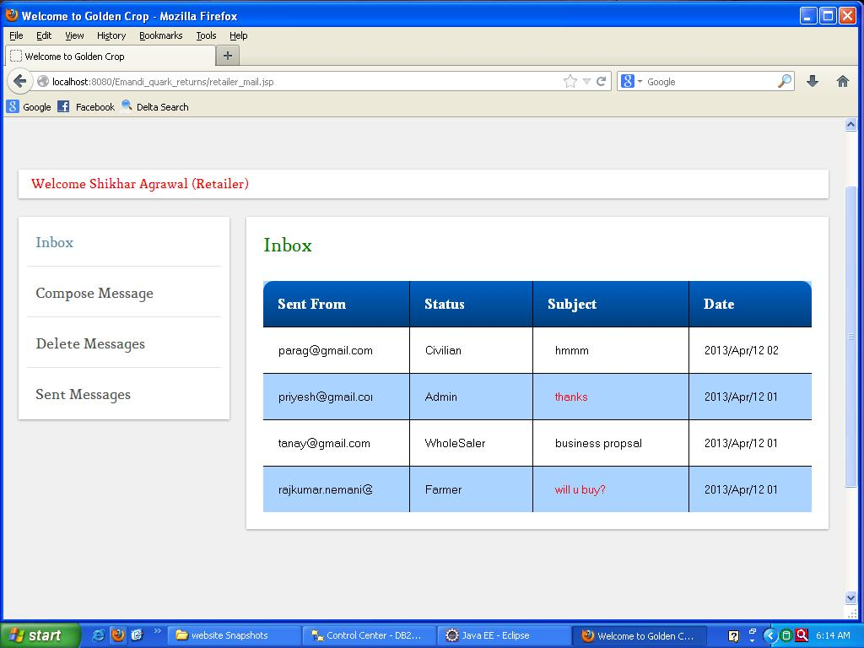

**Retailer Mailbox (Read Messages):**

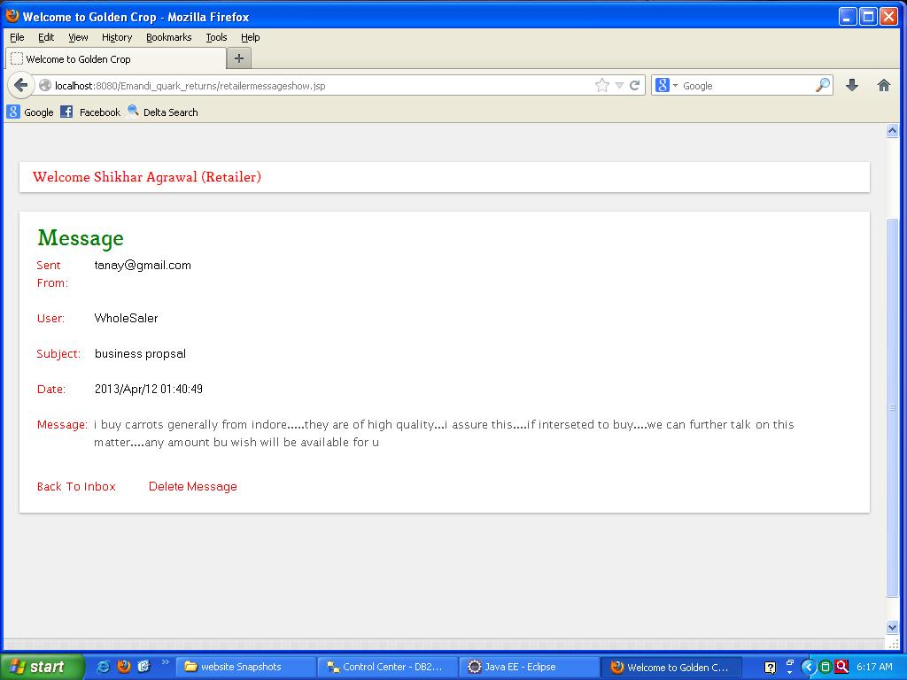

**Retailer Mailbox (Delete Mailbox):**

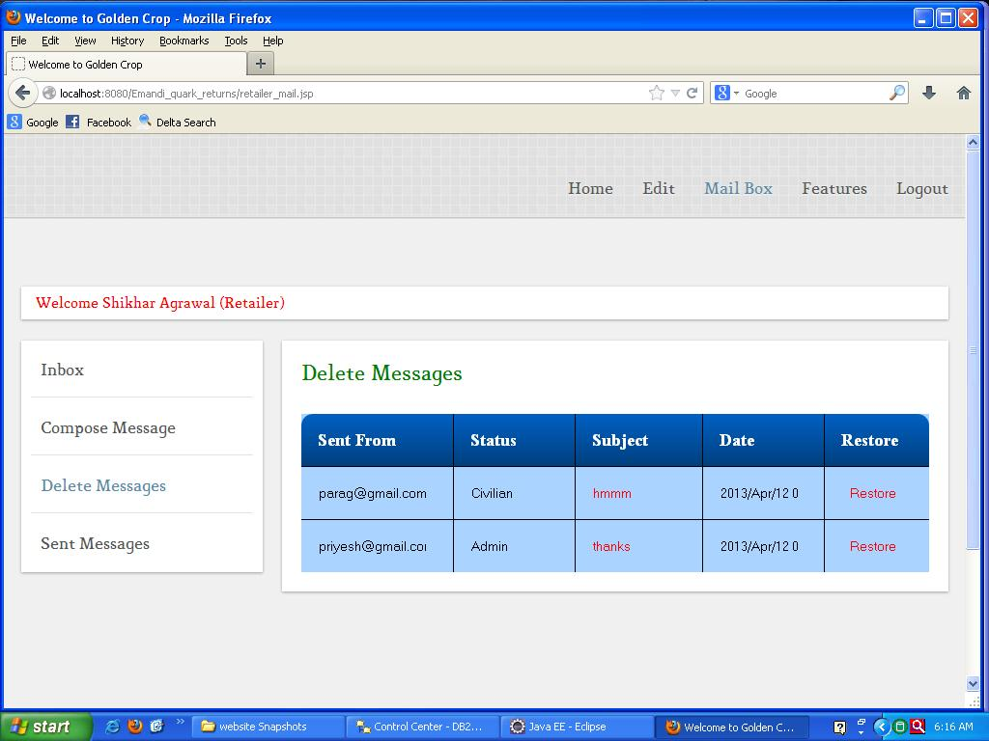

**Retailer Mailbox (Sent Messages):**

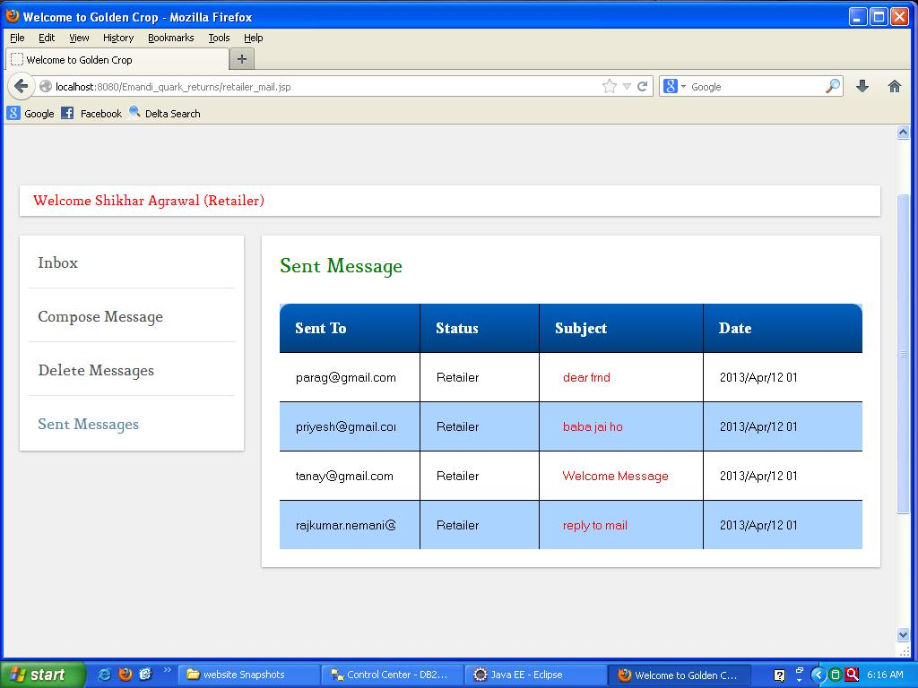

**Retailer Post Availibility:**

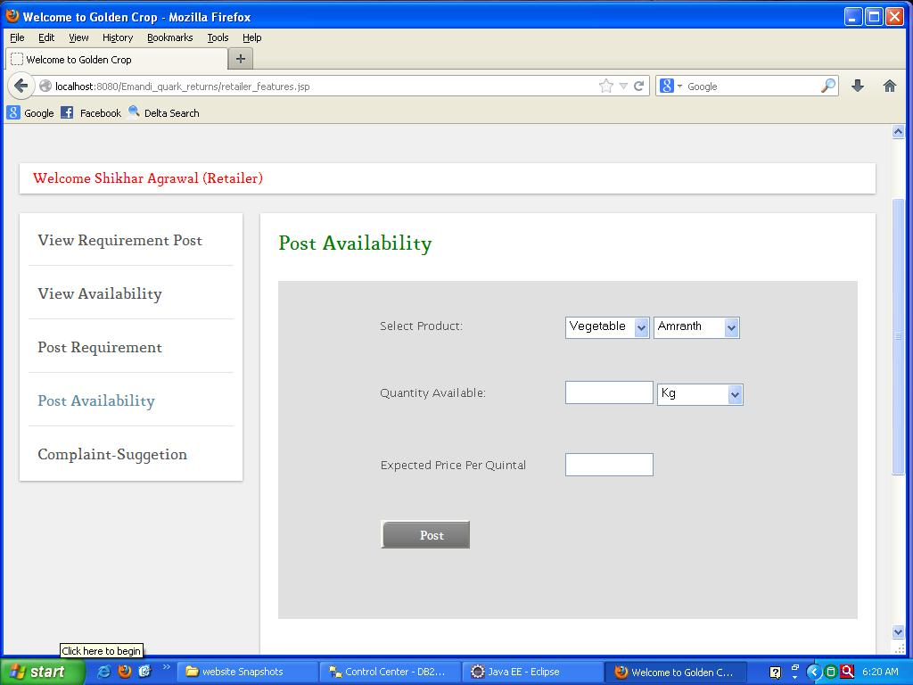

**Retailer Requirement Post:**

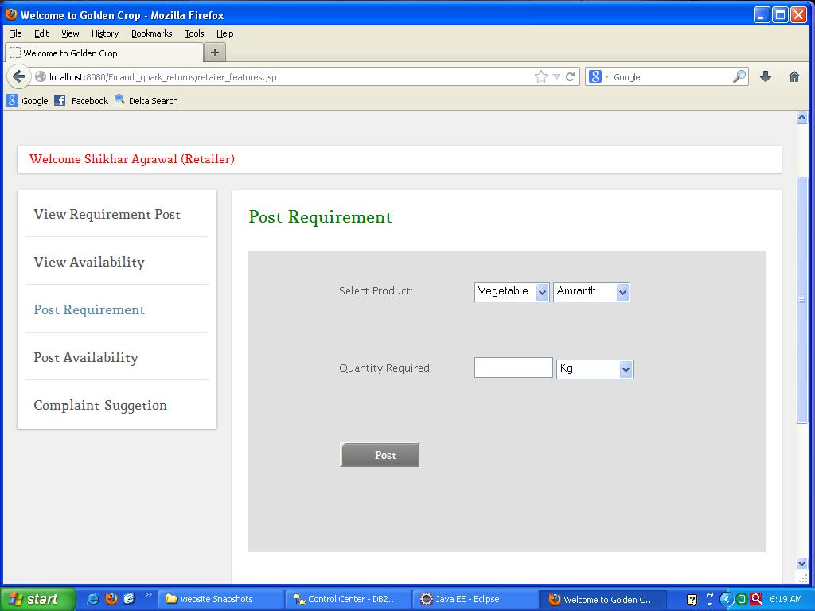

**Retailer Update Availability:**

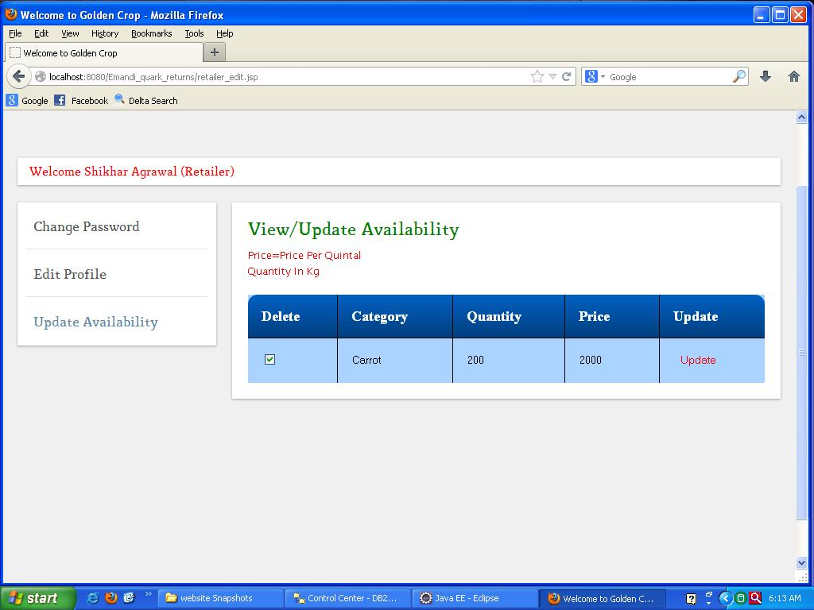

**Retailer View Availability:**

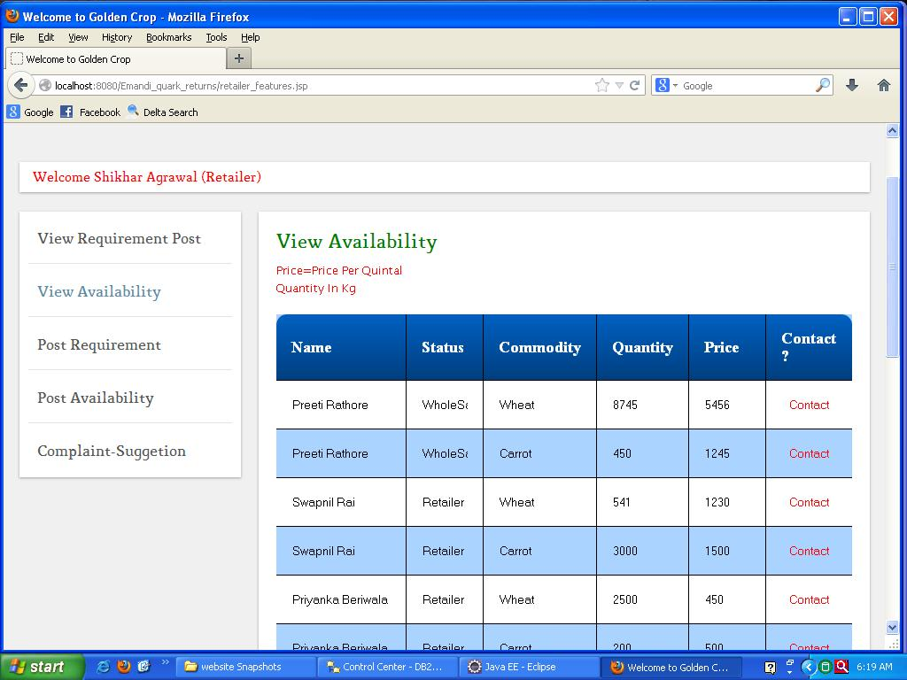

**Retailer View Requirement Post:**

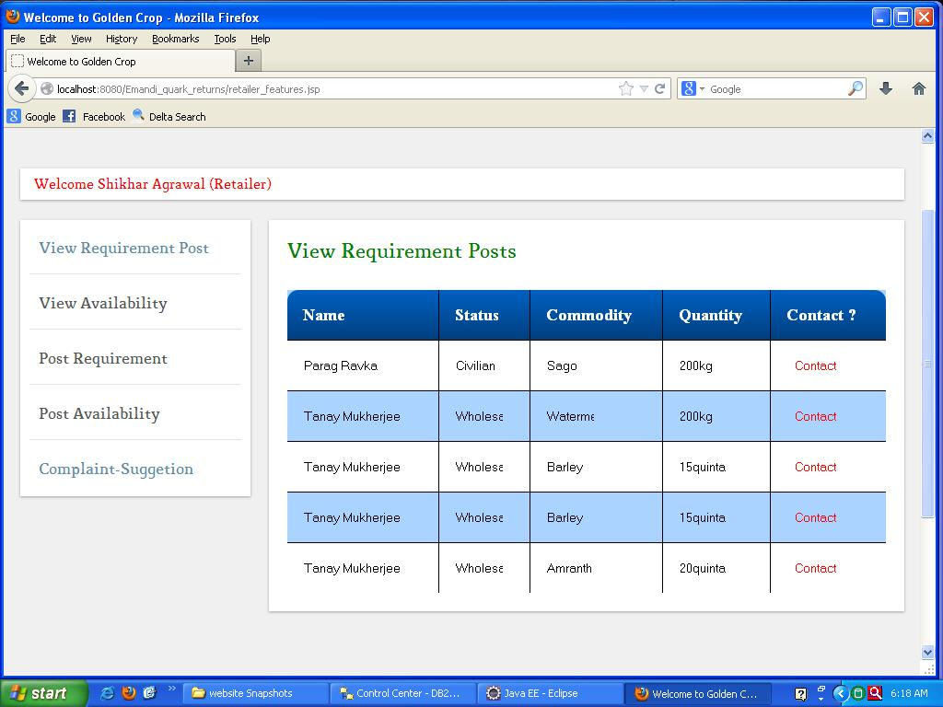

**CIVILIAN PROFILE:**

**Civilian Home Page:**

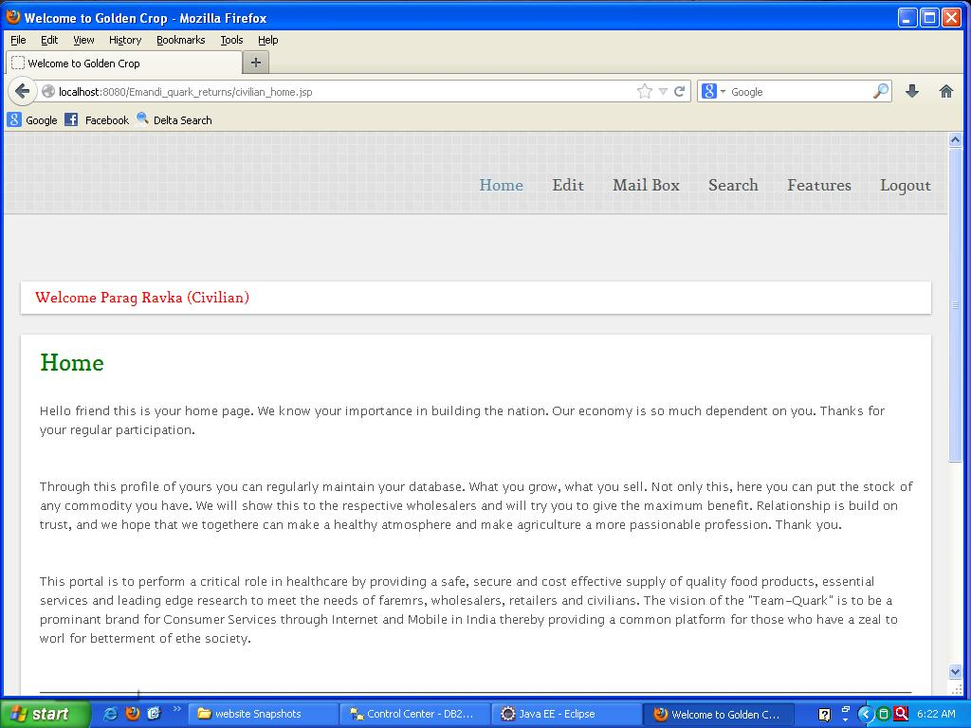

**Civilian Edit Profile:**

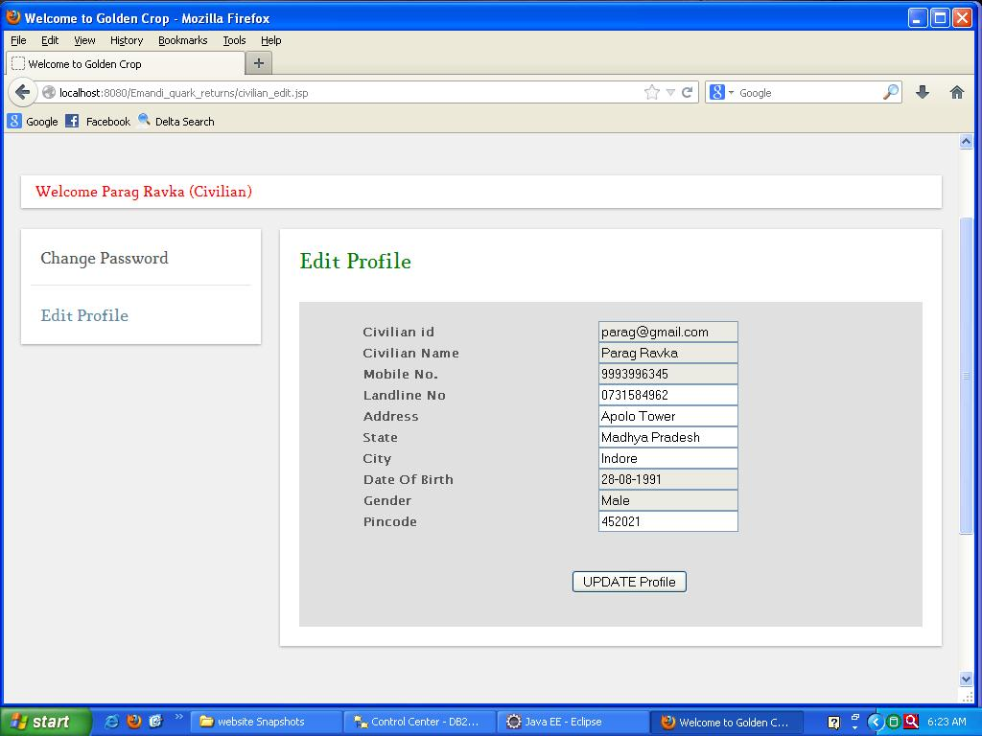

**Civilian Change Password:**

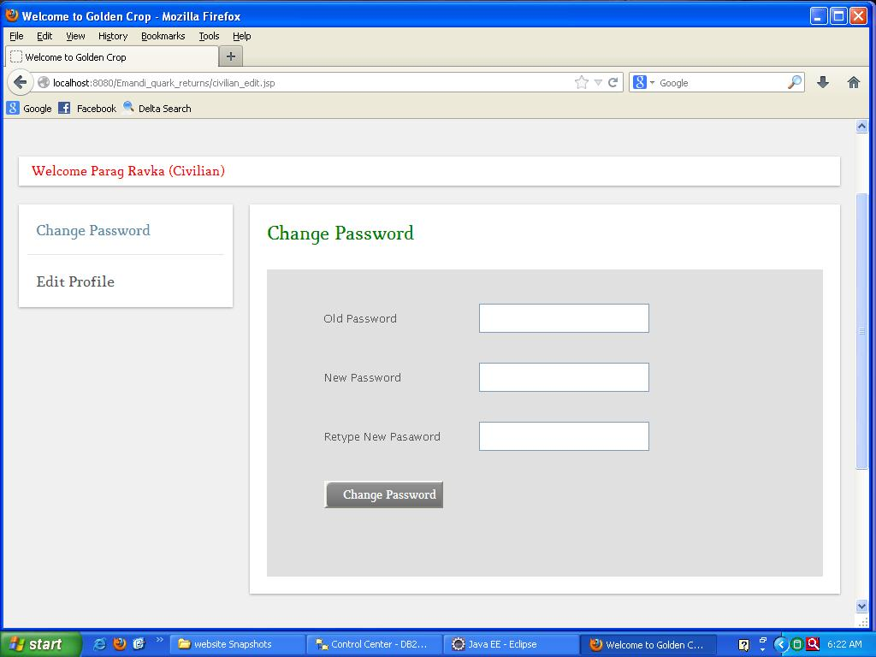

**Civilian** 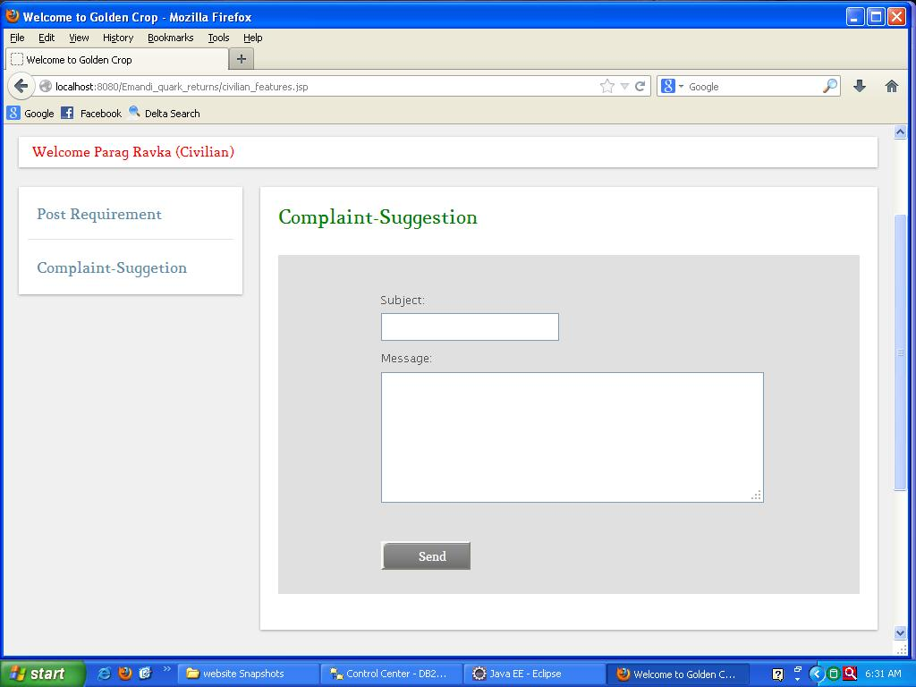

**Civilian Mailbox (Compose Message):**

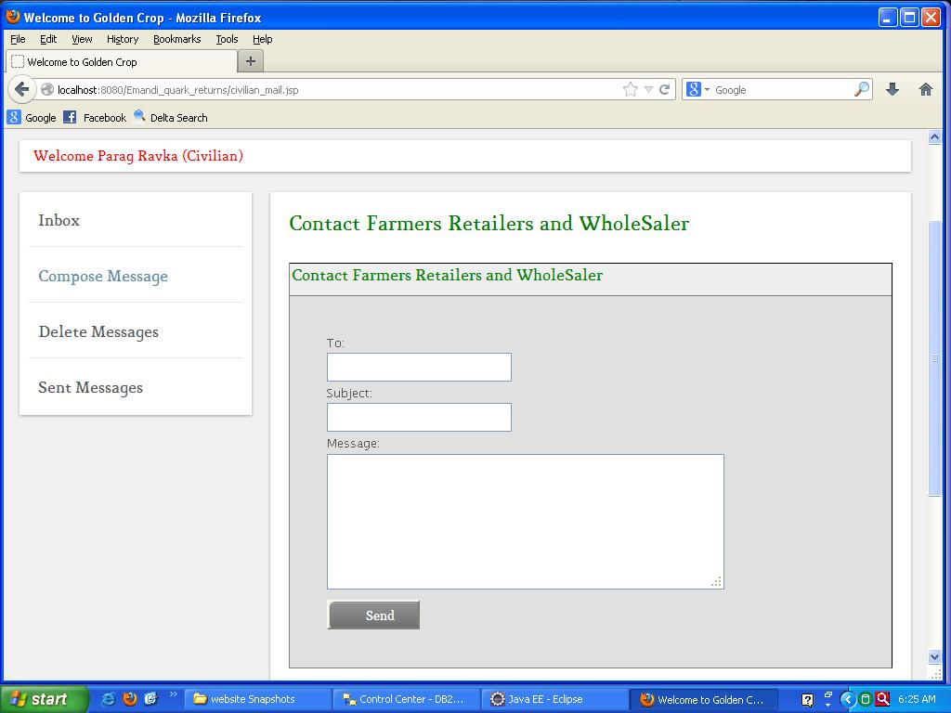

**Civilian Mailbox (Inbox):**

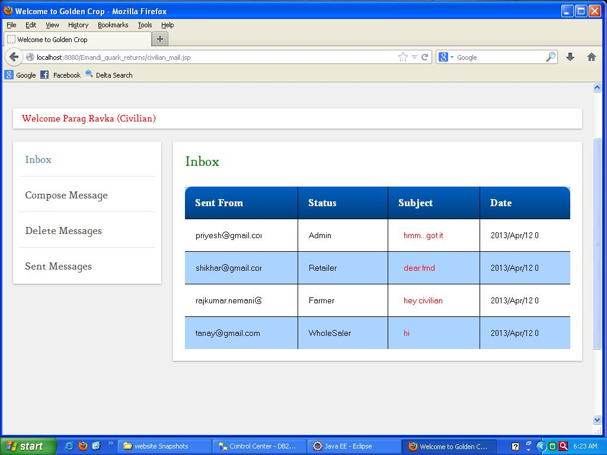

**Civilian Mailbox (Read Messages):**

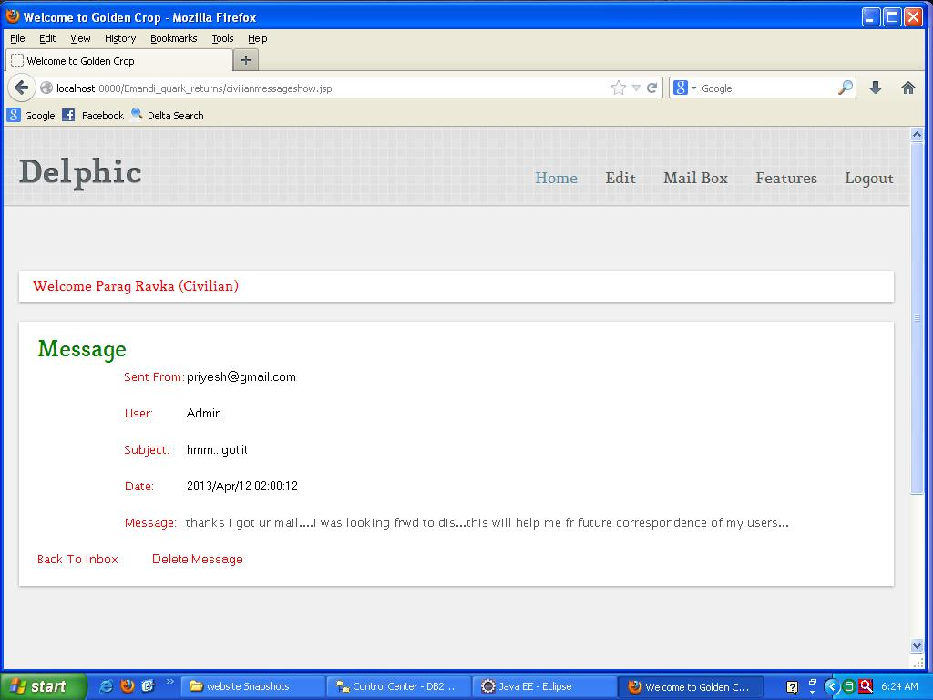

**Civilian Mailbox (Delete Mailbox):**

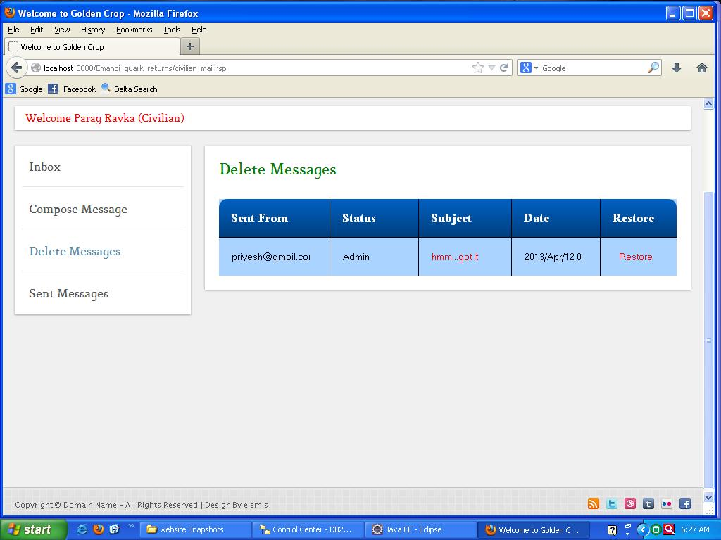

**Civilian Mailbox (Sent Messages):**

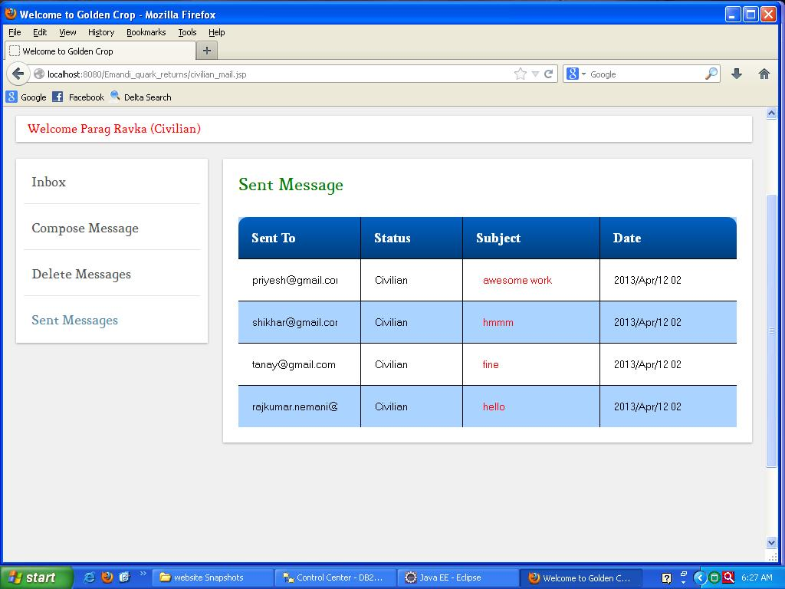

**Civilian Requirement Post:**

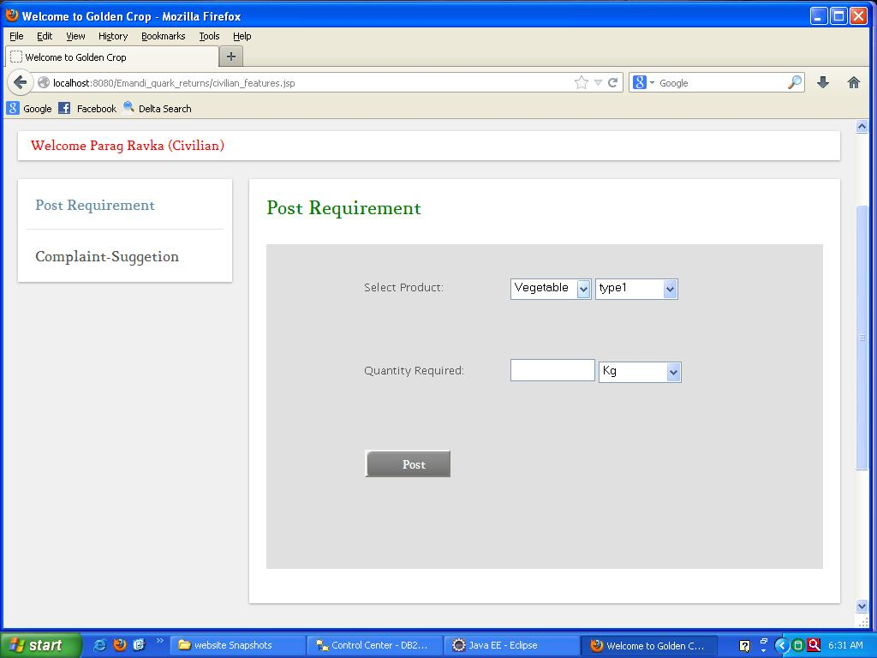

**Civilian Search Mandi Price:**

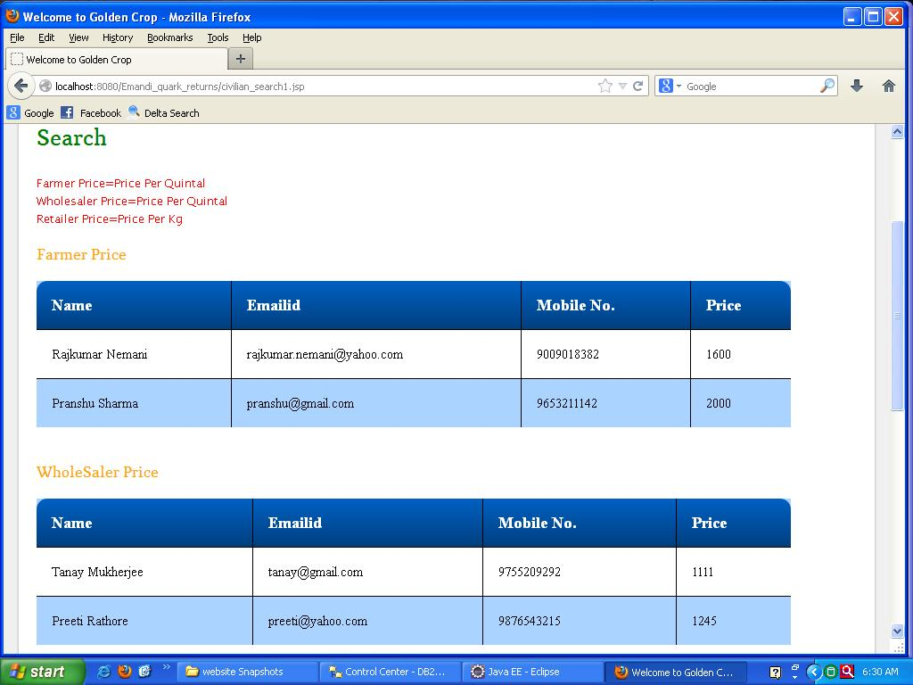

**Civilian Search Mandis:**

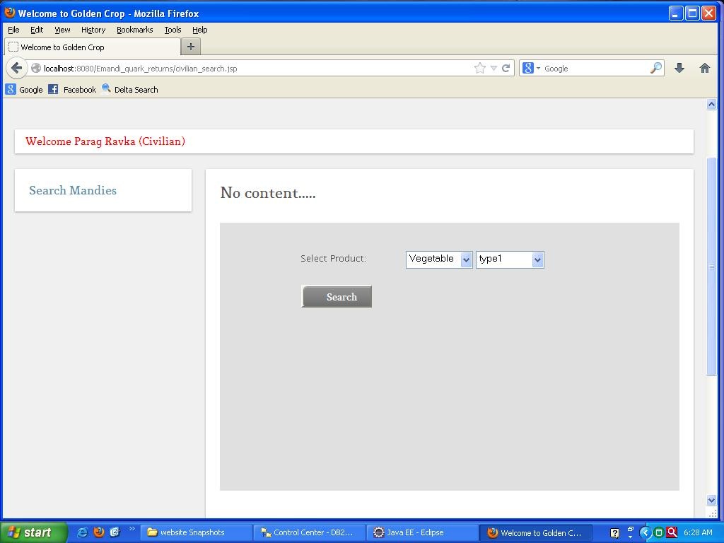

**ADMIN PROFILE:**

**Admin Home Page:**

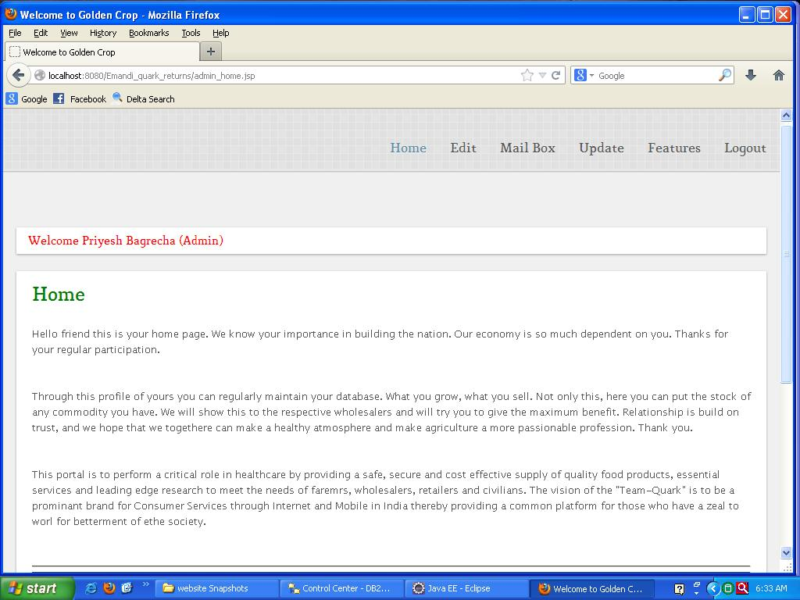

**Admin Edit Profile:**

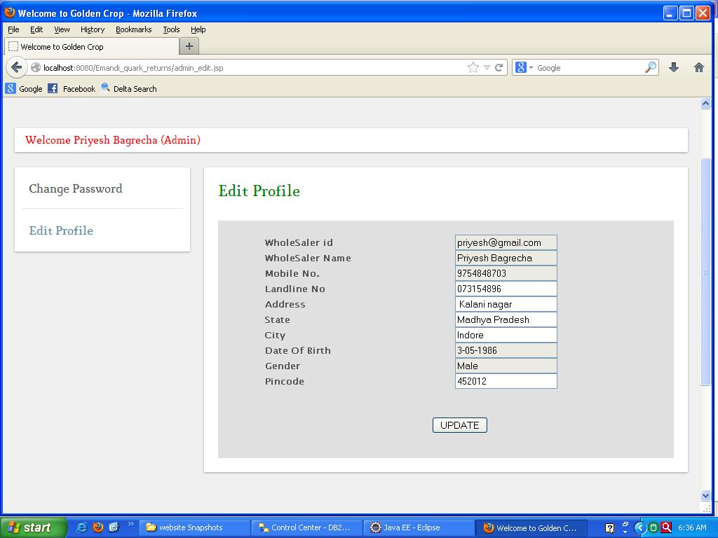

**Admin Change Password:**

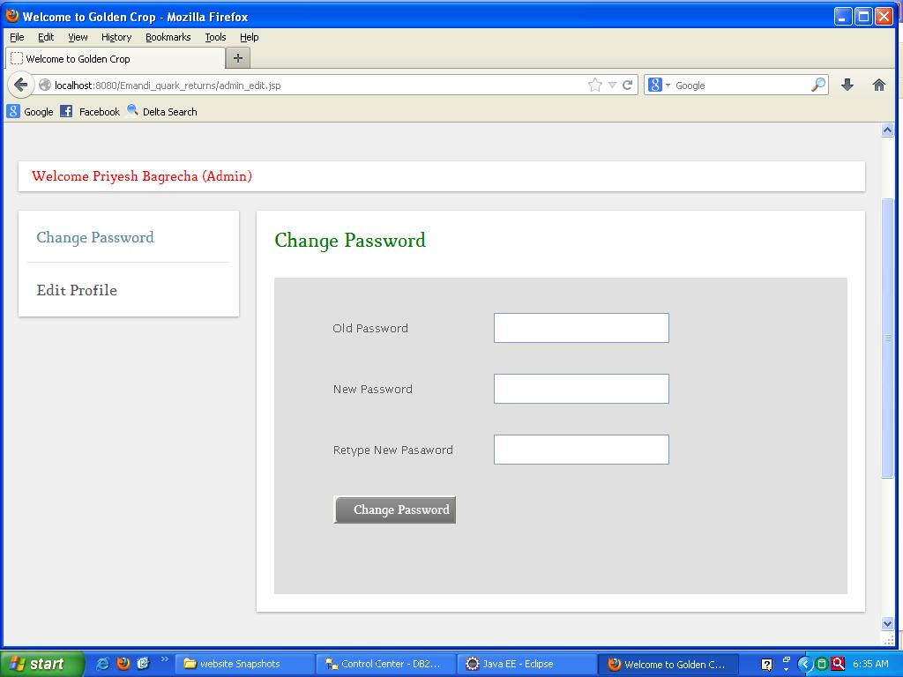

**Admin Mailbox (Compose Message):**

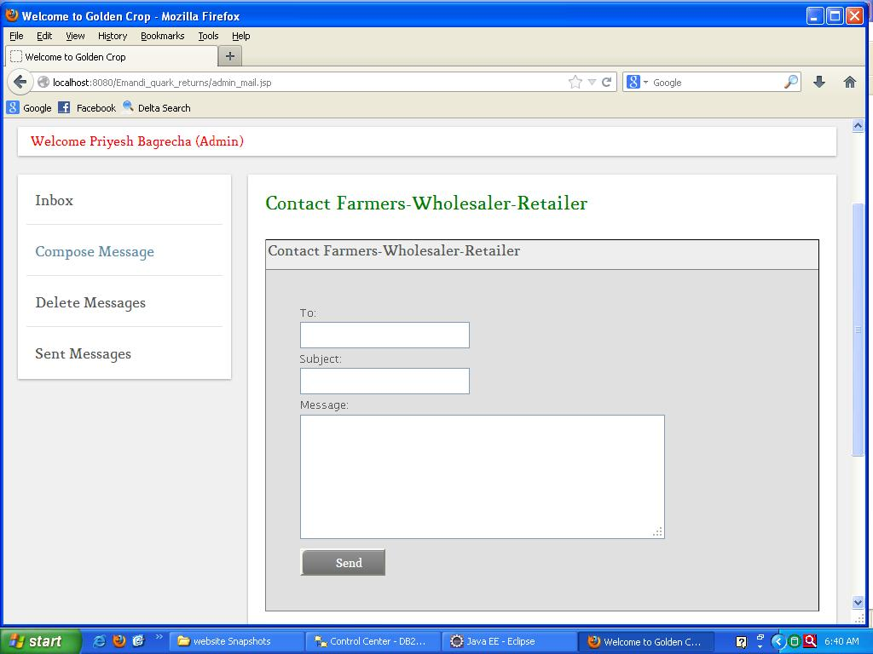

**Admin Mailbox (Inbox):**

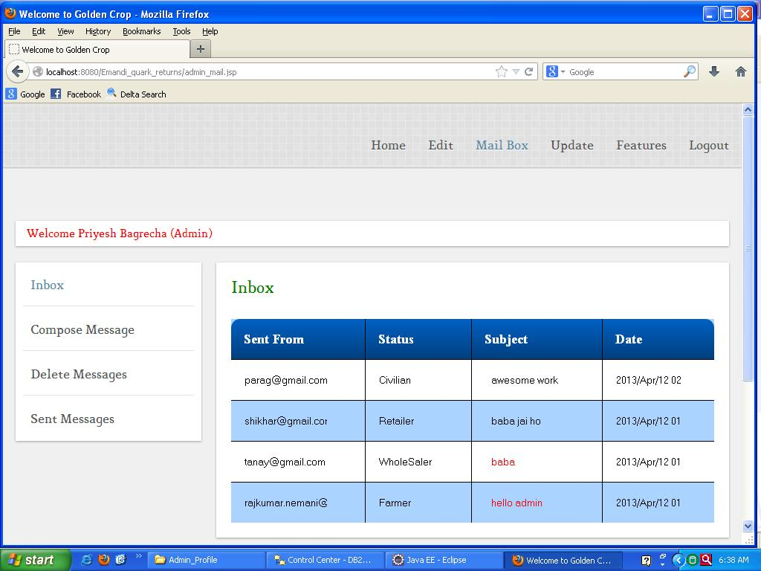

**Admin Mailbox (Read Messages):**

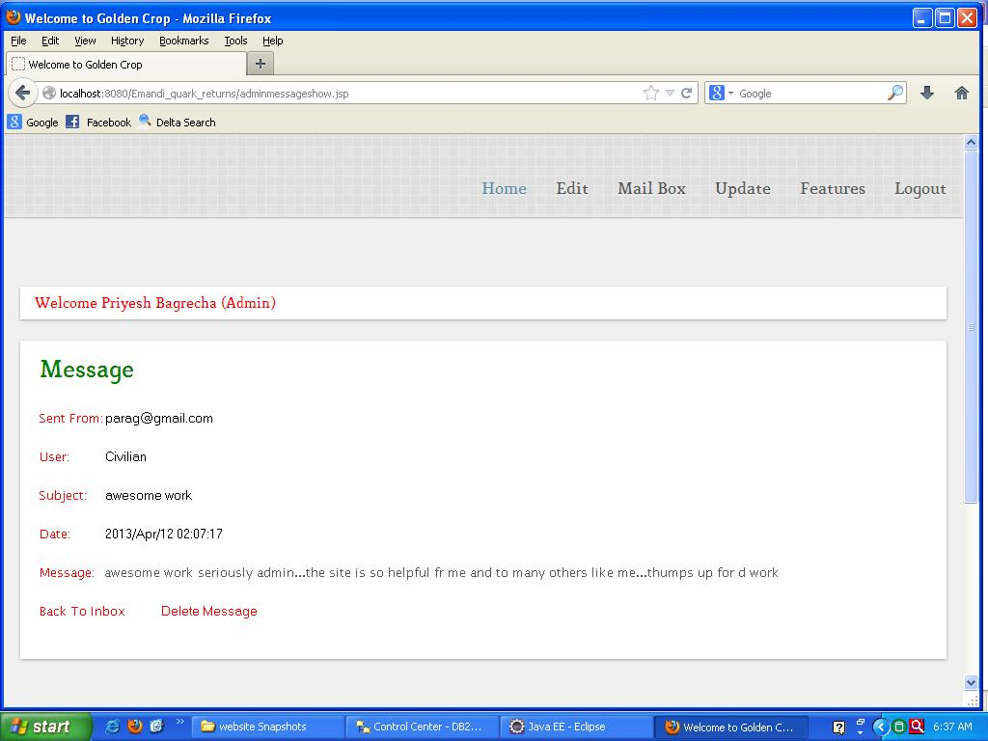

**Admin Mailbox (Delete Mailbox):**

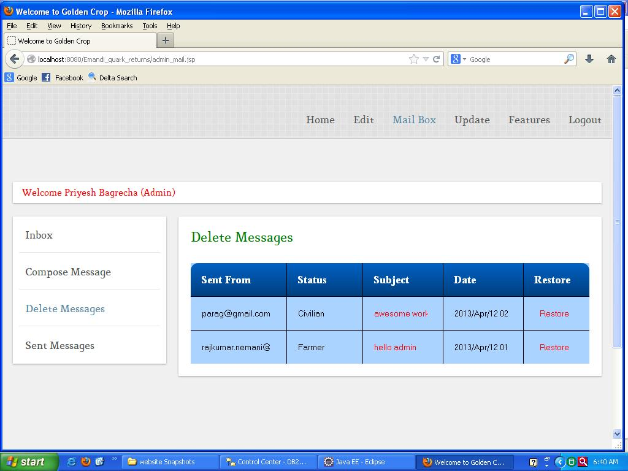

**Admin Mailbox (Sent Messages):**

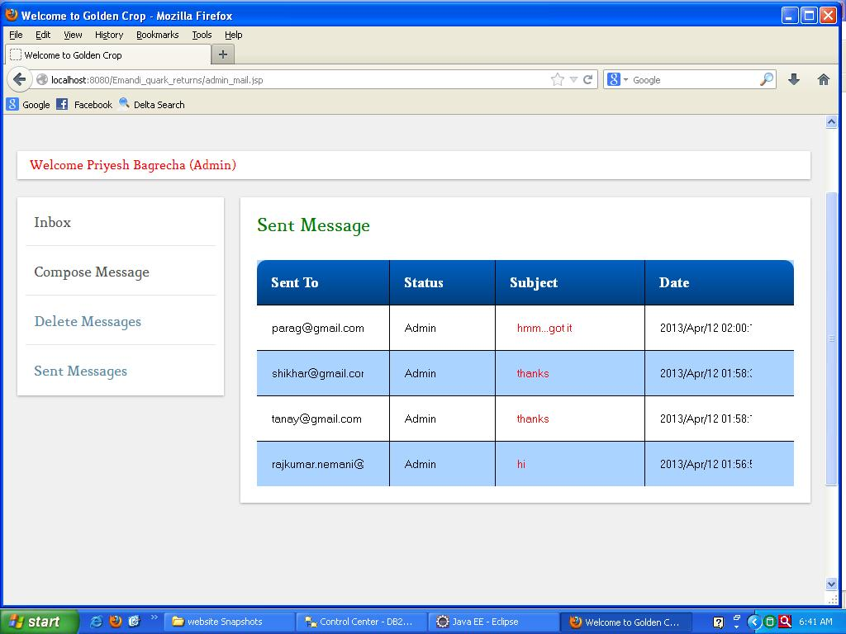

**Admin View Complaints:**

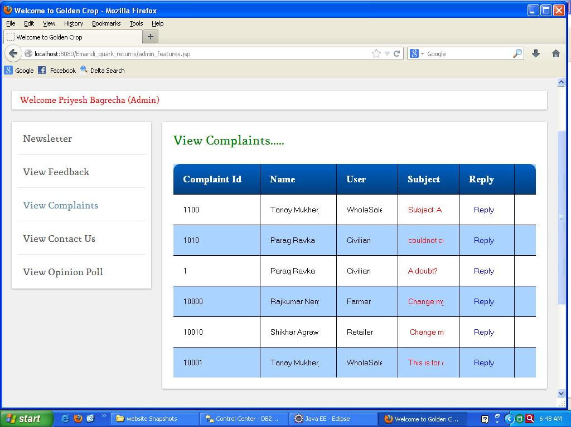

**Admin Newsletter:**

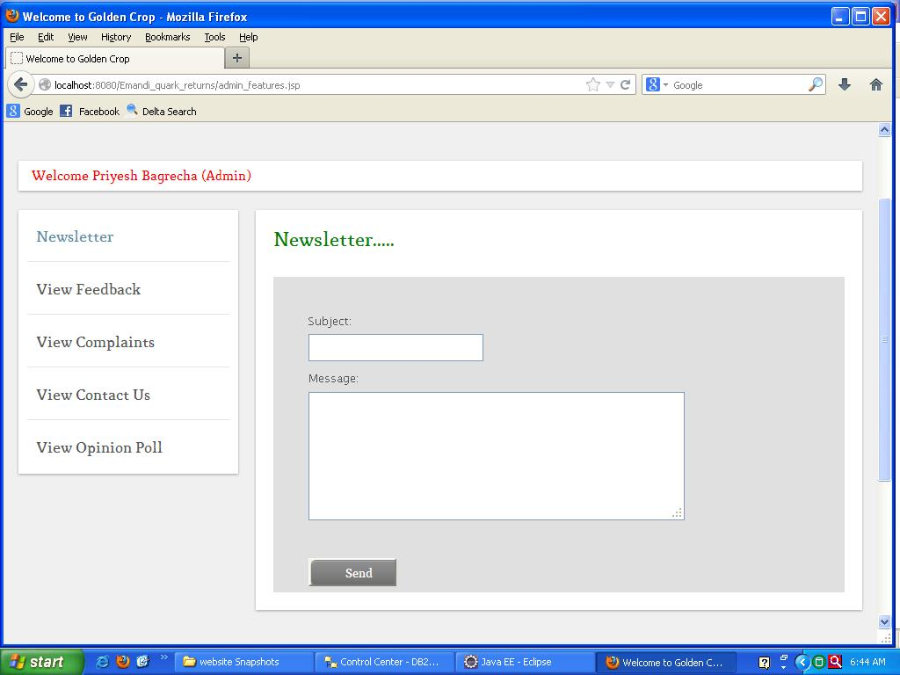

**Admin Reply to Complaint:**

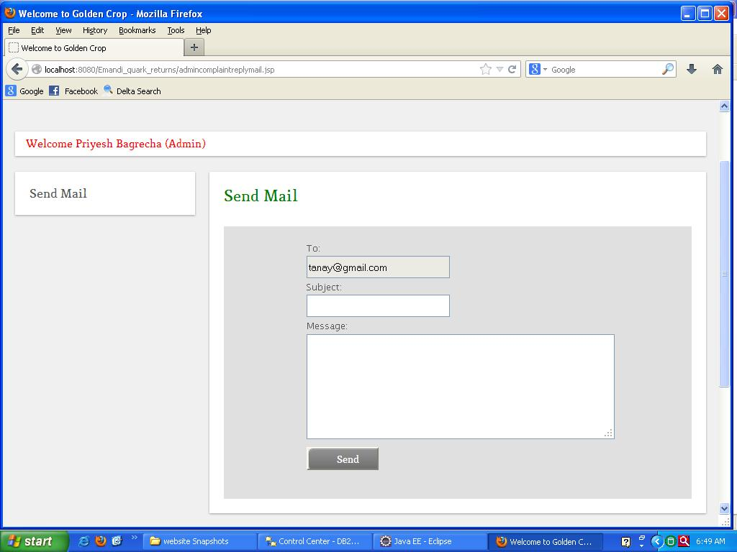

**Admin View Contact Us:**

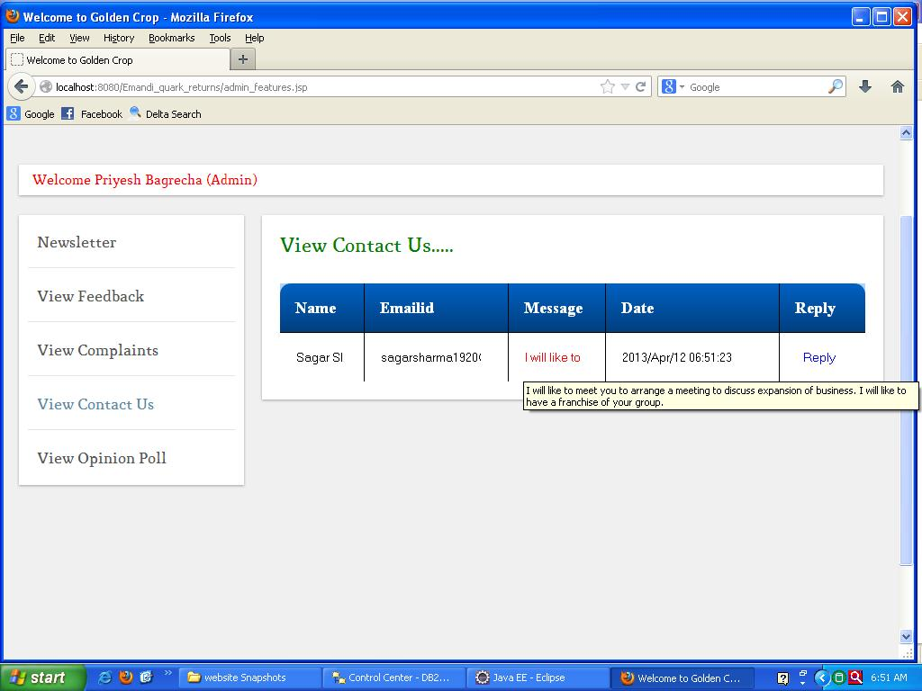

**Admin View Feedback:**

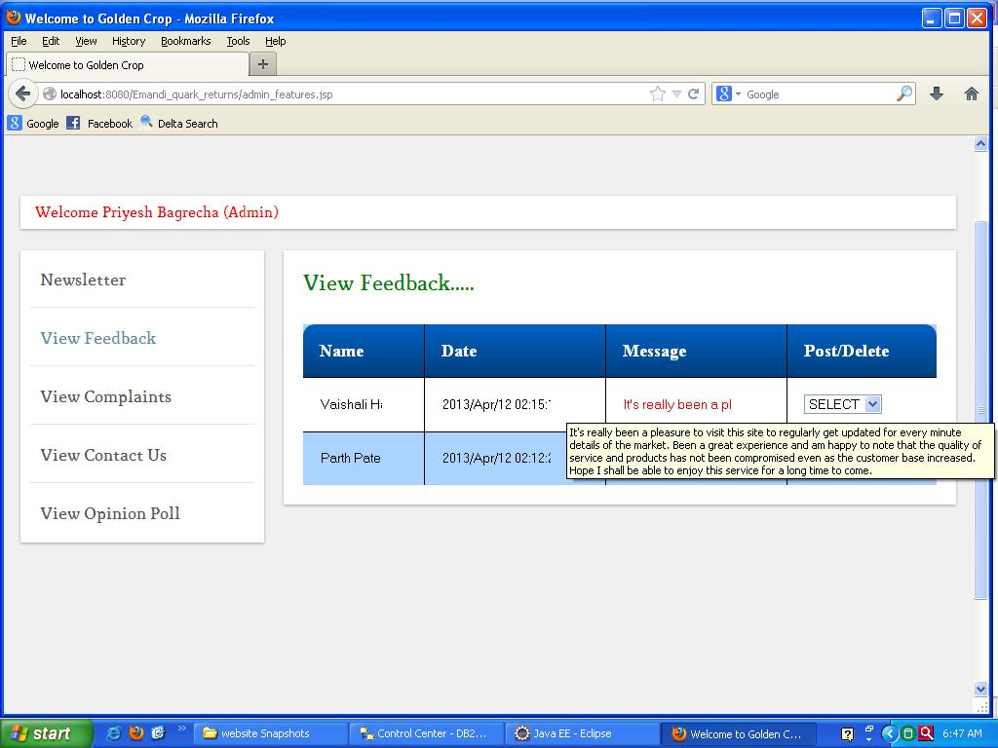

**Admin Authenticating Feedbacks:**

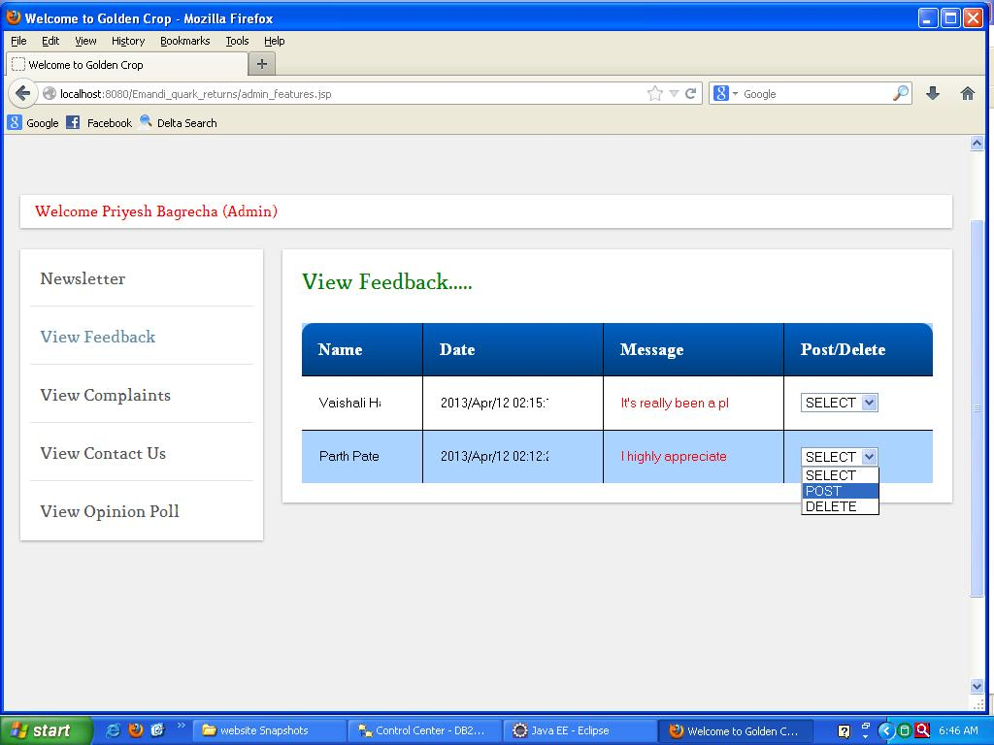

**Admin Update Vegetable Price:**

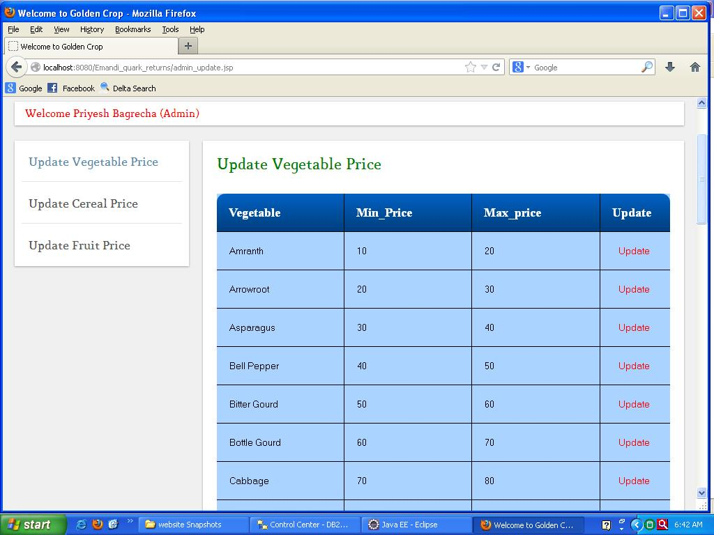

**Admin Update Cereal Price:**

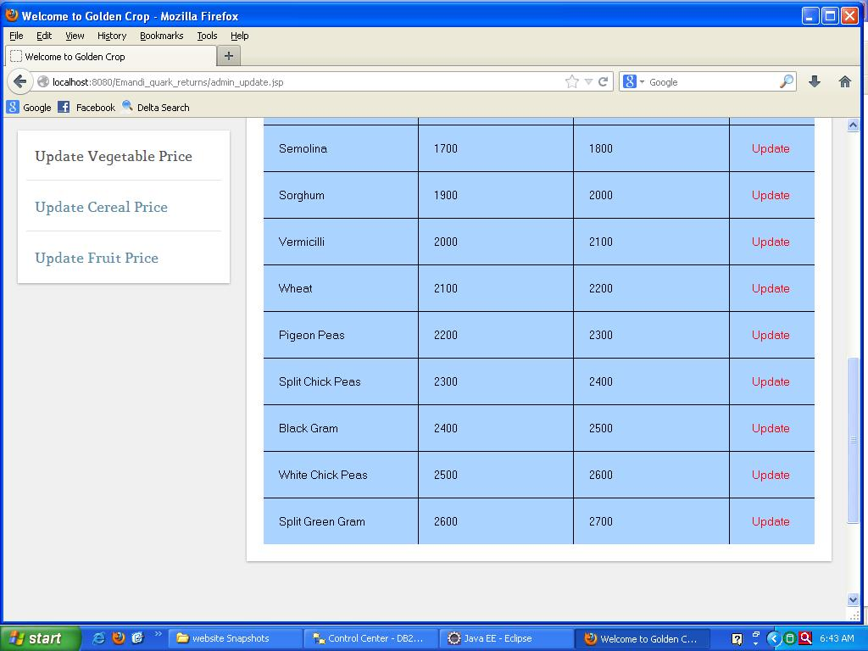

**Admin Update Fruit Price:**

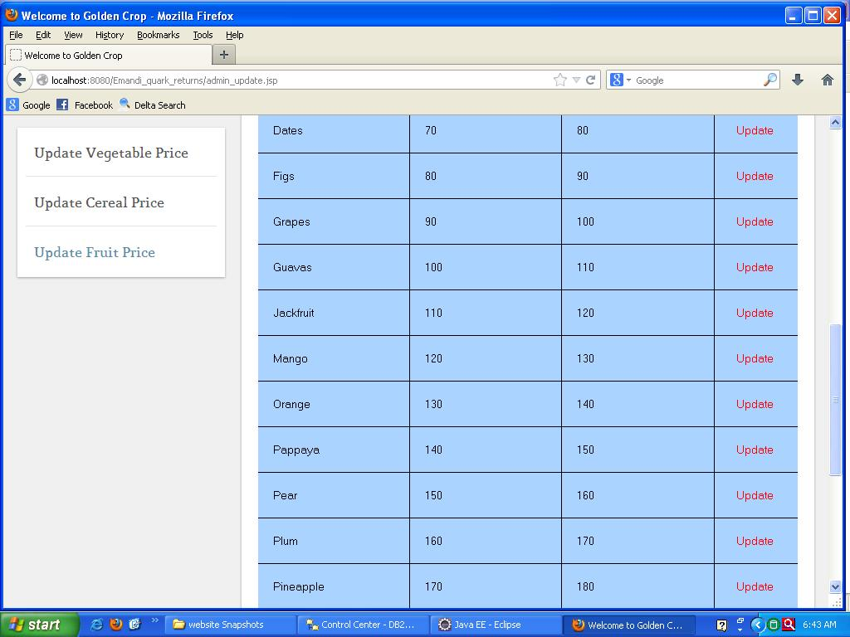

**SEARCH INTERFACE:**

**Search Overall View:**



**Search what to search and where to search, with whom to search:**



**Search Result View:**

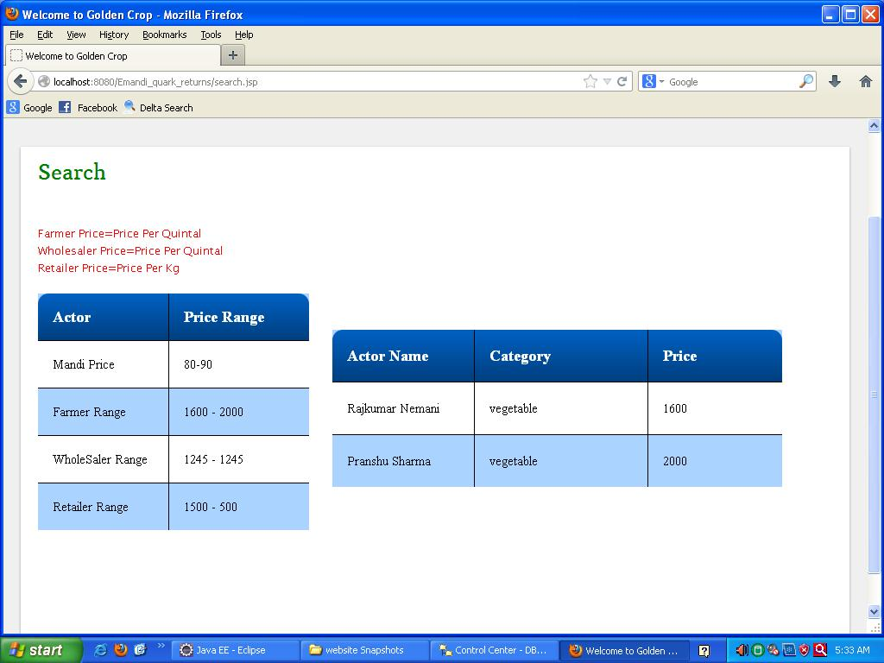

**Search Mandi Location:**



**Search Mandi Location Result View:**

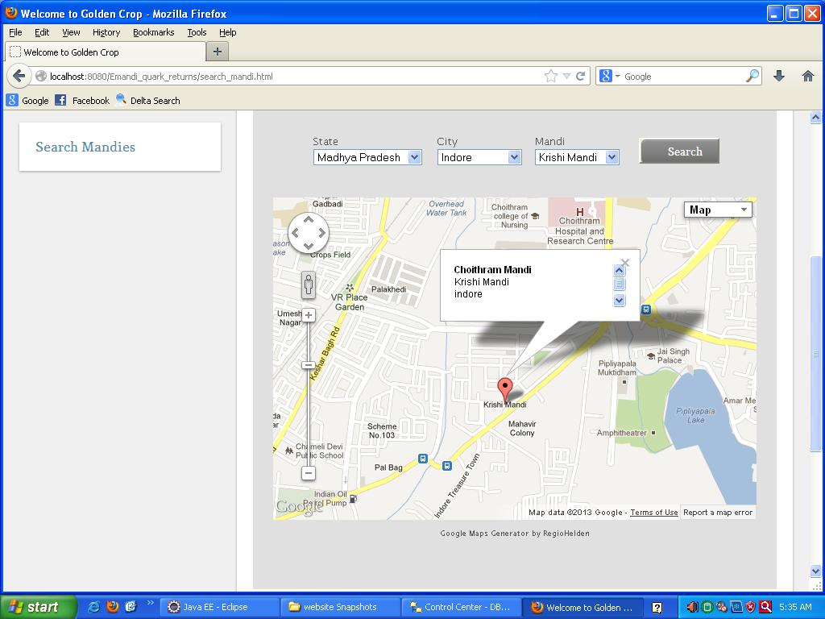

**MAIL SENDING INTERFACE:**

**Mail on Successful Registration:**

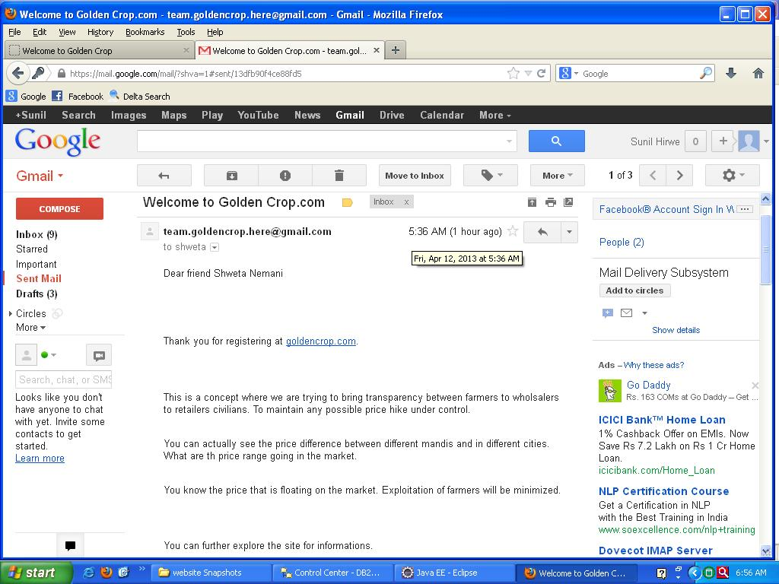

**Mail on Change Password:**

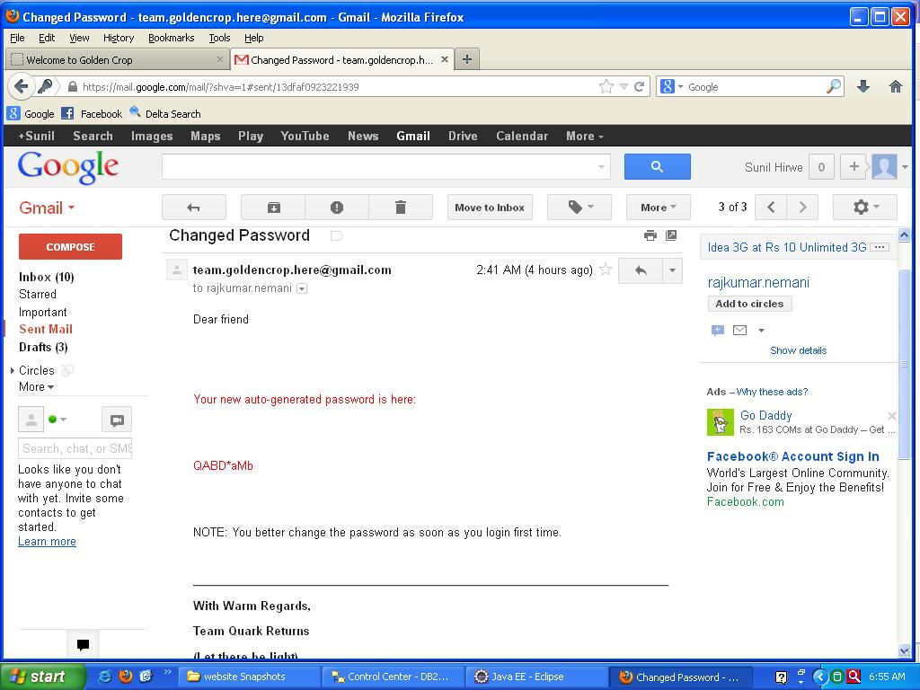

**Mail on Successful Registration:**

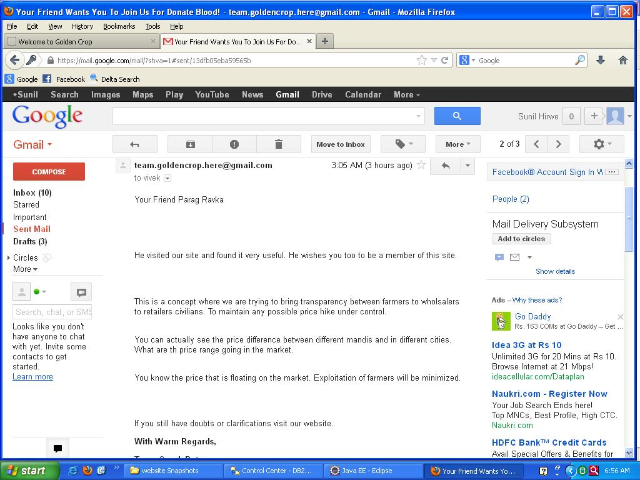

**Mail Sending Code (Inbox of the golden crop team):**

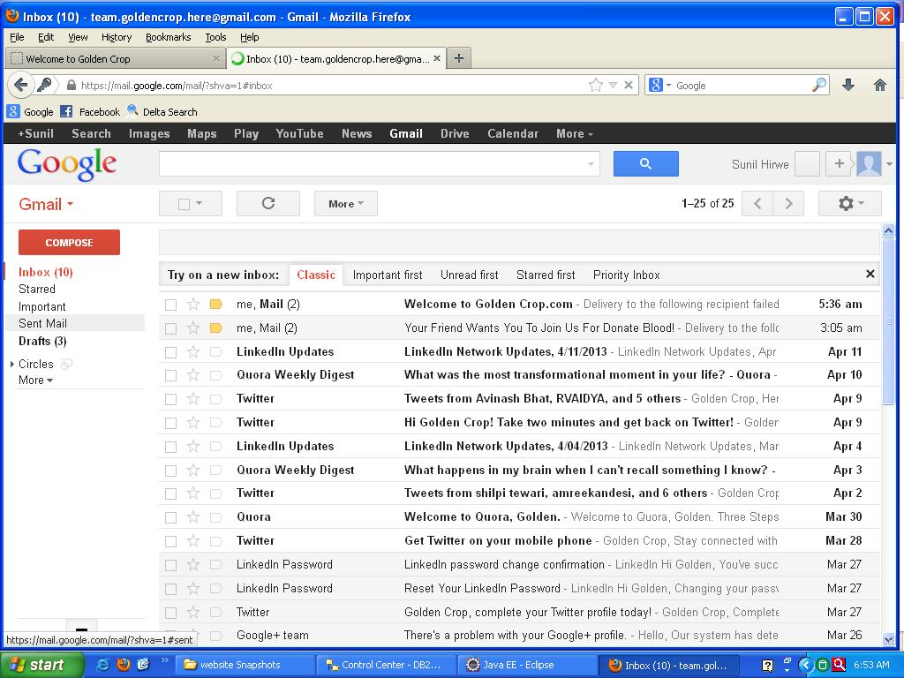

**MULTILANGUAGE INTERFACE:**

**Multilanguage Convertor**

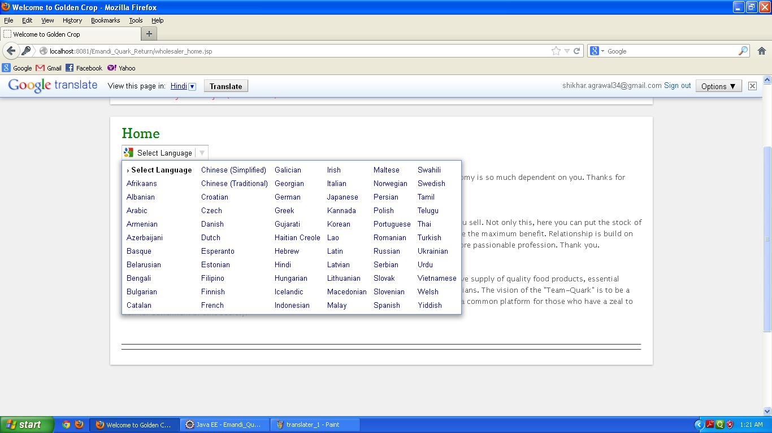

**Regular Page (in English):**

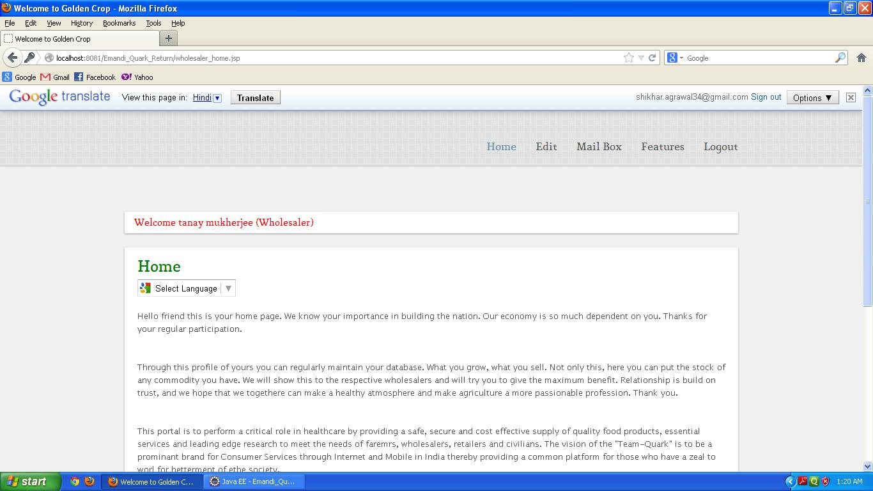

**Regular Page Translated (in Hindi):**

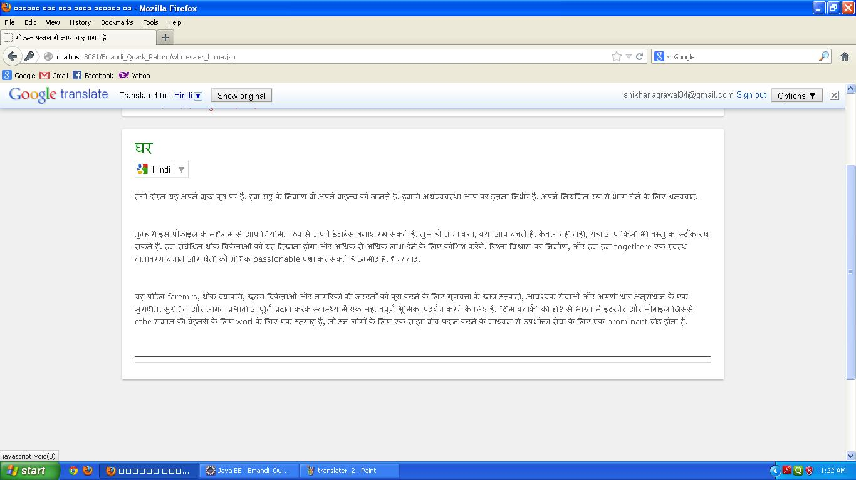

**6.2 Installation/ Deployment Instructions :**

**Procedure to deploy a project on new machine:**

1. First of all import war file in Eclipse.

2. Execute the DDL commands to create tables in DB2.

3. Execute the backup file.

4. Now, connect the DB2 to Eclipse.

5. And also start webspher application server.

6. Now, enjoy the site.

**Installation Requirement:**

1. DB2 v9.1

2. Eclipse helios v3.6.0

3. websphere v2.1

The following information provides username and password of different users to run the application.

1. **Farmer**

Username = rajkumar.nemani@gmail.com

Password = rajkumar

1. **Wholesaler**

Username = tanay@gmail.com

Password = tanay

1. **Retailer**

Username = shikhar@gmail.com

Password = shikhar

1. **Civilian**

Username =parag@gmail.com

Password = parag

1. **Admin**

Username =priyesh@gmail.com

Password = priyesh

**CHAPTER 7**

**CONCLUSION**

7.1 Conclusion

**7.1 Conclusion:**

According to requirements gathered and the technologies used to realize those requirements are best utilized to achieve functionalities. The Project has been completed successfully and fulfils all the requirements. And this project has been ready for the deployment on the server for the E-Mandi. But, for its successful operation, all the requirements like server Configuration have to be maintained.

**7.1.1 Advantages-**

* There is no problem of any lack of proper report due to automization of mandi system.
* Controlling the inflation and black marketing of items is possible
* The legal proof of negotiations and agreements between parties are now visible in log for future confirmation.
* E-mandi may help in statistical analysis like to calculate the annual production of any item and also the average price in most of the mandis.
* In future, this project can be associated with online grocery selling.
* Keeping in mind the Indian people, development of portal is made to be available in hindi and other regional languages also, so as to increase its reach among citizens.

**7.2.2 Disadvantages-**

* Login and password is needed for the identification of users, to differentiate donors to end users.
* Only registered farmers, whole sellers, retailers and civilians directors will be authorized to avail the services.
* Limited to HTTP/HTTPS.

**CHAPTER 8**

**LIMITATIONS AND FUTURE ENHANCEMENT**

8.1 Limitation of Project 8.2 Future Enhancement

**8.1 Limitation:**

* **No web camera interaction**.

Like in some other sites this facility is provided but this is the drawback of are site that no video camera interaction is provided for student teacher interaction.

* **People living in remote areas**

People belonging to remote area who don’t know how to access internet can’t use it if they want to use this application then they need to have knowledge about it or need someone’s help to get himself registered .

* **No mobile connectivity**

We have not included that application by which people can register via a mobile phone but we can include it in the future if needed.

* **Protected but time consuming**

Registration process can take time and we are providing full access only after registration process. So this might slows down accessing to resources.

**8.2 Future Enhancement:**

* It is provide more facilities like video conferencing and streaming is made available in our project.
* Provide facility to user for direct registration through Mobile phone.
* Allowing online selling of items and maintaining proper transaction details
* Upload videos of experts on these subjects.
* Create individual group for schools and colleges to provide better interaction between student and teachers.
* Propaganda shall be held to promote various activities like organic farming and educating farmers.

**CHAPTER 9**

**REFERENCES**

1. Software Engineering –Roger S. Pressman

2. J2EETM 1.4 BIBLE

Author: Scott W. Ambler (Edition2010)

3. Professional Java Server Programming J2EE 1.3 Edition

Author: Subrahmanyam Allamarju and Cedric Buest ( Edition: 2010)

4. Database System Concepts-HENRY F. KORTH

5. Java Servlet Programming-JASON HUNTER

6. The Complete Reference of Java- HERBERT SCHILDT

7. Programming with Java 3E-E.BALAGURUSAMY

8. The Complete Reference JSP 2.0

9. UML by Joseph Schemuller

10. http://www.netbeans.org

11. http://www.java.com

12. http://www.nptel.iitm.ac.in

13. http://www.ibm.com

**CHAPTER 10**

**GLOSSARY**

**Definition, Acronyms, and Abbreviations:**

* **Zones -** Locations into which the whole district/town will be divided so as to maintain the database in an easier way and to help donors, needier and hospitals to locate the quickest and nearest place for details.
* **HTML –** Hyper Text Markup Language, used for creating static web pages.
* **J2EE –** Java 2 Enterprise Edition is a programming platform and is a part of java for developing and running distributed java applications.
* **RSA –** Rational software Architect is a designer toolkit which is designed for develop for more complex projects by providing fully dynamic web service applications.
* **DB2 –** Database 2 is the database management system that provides a flexible and efficient database platform to erect on strong on demand business applications.
* **XML –** Extensive Markup Language used for data transfer and XML is stored naturally in DB2.
* **HTTP –** Hyper Text Transfer Protocol is a transaction oriented client/server protocol between web browser and web server.
* **TCP/IP –** Transmission Control Protocol/internet protocol is the communication protocol used to connect hosts on the internet.
* **WSAD -** It stands for WebSphere Studio Application Developer. It is a designer toolkit which is designed to develop more complex projects by providing a complete dynamic web service.